Team 2 Final Design Report: Colorimetric Glucose Biosensor, P.I.P.

Brooke Moon, Grace Holmes, Landon Goetz, Logan Lawson,
Michael Carmosino, Rowan Creps, Siyi Li
Miami University
Senior Capstone Design Report
Dr. Jason Berberich
05/13/2026
Abstract
This report presents the design, prototyping, and testing of P.I.P. (Personal Insulin Pal), a low-cost colorimetric glucose-monitoring device for pediatric users. The device optically reads enzymatic test strips based on a glucose oxidase/horseradish peroxidase/TMB (3,3',5,5'-tetramethylbenzidine) reaction system using a red LED (630–660 nm) and BPW34 silicon photodiode arranged in a reflectance configuration. A transimpedance amplifier converts the photodiode current into a voltage signal, which is read by an ESP32 microcontroller and displayed on a color-coded OLED screen housed within a child-friendly turtle-shell enclosure.
A kinetic measurement protocol was developed to address the concentration-dependent variability in TMB reaction rates. The device samples reflected light intensity over a 200-second window and derives glucose estimates from the 180–200 second plateau region. This approach produced a quadratic calibration curve across 100–400 mg/dL with an R² of 0.997 and back-calculated accuracy within ±5% under controlled laboratory conditions. Iterative refinement of the LED–photodiode geometry across three successive enclosure prototypes produced a monotonic calibration response in the final complete turtle-shell configuration. Independent verification strips at 300 and 400 mg/dL returned readings with correct rank ordering, though absolute errors of 33–37% indicate that inter-strip enzymatic variability and optical path sensitivity remain significant challenges. Field testing at the design expo revealed further degradation in accuracy attributable to environmental and mechanical factors.
The project demonstrates that a colorimetric glucose reader based on inexpensive consumer-grade components can achieve concentration discrimination in a controlled setting. Future work focuses on hardware consolidation to soldered connections, mandatory field recalibration protocols, and standardized strip fabrication to improve accuracy toward accepted glucose-meter performance benchmarks.

1. Project Description
P.I.P., Personal Insulin Pal, is a low-cost colorimetric glucose biosensor prototype designed for pediatric users. The device uses disposable GOx/HRP/TMB enzymatic test strips and a reflectance-based optical system to estimate glucose concentration. A red LED illuminates the test strip reaction zone, and a BPW34 silicon photodiode measures the reflected light intensity. As glucose concentration increases, the TMB reaction produces a darker blue-green product that absorbs more red light, reducing the reflected signal detected by the photodiode.
The final prototype integrates a disposable test strip, an optical-electrical sensing circuit, ESP32-based signal processing, an SSD1331 color OLED display, and a pediatric-friendly turtle-shell enclosure. The firmware uses differential and kinetic measurements, applies a quadratic calibration model, and displays both a numerical glucose estimate and a color-coded status indicator.
The design aims to combine glucose concentration discrimination with a less clinical, more approachable user experience for children and caregivers. Under controlled laboratory conditions, the prototype demonstrated concentration discrimination from 100 to 400 mg/dL. However, verification and field testing showed that accuracy remains limited by strip-to-strip variability, optical alignment sensitivity, ambient lighting changes, and breadboard-level electrical connections. Therefore, the current device should be considered a functional proof-of-concept rather than a clinically validated glucose meter.

2. Background & Prior Art

2.1 Literature Background
Diabetes mellitus is a chronic metabolic disorder characterized by dysregulation of blood glucose due to insufficient insulin secretion, impaired insulin action, or both. Persistent hyperglycemia increases the risk of acute complications such as severe hypoglycemia, diabetic ketoacidosis, and hyperosmolar crises, as well as long-term vascular complications, including atherosclerotic cardiovascular disease, peripheral neuropathy, nephropathy, and diabetic retinopathy. Accurate and frequent glucose monitoring is a fundamental component of disease management, enabling patients and clinicians to maintain glycemic control and mitigate these risks (Mathew et al., 2025).
Self-monitoring of blood glucose (SMBG) has transformed diabetes care by providing rapid, quantitative feedback that informs insulin titration, carbohydrate intake decisions, and behavioral adjustments (Ewunetu et al., 2025). Over the past several decades, blood glucose meters have evolved from visually interpreted color-change strips to compact digital analyzers with high analytical precision. Modern reflectance-based devices, such as the ACCU-CHEK Inform II and GLUCOCARD S onyx, meet or exceed current international standards for precision and reproducibility (Azuma et al., 2025).

2.2 Clinical Need and User Population
The primary users of blood glucose meters are patients with type 1 or type 2 diabetes who require insulin or other glucose-lowering medications. Blood glucose meters are also indicated for patients with gestational diabetes, individuals at risk for hypoglycemic episodes, and patients in critical care settings where glucose fluctuations are common (Berger, 2025; Nichols et al., 2021). Regular home self-monitoring is associated with improved glycemic control and greater patient knowledge of their condition, leading to reduced complications (Ewunetu et al., 2025).
Glucose concentrations vary with physiological state, including age, circadian rhythm, and feeding status. Following an overnight fast, glucose levels typically fall within 70–150 mg/dL, rising after meals and returning toward baseline within approximately two hours as insulin promotes cellular glucose uptake (Berger, 2025). In diabetes, this regulatory mechanism is impaired, resulting in exaggerated or prolonged excursions that require external monitoring. Accurate measurement during both fasting and postprandial periods is therefore essential for optimizing glycemic management (Berger, 2025; Mathew et al., 2025).

2.3 Operating Principles of Detection
Enzymatic colorimetric glucose meters quantify glucose by analyzing a small blood sample applied to a disposable test strip. These strips function as integrated microchemical reactors containing immobilized Glucose Oxidase (GOx), Horseradish Peroxidase (HRP), and a chromogenic substrate. The detection mechanism proceeds through a well-characterized biochemical cascade.
Capillary action draws the applied glucose sample into the reaction zone of the test strip. GOx catalyzes the oxidation of β-D-glucose into gluconic acid, generating hydrogen peroxide (H₂O₂) as a stoichiometric byproduct. In the presence of HRP, the hydrogen peroxide oxidizes the chromogenic substrate (e.g., TMB), forming a dye with a characteristic absorbance spectrum. A wavelength-specific LED illuminates the reaction zone, and a photodiode quantifies the intensity of reflected light, which decreases proportionally with increasing dye concentration. The device compares the reflectance intensity to a stored calibration curve, converting the optical signal into a glucose concentration for display (Azuma et al., 2025).
Reflectance-based colorimetric meters eliminate the need for electrochemical mediators and enable intuitive optical measurements, though performance still depends on strip chemistry, optical geometry, and calibration stability. As with all glucose meters, test strips must be device-specific; incompatible strip chemistries can produce inaccurate readings or system errors (Azuma et al., 2025).

2.4 Value and Need
Despite the availability of both SMBG devices and continuous glucose monitors (CGMs), children frequently experience fear, anxiety, and sensory discomfort associated with traditional glucose monitoring. The combination of finger-prick pain, clinical device appearance, and the absence of child-friendly features can lead to poor adherence, inconsistent testing frequency, and increased caregiver difficulty. Because stable glycemic control during childhood is critically important for preventing long-term complications, pediatric-appropriate monitoring tools offer substantial clinical and psychosocial value (Thomas et al., 2023).
Current glucose meters are engineered primarily for analytical performance, with limited consideration of emotional comfort or pediatric usability. There is a clear unmet need for devices that integrate high-fidelity enzymatic detection with engaging, reassuring, and developmentally appropriate interfaces (Thomas et al., 2023).

2.5 Comparison to Existing Products
Several companies currently lead the glucose monitoring market. Dexcom's G6 and G7 sensors offer continuous monitoring with smartphone integration. Abbott's FreeStyle Libre provides patch-based monitoring with minimal finger pricks. Medtronic's Guardian sensor integrates with insulin pumps for automated management. These devices are highly accurate and technologically advanced, yet they are designed for adult users and lack features tailored to pediatric comfort or simplified interpretive displays. Their interfaces typically present only numerical results, which can be difficult for young or newly diagnosed users to interpret quickly.
P.I.P. uses the same general enzymatic glucose-recognition principle as many commercial glucose meters, but replaces electrochemical transduction with a low-cost optical reflectance readout, while introducing pediatric-oriented usability features. The turtle-shell form factor reduces fear and resistance during testing, and the color-coded OLED display provides instant visual interpretation alongside the numerical glucose value. This dual-output system enables caregivers to make faster decisions and reduces cognitive load for children who may not yet understand glucose thresholds. By combining emotional comfort with intuitive visual feedback while preserving enzyme-based glucose recognition, P.I.P. addresses a gap in the current market: a pediatric-focused glucose meter that remains low-cost, portable, and technically aligned with proven detection methods.

2.6 Prior Art Considerations
To inform the design of P.I.P., the team reviewed ten patents spanning continuous glucose monitoring, user-accessible interfaces, sampling and strip design, and optical detection methods. These patents clarified the current state of the field, identified gaps in pediatric usability, and provided technical reference points for the optical and chemical subsystems.

2.6.1 Continuous and Integrated Monitoring Systems
Several patents demonstrate the trajectory toward integrated glucose management platforms. The Dexcom integrated device (US8425417B2) presents an early closed-loop system that combines a continuous glucose sensor, a vascular access device, and an insulin-infusion module, establishing the feasibility of merging sensing and therapeutic delivery into a single platform. A more recent Dexcom patent (US12226617B2) extends this concept by coordinating a continuous sensor with an insulin-delivery unit and an optional single-point meter through internal communication protocols. A Turkish university patent (TR2024020207A2) adopts a different integration approach, combining a lancet and a glucometer into a single handheld unit with internal needle storage to improve hygiene. While these systems target different clinical scenarios than P.I.P., they illustrate the broader trend toward consolidating multiple functions into compact, user-facing devices.

2.6.2 User Accessibility and Pediatric Design
The Bayer pictogram display patent (RU2401055C2) describes a glucose meter that replaces text-based interfaces with pictograms, improving accessibility for children and non-native speakers. Its emphasis on simplified visual communication directly informed P.I.P.'s color-coded display framework, which uses green, yellow, and red backgrounds to convey glucose status without requiring the user to interpret numerical values.

2.6.3 Sampling and Biosensor Strip Design
Strip-level innovation has focused on reducing sample volume, improving plasma separation, and enhancing enzymatic sensitivity. Cha et al. (WO2008100118A1) describe a device that combines a fine-needle array with a biosensor strip, where strengthened micro-needles and an enlarged electrode area enable glucose detection from minimal blood volumes while reducing pain. The Arkray biosensor patent (US20170108459A1) addresses enzymatic efficiency by using a multi-electrode disposable strip with optimized electron-transfer pathways, demonstrating material and structural strategies for improving enzyme-based sensing at low cost. The Roche dual-blade lancing strip (US8016775B2) and the LifeScan rapid electrochemical system (JP4988059B2) contribute additional approaches to sampling comfort and measurement speed, respectively, through paired shallow incisions and miniaturized microelectrode impedance sensing.

2.6.4 Optical and Colorimetric Detection
Two patents provided direct technical reference for P.I.P.'s optical subsystem. The IIT Kharagpur paper-based device (WO2021019552A1) demonstrates that a low-cost microfluidic paper strip can separate plasma and detect glucose colorimetrically, with results analyzed via a smartphone application. This validated the feasibility of combining simple filter-paper substrates with color-based detection for affordable glucose monitoring. The Chongqing University non-invasive optical sensor (CN113598763A) uses near-infrared light and correction algorithms to estimate glucose from skin-reflected signals. Although P.I.P. uses a contact-based reflectance approach rather than non-invasive sensing, this patent provided a useful reference for optical signal processing and algorithmic modeling of reflectance data.
Collectively, these patents confirmed that the core detection principle underlying P.I.P., enzymatic colorimetric reflectance, is well-established and commercially validated. The primary gap identified across the prior art is the absence of devices that combine this detection method with a pediatric-oriented form factor and simplified interpretive display.

3. Market Analysis
The primary target users for P.I.P. are children with diabetes, particularly those who are newly diagnosed or who struggle with the emotional discomfort associated with routine glucose testing. The pediatric diabetes management device market has grown substantially in recent years and continues to expand at a high single-digit to low double-digit CAGR. Global market revenue was estimated at approximately $5.59 billion in 2024, with North America accounting for roughly 40% of that share (Grand View Research, 2025a). The U.S. pediatric diabetes management market alone was valued at $2.02 billion in 2024 and is projected to reach $4.69 billion by 2033 at a CAGR of 9.9% (Grand View Research, 2025b). Growth in this segment is driven by the rising prevalence of Type 1 and Type 2 diabetes in children, increasing adoption of advanced monitoring technology, and expanding insurance coverage for pediatric diabetes devices (TechSci Research, 2024).
The commercial landscape is dominated by a small number of large device manufacturers, including Medtronic, Dexcom, Abbott, Roche, Insulet, Tandem Diabetes Care, and Ascensia (Polaris Market Research, 2026). These manufacturers offer two main product categories. Traditional blood glucose meters (BGMs) such as the Accu-Chek Guide, Contour Next One, and OneTouch Verio remain widely used. Standard-quality BGMs typically sell in the $30 to $60 range, with low-cost options available below $10 and premium meters reaching up to $250, alongside recurring test strip costs that can exceed $1 per strip (AvaCare Medical, 2025). Continuous glucose monitors (CGMs), led by the Dexcom G7 and Abbott FreeStyle Libre, held the largest pediatric segment share at approximately 34% of revenue in 2024 (Grand View Research, 2025), providing real-time glucose tracking through a wearable sensor at a substantially higher recurring cost.
Despite the size and maturity of this market, finger-stick BGMs designed specifically for pediatric users are largely absent from current product lines. Existing BGMs are engineered primarily for adult users, with clinical aesthetics, monochrome displays, and numerical-only output that can intimidate young children and discourage routine testing. Pediatric-oriented form factors do exist within the CGM category, such as the smaller sensor introduced with the Dexcom G7, yet the ongoing sensor subscription cost limits accessibility for families without comprehensive insurance coverage (Polaris Market Research, 2026). This combination of adult-oriented BGM design and high CGM recurring cost leaves a clear opening for a low-cost, pediatric-focused finger-stick device.
P.I.P. is positioned to address this gap on two fronts. The turtle-shell enclosure, color-coded OLED display, and child-friendly visual elements target the pediatric user experience directly, reducing the medical anxiety associated with traditional glucose testing. At the same time, the total hardware cost of approximately $53.51 (Section 4.2.1) places the device in the same price band as standard adult BGMs, allowing families to access a pediatric-friendly design without the recurring sensor subscription expense of a CGM. Although the prototype is not yet validated to FDA point-of-care accuracy standards, the cost profile, reusable hardware, and pediatric form factor identify P.I.P. as a candidate for a market segment that is currently underserved.

4. Design Specifications & Constraints

4.1 Engineering Requirements
The engineering requirements for P.I.P. were established during the first semester to guide subsystem development and provide measurable targets for evaluation. They cover analytical performance, user experience, and physical form factor for a pediatric user population.
For analytical performance, the device was required to detect glucose across a clinically relevant range of 20–600 mg/dL, encompassing hypoglycemic, normal, and severely hyperglycemic conditions. Measurement accuracy was evaluated relative to commonly cited glucose-meter performance benchmarks, including FDA and ISO accuracy expectations for blood glucose monitoring systems. Because the prototype was tested using prepared glucose standards rather than clinical blood samples and a laboratory reference method, these benchmarks were used as design targets rather than regulatory validation criteria. Test strip reaction time was targeted at under 60 seconds, and the detection chemistry was specified as a glucose oxidase, horseradish peroxidase, and TMB enzymatic system with reagent stability supporting a six-month strip lifespan after opening.
For user experience and form factor, the device was required to display both a numerical glucose value and a color-coded indicator (green for safe, yellow for moderate, red for high or low, and flashing red for critical levels), to adopt a pediatric-friendly, non-clinical enclosure that reduces testing anxiety, and to operate from a portable battery in a single handheld unit. Performance against these requirements is evaluated in Section 7.

4.2 Constraints
The P.I.P. design operated under several constraints that shaped subsystem selection throughout the project. The defining technical constraint was a prohibition on electrochemical detection, the industry-standard method based on direct measurement of enzymatic reaction current. The team adopted an optical reflectance system using a red LED and a BPW34 silicon photodiode, which introduced additional requirements for housing light shielding and firmware signal processing. Cost, safety, accuracy, manufacturability, and ethical constraints are discussed below.

4.2.1 Cost
A primary economic constraint was to keep the total bill of materials competitive with consumer-grade adult blood glucose meters. The final prototype component cost was approximately $53.51, placing the device within the $30 to $60 price band of standard commercial BGMs and well below the recurring subscription cost of continuous glucose monitors. A complete cost breakdown is provided in Appendix E.

4.2.2 Safety
User exposure to reagents is limited by the enclosed strip geometry and dry reagent format. Although the selected TMB-based chemistry is safer than the rejected fluorescence pathway, reagent handling and strip disposal would still require defined safety procedures in a production design.

4.2.3 Accuracy and Regulatory
Blood glucose meters are subject to formal accuracy expectations under FDA guidance and ISO 15197 standards. These standards are intended for validated devices tested against reference methods using appropriate clinical sample sets. The P.I.P. prototype was not evaluated under those conditions; therefore, FDA and ISO criteria are used here only as design benchmarks. Under controlled laboratory calibration, the final prototype produced back-calculated concentrations within approximately ±5% of the nominal standards. However, independent verification strips at 300 and 400 mg/dL produced absolute errors of approximately 33% and 37%, respectively (Section 7.3). The current prototype therefore does not meet glucose-meter accuracy expectations. Improving performance will require reduced inter-strip variability, more repeatable optical alignment, soldered electrical connections, field recalibration, and validation across a larger sample set.

4.2.4 Manufacturability
Two manufacturability constraints shaped the project. Prototype-scale strip fabrication currently requires approximately 5 to 10 minutes of hands-on time per strip for reagent deposition, drying, and assembly; automated dispensing and large-batch PET cutting would shorten this substantially at commercial scale. Consistent production also depends on reliable sourcing for enzymes (GOx, HRP), chromogenic substrates (TMB), filter paper, PET sheet stock, and electronic components, all currently available from multiple suppliers though requiring qualification at production volumes.

4.2.5 Ethical Considerations
Ethical considerations centered on pediatric safety, clinical transparency, and accessibility. The originally proposed fluorescence detection pathway was rejected because the indicators considered carried higher toxicity than the TMB-based chemistry ultimately selected. The turtle-shell form factor and color-coded OLED display reduce the medical anxiety children often experience with traditional glucose monitors, and a firmware-based calibration verification mode displays a warning when readings deviate beyond a defined tolerance. The PLA enclosure supports low-cost rapid prototyping with a lower environmental impact than petroleum-based filaments.

5. Concept Development & Selection
The final P.I.P. design combines two preliminary concepts developed during the first semester: a child-friendly turtle-shell concept focused on reducing pediatric anxiety, and a compact handheld concept focused on portability, simplified operation, and practical glucose measurement. The final design integrates the user-centered form of the first concept with the functional layout and sensing strategy of the second concept.
The turtle-shell form factor was retained because it directly supports the pediatric design goal. The rounded shell creates a less clinical appearance than a conventional rectangular glucose meter and provides enough internal volume to house the ESP32 development board, analog front-end circuit, OLED display, and optical sensing module. The head region was used as the strip insertion and optical measurement area, allowing the test strip to slide into a fixed sensing position while keeping the display visible on the upper shell.
The original concept considered both fluorescence-based and colorimetric detection. The fluorescence pathway was rejected because the candidate indicators introduced greater safety and handling concerns. The team therefore selected a GOx/HRP/TMB colorimetric pathway, which uses a visible color change that can be measured optically with low-cost components. This chemistry also allowed the device to avoid electrochemical detection, which was restricted by the project constraints.
Reflectance-based detection was selected for the optical subsystem. A red LED with an emission range of approximately 630–660 nm illuminates the TMB reaction zone, and a BPW34 silicon photodiode measures the reflected light from the strip surface. The LED and photodiode are mounted on the same side of the test strip and separated by a 3D-printed black wall to reduce direct light leakage. As glucose concentration increases, the TMB reaction produces a darker blue-green color, which absorbs more red light and decreases the reflected signal reaching the photodiode. This inverse relationship between glucose concentration and reflected red-light intensity forms the basis of the calibration model.
The display subsystem was revised from the originally proposed monochrome I2C OLED to an Adafruit SSD1331 96 × 64 color OLED connected through SPI. This change allowed the firmware to display both a numerical glucose estimate and a full color-coded background. The interface uses green, yellow, red, and flashing red status cues to communicate glucose categories quickly. This dual-output format was selected to support both quantitative interpretation by caregivers and rapid visual interpretation by pediatric users.
The electrical design also evolved during prototyping. The original transimpedance amplifier design used a 1.65 V virtual reference node, but the final as-built prototype connected the MCP6002 non-inverting input directly to ground. The firmware and calibration procedure were therefore based on the measured response of the final hardware configuration rather than the original virtual-ground model. Similarly, the LED current-limiting resistor was removed during prototype testing to increase optical signal strength. This direct GPIO-driven LED configuration improved light intensity during testing, but it is not recommended for a production-ready design. A future version should restore current limiting or use a dedicated LED driver to protect the ESP32 GPIO pin and improve electrical robustness.
The final integrated prototype therefore represents an engineering compromise between safety, optical signal strength, manufacturability, and pediatric usability. It combines a turtle-shell enclosure, GOx/HRP/TMB test strip chemistry, reflectance-mode optical detection, ESP32-based signal processing, and a color OLED interface. Under controlled laboratory conditions, this architecture supported monotonic glucose discrimination across the validated 100–400 mg/dL range, although later verification and field testing showed that additional hardware consolidation and calibration controls are necessary before the system could approach clinical accuracy requirements.

5.1 Chemistry Concept and Test Strip Design
The P.I.P. test strip integrates the chemical and physical layers required for colorimetric glucose detection. The active chemistry follows a glucose oxidase/horseradish peroxidase/TMB cascade. First, glucose oxidase catalyzes the oxidation of glucose to gluconic acid while producing hydrogen peroxide:
Glucose + O₂ + H₂O $\frac{Glucose Oxidase }{}$> Gluconic Acid + H₂O₂ (1)
The hydrogen peroxide then serves as the oxidizing species in the HRP-catalyzed oxidation of reduced TMB:
H₂O₂ + 2 TMB_{reduced} $\frac{Horseradish Peroxidase }{}$> 2 TMB._{oxidized} + 2 H₂O (2)
The oxidized TMB product appears blue-green and absorbs strongly in the red wavelength region. Therefore, as glucose concentration increases, the strip develops a darker color, reflects less red light, and produces a lower photodiode signal in the reflectance-mode optical system. This inverse relationship between glucose concentration and reflected red-light intensity is used as the basis for calibration.
The strip is built as a four-layer assembly. Two inner layers of Whatman Grade 4 filter paper carry the active reagents. One paper disc holds the enzyme working solution, prepared by combining glucose oxidase and horseradish peroxidase in pH 6.36 potassium phosphate buffer to final activities of 0.835 U/mL GOx and 1.33 U/mL HRP. The second paper disc holds TMB dissolved in acetone at 3.15 mg/mL; acetone is required as the solvent because TMB is insoluble in water. Each disc receives a 10 μL deposition. The two reagents are placed on physically separate paper layers to prevent premature oxidation of TMB during fabrication and storage and to keep color development reproducible once the sample is introduced.
The two paper discs are sandwiched between an outer pair of laser-cut PET sheets sized 10 × 50 mm. The top PET sheet includes a 3 mm circular capillary opening positioned over the reaction zone, which admits the sample directly to the reagent stack. The bottom sheet is a plain cut that provides mechanical support. A capillary-hole cover sticker shields the reagents from air exposure until use, and electrical tape applied 1.5 cm from the bottom edge masks the section of the strip that sits outside the optical window when inserted into the device.
The two-layer paper design replaces an earlier multi-grade filter stack originally intended to separate plasma from whole blood. The team removed the plasma separation requirement during the first semester to simplify the strip and improve chemical compatibility with the GOx/HRP/TMB system. Using a single filter paper grade across both reagent layers also reduces batch-to-batch variability in fabrication. The complete step-by-step fabrication procedure, including buffer preparation, reagent deposition order, drying conditions, assembly, and storage, is provided in Appendix J.
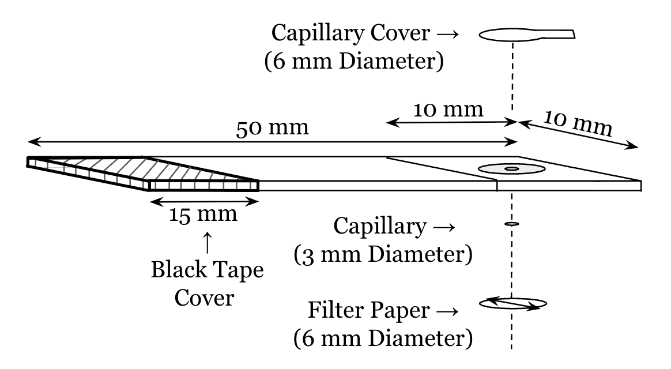
Figure 1. Schematic representation of the developed paper-based test strip design. Fully assembled test strip with labeled dimensions of each component.
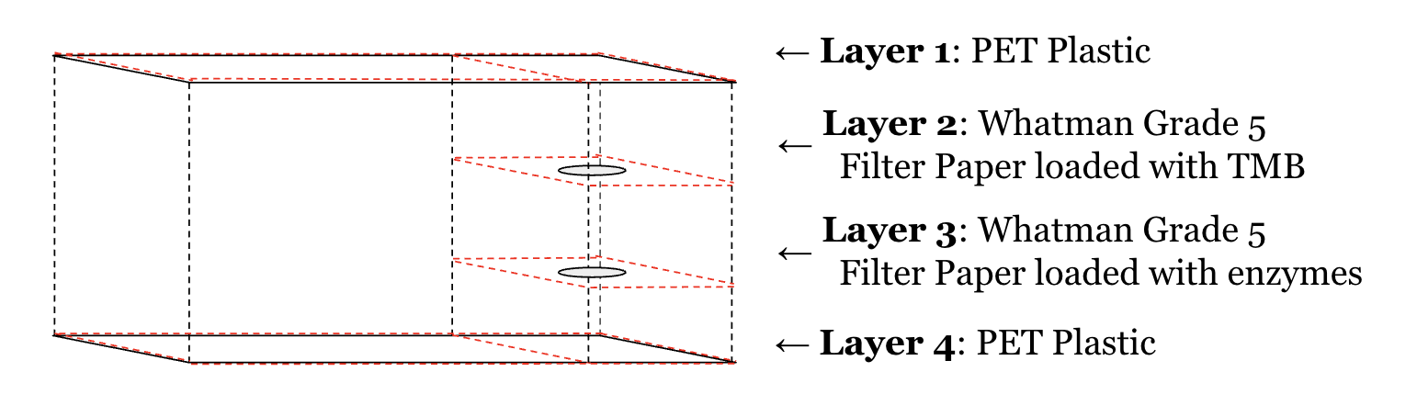
Figure 2. Exploded layer-by-layer view of the test strip showing the arrangement and assembly of individual filter paper layers and functional materials.

5.2 Electrical System Design
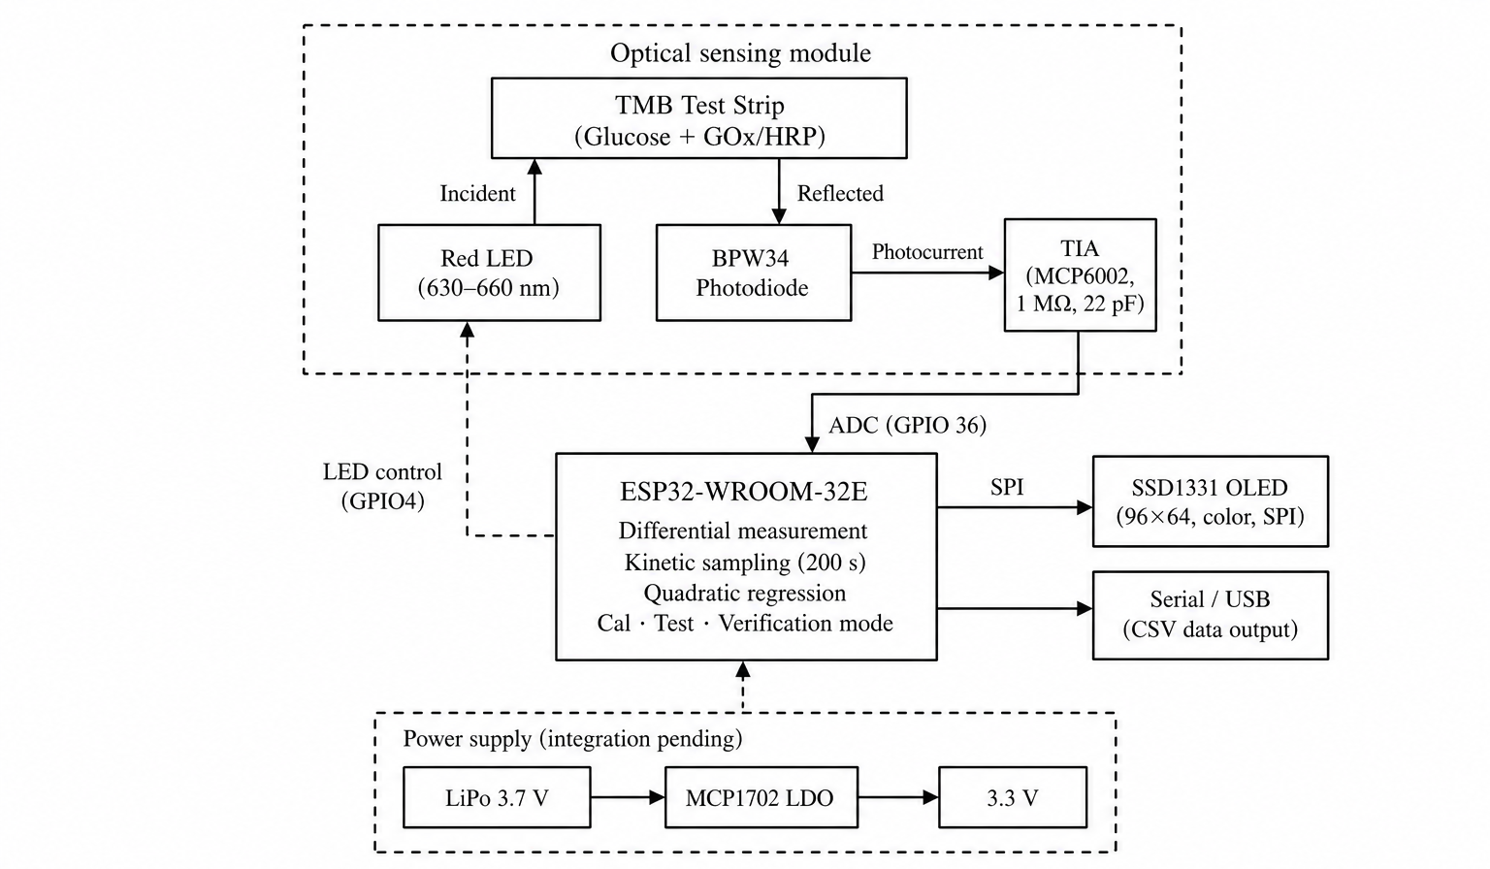
Figure 3. System block diagram of the P.I.P. colorimetric glucose monitoring device. Solid arrows indicate signal flow; dashed arrows indicate control lines and power distribution. The power supply subsystem was selected and tested independently but had not been physically integrated at the time of reporting.
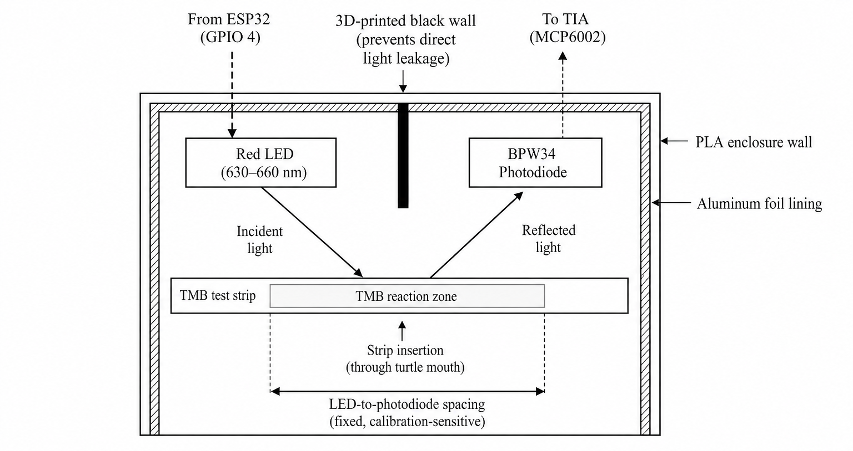
Figure 4. Cross-section of the optical sensing configuration. The LED and photodiode are mounted on the same side of the test strip surface in a reflectance geometry, facing the reaction zone and separated by a 3D-printed black wall to prevent direct light leakage. Inner enclosure walls are lined with aluminum foil to maximize reflected signal recovery. The LED-to-photodiode spacing is treated as a fixed, calibration-sensitive parameter.
The initial firmware design used a single endpoint reading taken after a fixed reaction time. Testing with real TMB strips revealed that this approach produced inconsistent results across the 100–400 mg/dL range, because the TMB reaction rate varies significantly with glucose concentration: high-concentration strips reach peak coloration within seconds, while low-concentration strips require several minutes. The design was revised to a kinetic measurement protocol, in which the device samples reflected-light intensity continuously over a 200-second window and derives the glucose estimate from the 180–200 second plateau region. This improved both the monotonicity and reproducibility of calibration data.
The analog front-end uses an MCP6002 transimpedance amplifier to convert BPW34 photodiode current into a voltage signal readable by the ESP32 ADC. The original conceptual design biased the non-inverting input at a 1.65 V virtual reference node. During prototyping, this reference network was removed, and the final as-built circuit connected the non-inverting input directly to ground. As a result, the calibration model and firmware interpretation were based on the measured behavior of the final grounded-reference circuit rather than the original virtual-ground design. For standalone battery operation, an MCP1702-3302E/TO low-dropout regulator steps down the 3.7 V lithium polymer battery voltage to a stable 3.3 V rail, with input and output decoupling capacitors selected according to the regulator datasheet.

5.3 Design Specifications and Benchmarking
Before developing our final design concept, we conducted a benchmarking assessment to compare the functional components of established products with our design. Shown below is a tabulated list of our design metrics compared to the market-established Metene glucose biosensor specifications.
No. | Metric | Unit | Metene | P.I.P.
1 | Dimensions | mm | 89.8 (L) × 52.4 (W) × 17.3 (H) | 101.6 (L) × 66 (W) × 30 (H)
2 | Power source | V | AAA battery (1.5 V) | Lithium battery (3.7 V)
3 | Display | — | LCD | SSD1331 96×64 color OLED (SPI)
4 | Measurement range | mg/dL | 20–600 | 100–400 (validated)
5 | Sensor | — | Glucose oxidase | Glucose oxidase
6 | Detection mechanism | — | Electrochemical | Colorimetric (reflectance)
7 | Accuracy | % | Not public | Back-calculated calibration error within ±5%; independent verification error 33–37%
8 | MCU | — | — | ESP32-WROOM-32E
9 | Test strip lifespan | — | 6 months (opened) | ~6 months
10 | Test strip reaction time | s | 7 | 200 (kinetic protocol)
11 | Test strip body | mm | 100 (L) × 10 (W) × 1.15 (H) | 50 (L) × 10 (W) × 1.15 (H)
12 | Test strip testing site | mm | 10 (L) × 10 (W) × 0.18 (H) | 9 (L) × 9 (W) × 0.36 (H)
Table 1. Benchmarking comparison between the Metene commercial glucose biosensor and the P.I.P. prototype as built across mechanical, electrical, and analytical metrics. The two devices share the same enzymatic sensing chemistry (glucose oxidase) but differ in transduction mechanism (electrochemical vs. colorimetric reflectance) and resulting form factor. The validated measurement range for P.I.P. is narrower than the Metene reference range due to TMB saturation above 400 mg/dL. Reaction time reflects the kinetic measurement protocol used by P.I.P., which samples reflectance over a 200 s window and derives the glucose estimate from the 180–200 s plateau region.

6. Prototype Development

6.1 Analog Front-End Circuit
The transimpedance amplifier circuit was assembled on a solderless breadboard according to the design described in Section 5.2. Initial testing revealed that the TIA output was fixed at approximately 2.1 V and unresponsive to light changes. Systematic pin-by-pin debugging uncovered three independent wiring errors: a loose ground connection to the voltage divider (Pin 3 reference reading 0.57 V instead of the expected 1.65 V), the BPW34 photodiode connected to Pin 1 (output) rather than Pin 2 (inverting input), and a 1 kΩ resistor between Pin 1 and ground attenuating the signal. After correcting all three, the TIA output exhibited a 0.3 V swing between dark and illuminated conditions, confirming successful signal acquisition.
The ADC readings then exhibited high-frequency oscillation, a known consequence of operating a TIA at high gain with a capacitive source. Two 22 pF ceramic capacitors placed in parallel with the 1 MΩ feedback resistor, as close to the MCP6002 pins as possible, suppressed the oscillation and were retained in all subsequent builds.
During prototyping, several additional modifications were made to the original circuit design. The voltage divider providing the 1.65 V virtual ground reference was replaced with a 0 Ω resistor connecting the non-inverting input directly to ground. The 220 Ω current-limiting resistor on the LED was removed, with the LED driven directly from GPIO 4. This modification increased the red LED intensity and improved the measurable reflected signal during prototype testing. However, it also removed the normal current-limiting protection for both the LED and ESP32 GPIO pin. This configuration was therefore treated as a prototype-only workaround rather than a production-ready circuit choice. Future hardware revisions should restore a current-limited LED drive circuit or use a dedicated LED driver while preserving sufficient optical intensity for TMB detection.
A 10 μF decoupling capacitor was added between VDD and VSS for power supply stability. The second channel of the MCP6002 (Pins 5–7) was configured as a unity-gain follower to prevent oscillation of the unused channel. The final circuit schematic is provided in Appendix C.

6.2 Firmware Development
Firmware was developed iteratively on the ESP32-WROOM-32E using the Arduino IDE, with each version addressing a limitation identified during testing.
The initial firmware performed a single-point ADC read with the LED on, which proved highly sensitive to ambient light. A differential measurement protocol was implemented to address this: the system records 30 seconds of ADC samples with the LED off (ambient baseline), then 30 seconds with the LED on (signal), and subtracts the two. A blank-strip calibration step was then added at the start of each session, establishing a reference maximum against which all subsequent readings are expressed.
Early calibration used a single endpoint reading taken after a fixed reaction time. However, TMB reaction kinetics vary dramatically with glucose concentration: high concentrations produce a visible color change within seconds, while low concentrations require several minutes. A single endpoint at any fixed time would either undercount low concentrations or miss the dynamic range at high concentrations. The firmware was therefore redesigned around a kinetic measurement approach: the device samples continuously over a 200-second window, and the glucose estimate is derived from readings within a 180–200-second window, empirically determined to capture the late-phase plateau across 100–400 mg/dL. This substantially improved monotonicity and reproducibility.
Per Dr. Berberich’s feedback, a user-facing calibration verification mode was incorporated into the main program. In this mode, the user inserts a test strip with a known glucose concentration, and the device performs the standard 200-second kinetic measurement. If the resulting reading deviates from the expected value by more than a preset tolerance, the device displays a warning indicating that the hardware may be compromised and that subsequent results should not be trusted.
Additional features include serial commands (ledon/ledoff) for manual LED control during debugging, CSV-formatted serial output for data capture, quadratic regression with R² computation, and a dual-mode architecture that allows the user to switch between calibration and testing modes.
The user interface runs on an Adafruit SSD1331 96×64 color OLED display connected via SPI. The display presents a color-coded background transitioning from green through yellow to red based on glucose concentration. A boot animation and home screen were added in the final revision under the "P.I.P. - Personal Insulin Pal" branding. The firmware flowchart is provided in Appendix A.

6.3 CAD Development
Computer-aided design (CAD) was performed in Autodesk Fusion 360, and physical prototypes were fabricated using Bambu Lab 3D printers with PLA filament. PLA was selected because it supported rapid, low-cost iteration and provided sufficient mechanical rigidity for the prototype enclosure.
Early P.I.P. prototypes were intentionally oversized to provide enough internal volume for the electrical components. Subsequent CAD iterations refined the enclosure toward an ellipsoid turtle-shell form while adding hollow internal regions for the ESP32, breadboard, OLED display, battery pack, and optical sensing module. As the internal layout became better defined, the enclosure dimensions were reduced to improve portability while preserving sufficient space for assembly and wiring.
Early CAD iterations, notably Shell V1, focused purely on securely housing the internal components: such as the breadboard, OLED display, and battery pack, which initially resulted in a bulky, "blocky" box turtle aesthetic. Upon consulting with the broader team regarding the general shape, the mechanical design was revised in versions V2 and V3 to feature a more eclipsed, elliptical shape that authentically mimicked a natural tortoise shell. Additionally, these early models introduced a sliding door mechanism on the device's underbelly to facilitate easy battery replacements.
As the design transitioned from software to physical testing, the team constructed rudimentary paper models to visually estimate the volume required for the internal components. Initial CAD projections had slightly increased the shell's dimensions by roughly 0.125 to 0.150 inches to accommodate the protoboard. However, coordination with the electrical team member, Siyi, revealed that the chosen components required significantly less space than originally anticipated. Consequently, the CAD files were swiftly modified to produce a far more compact product. Following these critical dimension adjustments, the first physical test print of the shell's lower base was executed on a Bambu Carbon printer, taking approximately three hours to complete.
The development of the turtle's head and neck, the primary housing for the photodiode and test strip reader, required extensive physical troubleshooting. The initial physical prototypes demonstrated critical reading failures because the red LED's light was being absorbed over the large distance between the reflection point, the LED, and the photodiode. To isolate the issue, the team printed two alternative neck designs featuring white and black inlines to test different behaviors of light absorption. This testing phase culminated in the creation of a compact "light-box" system, which involved relocating the breadboard directly into the neck to minimize the light's overall distance of travel. By printing this redesigned component in black PLA, this redesign restored the monotonic calibration behavior observed in the earlier optical housing and improved reading consistency under laboratory conditions.
In the final weeks of development, the team focused on cosmetic enhancements and structural finalization. Minor aesthetic details, such as rounding the neck and modeling eyes, were integrated into the CAD files based on feedback from the original illustrator, Brooke. The mechanical team also evaluated different appendage orientations, including a sprawled "splooting" posture, but ultimately selected a standard standing pose to guarantee physical stability. The final structural components were printed using green and brown PLA, requiring a combined total of ten hours of printing time. Final assembly involved sanding down connection pins to achieve precise interference fits and embedding small magnets within the casing, ensuring the shell remained securely sealed and the internal components were protected while traveling to the Senior Design Expo.
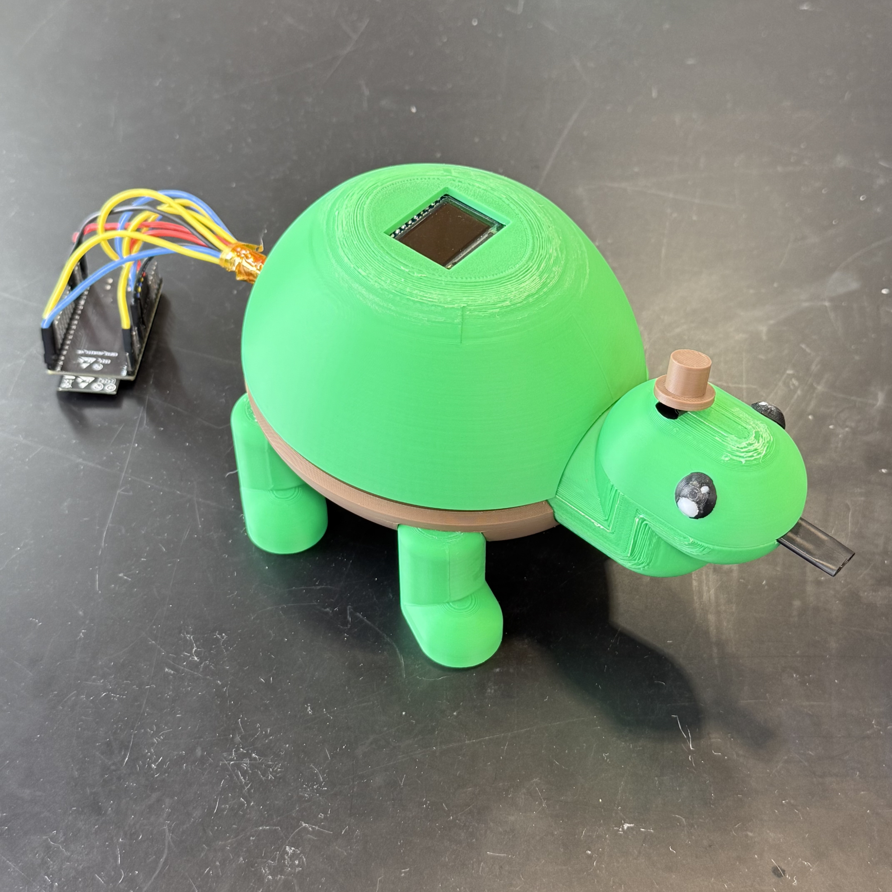
Figure 5. Final prototype shows the OLED display through the dorsal aperture and the strip insertion guide protruding from the head. The ESP32-WROOM-32E development board appears at left because final consolidation onto the perfboard remained pending at the time of the photograph. The deployed configuration places the controller within the upper shell cavity shown in Figures D1, D2, and D5.

7. Experimental Methods & Testing

7.1 Testing Protocol
All measurements follow the differential kinetic protocol described in Section 6.2. A blank strip establishes the reference maximum at the start of each session. For each sample, the system records a 30-second ambient baseline (LED off) followed by a 200-second kinetic measurement (LED on), using 30-sample averaging with a 30 ms settle time per reading to reduce noise. The glucose estimate is derived from the mean ADC reading within the 180–200 second window, empirically determined to capture the late-phase plateau of the TMB colorimetric reaction across the 100–400 mg/dL range. The differential value (Diff), defined as the blank reading minus the sample reading, serves as the primary measurement variable: higher glucose concentrations produce deeper blue coloration, absorb more red light, and yield larger Diff values.

7.2 Calibration
Calibration was repeated across three enclosure iterations: a standalone optical housing mounted over the breadboard (Iteration 1), a partial turtle shell consisting of the head module with the optical components integrated into the printed body (Iteration 2), and the complete integrated turtle-shell enclosure (Iteration 3).
The first two configurations yielded calibration R² values of 0.6601 and 0.5532 respectively, with point ordering scattered relative to glucose concentration. The standalone housing exhibited inter-strip baseline differences in initial reflectance. The head-integrated configuration introduced three compounding sources of signal degradation: ambient-light leakage through the open rear of the head module, an extended optical path of approximately 8 to 9 cm (compared with 2 to 3 cm in the standalone housing) that reduced the photodiode-incident signal, and mechanical play in the unsupported head module on the test bench.
The complete turtle-shell enclosure closed the rear opening, locked the head position through the shell-to-head interface, and shortened the optical path back to the 2 to 3 cm range, yielding a quadratic calibration with R² = 0.9972. Back-calculation of the calibration standards through the fitted equation produced estimated concentrations within ±5% of the nominal values.
Calibration was also tested at 500 mg/dL in the complete turtle-shell configuration. The kinetic signal saturated near the 300 to 400 mg/dL response level, and back-calculation of the measured endpoint through the fitted equation yielded 340 mg/dL, an error of −32%, establishing 400 mg/dL as the upper limit of the device's reportable range. Calibration curves, kinetic response plots, verification curves, and the 500 mg/dL data appear in Appendix F.
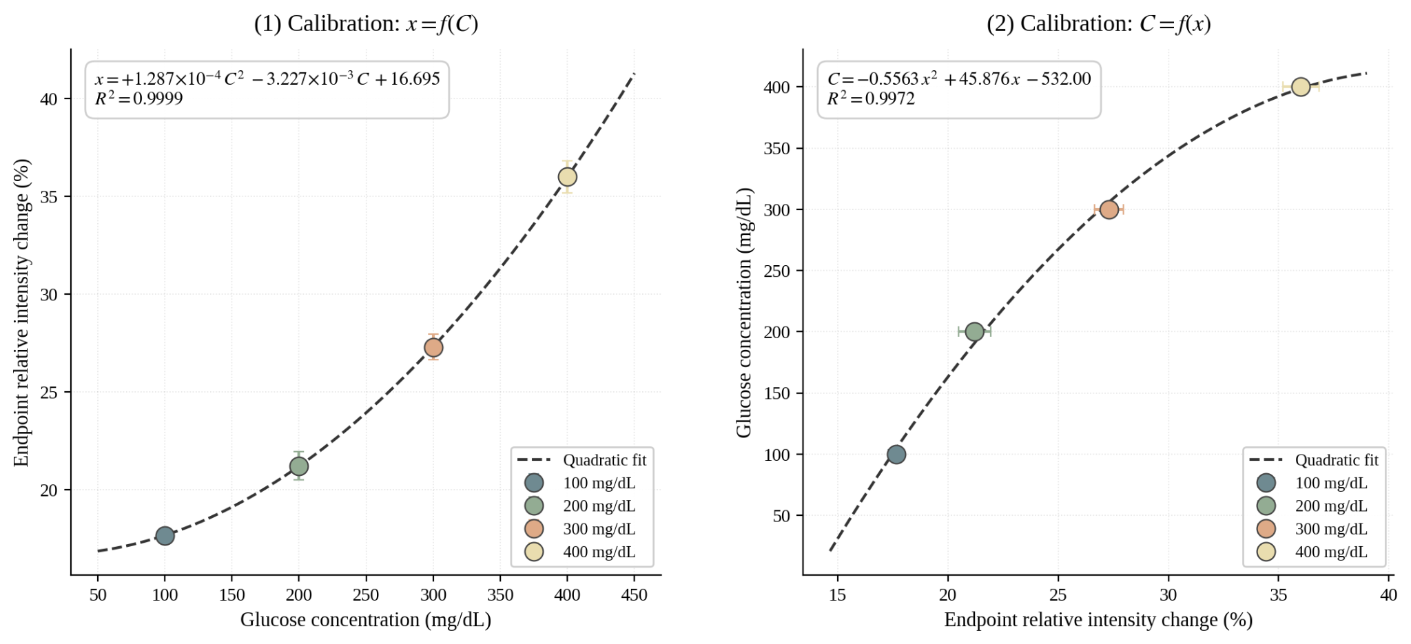
Figure 6. Calibration curve for the complete turtle-shell configuration relating endpoint relative color intensity change in the 180–200 s window to glucose concentration (n = 34 samples per concentration). Panel (1) presents the data in the experimental orientation with glucose concentration on the abscissa, fitted as x = f(C). Panel (2) presents the same data in the inverse orientation with intensity on the abscissa, fitted as C = f(x); this is the form used by the firmware to back-calculate glucose concentration from a measured intensity reading.

7.3 Verification Testing
To assess accuracy outside the calibration dataset, verification measurements were performed in the same laboratory under the same lighting conditions used during calibration. Test strips at 300 and 400 mg/dL were prepared independently from the calibration set and measured using the stored quadratic coefficients. Kinetic response curves for both strips are shown in Appendix F.
The device reported 201 mg/dL for the 300 mg/dL strip and 254 mg/dL for the 400 mg/dL strip. The readings preserved the correct rank order (201 < 254), with absolute errors of approximately 33% and 37%, respectively. Possible sources of this discrepancy include inter-strip variability in the enzymatic reaction (differences in enzyme loading, substrate distribution, or reaction completeness between individually prepared strips), minor differences in strip placement within the device affecting the optical path, and potential overfitting of the quadratic model to the specific set of strips used during calibration.

7.4 Field Testing
The device was demonstrated at the design expo, an indoor venue with substantially different ambient lighting from the calibration laboratory. During live demonstrations, test strips at multiple concentrations consistently returned readings of approximately 20 mg/dL, indicating a near-complete loss of discriminatory ability.
On-site troubleshooting included tightening wire connections and expanding the firmware clamp range from 0–400 to 0–600 mg/dL. After these adjustments, the device returned a reading of 0 mg/dL for one strip and 34 mg/dL for a 100 mg/dL strip. The latter result represented a partial improvement, yet performance remained far below the accuracy demonstrated in the laboratory.
Multiple factors likely contributed to the failure: a shifted ambient light baseline from different venue lighting (the blank calibration was performed in the original laboratory environment), mechanical disturbance of the LED-photodiode geometry during transport, and potential loose connections. Ground-wire disconnection had been a recurring issue throughout the project. Because multiple variables changed simultaneously between the laboratory and the expo, isolating the dominant failure mode was infeasible.

7.5 Limitations
The prototype demonstrated reliable concentration discrimination under controlled laboratory conditions and lost accuracy upon transfer to a new environment. Key limitations include the system's sensitivity to the physical alignment of optical components, the absence of a field-recalibration protocol for the ambient baseline, inter-strip variability in the enzymatic reaction, and the fragility of breadboard connections under transport. The calibration range is restricted to 100–400 mg/dL due to TMB saturation at higher concentrations. Proposed mitigations are discussed in Section 9.

8. Project Management & Team Contributions
The development of the P.I.P. (Personal Insulin Pal) colorimetric glucose biosensor was managed across two consecutive 15-week semesters using a phased and milestone-driven project management strategy. Because the project integrated chemical, mechanical, and electrical engineering systems into a single biosensor platform, strong communication and coordination between subsystems were essential throughout the design process. The team adopted a parallel-development workflow that allowed major subsystems to progress simultaneously while maintaining scheduled checkpoints, presentations, and integration milestones.
The project was divided into four primary phases: Project Conception and Initiation, Project Definition and Planning, Prototype Development and Testing, and Project Performance Evaluation. These phases were monitored through weekly progress discussions, milestone tracking, and a detailed Gantt chart (Appendix K) developed during the planning stage.
During the first semester, the team focused primarily on conceptual development and planning. In the Project Conception and Initiation phase, all team members collaboratively conducted a patent review and literature assessment to evaluate current glucose-monitoring technologies and identify opportunities for a low-cost, pediatric-oriented biosensor design. The team then developed an initial integrated design model outlining the interaction between the enzymatic colorimetric chemistry, optical sensing system, and mechanical housing components. Multiple design reports and presentations were completed throughout the semester, allowing the design requirements, constraints, and subsystem approaches to be refined through instructor feedback. Major engineering requirements established during this phase included measurement accuracy, colorimetric sensitivity, portability, manufacturability, and user accessibility. The primary milestone for this phase was the successful completion of the conceptual design presentation and approval of the overall project framework by the end of the semester.
The Project Definition and Planning phase focused on preparing each subsystem for fabrication and testing during the second semester. Initial enclosure concepts and layout planning were developed, preliminary electrical schematics were created, and the chemistry team researched enzyme systems and chromogenic reagents required for glucose detection. Test strip concepts and fabrication methods were also explored during this period. By the conclusion of the first semester, all major subsystem concepts and development plans had been established, allowing the team to transition into prototype construction and testing.
The second semester focused on Prototype Development and Testing, where subsystem development occurred in parallel. Responsibilities were divided according to each member’s technical focus area. Brooke Moon and Michael Carmosino led the chemistry development, optimizing reagent concentrations, validating the GOx/HRP/TMB reaction system, and preparing calibration standards for testing. Brooke Moon, Rowan Creps, and Grace Holmes managed test strip fabrication and optimization, including reagent loading, strip assembly, and iterative refinement of the strip geometry and capillary dimensions to improve color formation and repeatability.
Mechanical CAD development was divided between Logan Lawson and Landon Goetz. Logan Lawson designed and refined the turtle-shell biosensor enclosure, focusing on the external housing geometry and internal spacing for the electronics and optical sensing components. Landon Goetz focused on the development and refinement of the test strip holder geometry to improve strip placement consistency and alignment within the optical sensing region. Siyi Li independently managed the electrical and firmware subsystem, including construction of the analog front-end circuit, photodiode integration, ESP32 microcontroller programming, OLED display integration, and implementation of the kinetic measurement firmware used for glucose detection.
Although responsibilities were divided by subsystem, the final stages of the project required extensive collaboration between all team members. Calibration testing, device assembly, troubleshooting, and final system integration were completed collectively as a group. The team worked together to assemble the biosensor housing, integrate the electrical hardware with the chemistry-based test strips, perform calibration testing across multiple glucose concentrations, and evaluate device performance prior to the Design Expo.
One of the largest project management challenges occurred near the end of the second semester during final integration and testing. While subsystem development progressed effectively in parallel throughout much of the semester, integrating the chemistry, electrical, and mechanical components into a fully functional device proved more time-intensive than originally anticipated. The optical sensing system was highly sensitive to strip placement, enclosure geometry, ambient lighting conditions, and the spacing between the LED and photodiode. At the same time, variations in strip fabrication and reaction timing introduced additional complexity during calibration testing. These challenges required multiple rounds of troubleshooting and redesign late in the project timeline. As a result, the team identified final integration scheduling and earlier subsystem coordination as a major area for improvement in future multidisciplinary engineering projects.
Despite these challenges, the team successfully completed a functional biosensor prototype prior to the Design Expo. The final phase of the project focused on calibration analysis, verification testing, field demonstrations, and preparation of the final technical report. Device performance was evaluated by comparing measured reflectance intensities to known glucose concentrations, while sources of error and future improvements were documented for continued development.
Overall, the project management strategy emphasized structured milestones, subsystem delegation, and interdisciplinary collaboration across both semesters. While the project revealed the difficulties associated with integrating chemical, electrical, and mechanical systems under strict time constraints, it also demonstrated the importance of communication, flexibility, and collaborative troubleshooting in the successful completion of a multidisciplinary engineering design project.

9. Recommendations & Future Work
The immediate priority is hardware consolidation. All circuit connections should be transferred from the solderless breadboard to a soldered perfboard, which would eliminate the recurring ground-wire disconnection issue and secure the BPW34 photodiode leads against mechanical stress. The spatial relationship between the LED and photodiode must be preserved exactly during this transition, as calibration data is sensitive to this geometry.
Battery integration remains incomplete. A 3.7 V lithium polymer battery and MCP1702-3302E LDO regulator were selected and tested independently, and should be incorporated into the perfboard build to enable untethered operation.
The expo field-testing results exposed the system's dependence on the specific environment in which calibration was performed. A mandatory blank re-calibration at the start of every measurement session, enforced in firmware, would account for changes in ambient lighting and optical alignment. In the long term, calibration data collected across multiple lighting conditions would produce a more robust model.
Measurement accuracy should be improved toward accepted glucose-meter accuracy benchmarks, such as FDA and ISO performance expectations for blood glucose monitoring systems. Reducing inter-strip variability through standardized strip fabrication (e.g., replacing Whatman filter paper with membrane-based substrates) and improving strip placement repeatability with mechanical guides in the enclosure would both contribute to this goal. Formal repeatability testing, with the same strip measured consecutively, should be conducted to quantify device-level precision independent of strip variability.
Extending the measurement range above 400 mg/dL would require addressing TMB saturation at high glucose concentrations, potentially through an alternative chromogenic substrate or a multi-wavelength LED configuration.

Acknowledgements
We thank the Department of Chemical, Paper, and Biomedical Engineering in the College of Engineering and Computing at Miami University for funding this project and for providing the laboratory equipment and facilities used throughout development. We are especially grateful to Dr. Jason Berberich for his sustained guidance throughout both semesters of the capstone. His feedback on experimental design, troubleshooting strategy, and report preparation shaped the trajectory of the project and the quality of the final deliverable. Additional thanks goes out to Laurie Edwards, for allowing the continued use of her personal hole puncher utilized throughout the entire semester, as well as Kyle Turner for his assistance navigating the lab space.
We also acknowledge the software tools that supported the development work. Firmware drafting and debugging across the Arduino IDE and Python serial-logging pipeline were assisted by Claude Code. System block diagrams and flowcharts were created in draw.io, mechanical CAD was developed in Autodesk Fusion and Tinkercad, the analog front-end schematic was drawn in EasyEDA, and all data figures in this report were generated in Python.
Lastly, I would like to present the greatest appreciation to myself. Thank myself for being such a persistent, generous, and intelligent person.

References
AvaCare Medical. (2025). Glucose meters and diabetic testing supplies. https://www.avacaremedical.com/diagnostic/glucose-monitoring
Azuma, D., Okuda, H., & Saeger, B. (2025). System accuracy evaluation of the new blood glucose monitoring meter "GLUCOCARD S onyx" beyond ISO 15197:2013/EN ISO 15197:2015 requirements and with new patient safety features. Frontiers in Clinical Diabetes and Healthcare. https://doi.org/10.3389/fcdhc.2025.1465732
Berger, K. (2025). Blood sugar charts: Normal levels by age and more. SingleCare. https://www.singlecare.com/blog/blood-sugar-chart/
Biswas, S. K., Laha, S., Chatterjee, S., Pedireddi, V. M., Patel, S., Saha, S., & Chakraborty, S. (2021). System for estimation of plasma glucose by integrated paper-based device and method thereof (Patent No. WO2021019552A1). World Intellectual Property Organization.
Brauker, J. H., Tapsak, M. A., Saint, S. T., Kamath, A. U., Neale, P. V., Simpson, P. C., Mensinger, M. R., & Markovic, D. (2025). Integrated delivery device for continuous glucose sensor (U.S. Patent No. 12,226,617 B2). U.S. Patent and Trademark Office.
Ewunetu, M., Belay, B. M., Abere, Y., et al. (2025). Home self-monitoring of blood glucose using a glucometer and its determinants among diabetes mellitus. Scientific Reports, 15, Article 17217. https://doi.org/10.1038/s41598-025-02196-4
Freckmann, G., Pleus, S., Grady, M., Setford, S., & Levy, B. (2019). Measures of accuracy for continuous glucose monitoring and blood glucose monitoring devices. Journal of Diabetes Science and Technology, 13(3), 575–583.
Gamessa, T. W., Suman, D., & Tadesse, Z. K. (2018). Blood glucose monitoring techniques: Recent advances, challenges and future perspectives. International Journal of Advanced Technology and Engineering Exploration, 5(46), 338–344.
Grand View Research. (2025a). Pediatric diabetes management market size, share & trends analysis report, 2025–2033. https://www.grandviewresearch.com/industry-analysis/pediatric-diabetes-management-market-report
Grand View Research. (2025b). U.S. pediatric diabetes management market report, 2025–2033. https://www.grandviewresearch.com/industry-analysis/us-pediatric-diabetes-management-market-report
Guarino, J. E., Huang, D., Brown, D. W., & Burns, L. J. (2010). Pictogram display for measuring device (Russian Patent No. RU2401055C2). Federal Service for Intellectual Property.
Guo, S., Hodges, A., Chatelier, R., & Chan, P. (2012). Rapid electrochemical analysis system (Japanese Patent No. JP4988059B2). Japan Patent Office.
Ji, Z., Tang, J., Yang, F., & Mi, P. (2021). Non-invasive blood glucose detection device and method based on MIC-PCA-NARX correction algorithm (Chinese Patent No. CN113598763A). China National Intellectual Property Administration.
Katsuki, K., Saeda, M., & Shimazaki, J. (2017). Biosensor (U.S. Patent No. 2017/0108459 A1). U.S. Patent and Trademark Office.
Koyuncu, M., & Özkan, S. (2025). Lancet and glucometer device (Turkish Patent No. TR2024020207A2). Turkish Patent and Trademark Office.
Leach, J. S., & Simpson, P. C. (2013). Integrated device for continuous in vivo analyte detection and simultaneous control of an infusion device (U.S. Patent No. 8,425,417 B2). U.S. Patent and Trademark Office.
Mathew, T. K., Zubair, M., & Tadi, P. (2025). Blood glucose monitoring. In StatPearls. StatPearls Publishing. https://www.ncbi.nlm.nih.gov/books/NBK555976/
Nichols, J. H., Brandler, E. S., Fantz, C. R., Fisher, K., Goodman, M. D., Headden, G., Hoppensteadt, D., Matika, R., Peacock, W. F., Rodrigo, J., Schützenmeister, A., Swanson, J. R., Canada-Vilalta, C., Miles, G., & Tran, N. (2021). A multicenter evaluation of a point-of-care blood glucose meter system in critically ill patients. The Journal of Applied Laboratory Medicine, 6(4), 820–833. https://doi.org/10.1093/jalm/jfab005
Park, J. C., & Park, J. H. (2008). Biological information measuring apparatus and manufacturing method thereof (Patent No. WO2008100118A1). World Intellectual Property Organization.
Polaris Market Research. (2026). Pediatric diabetes management market: Trends, report overview 2034. https://www.polarismarketresearch.com/industry-analysis/pediatric-diabetes-management-market
Roe, S. N., & Roe, J. N. (2011). Dual blade lancing test strip (U.S. Patent No. 8,016,775 B2). U.S. Patent and Trademark Office.
Tang, L., Chang, S. J., Chen, C. J., & Liu, J. T. (2020). Non-invasive blood glucose monitoring technology: A review. Sensors, 20(23), 6925.
TechSci Research. (2024). Pediatric diabetes management market – Global industry size, share, trends, opportunity, and forecast, 2030F. https://www.techsciresearch.com/report/pediatric-diabetes-management-market/30511.html
Thomas, S., Ryan, N. P., Byrne, L. K., Hendrieckx, C., & White, V. (2023). Unmet supportive care needs of families of children with chronic illness: A systematic review. Journal of Clinical Nursing, 32(19–20), 7101–7124. https://doi.org/10.1111/jocn.16806
Wang, H.-C., Chang, F.-Y., Tsai, T.-M., Chen, C.-H., & Chen, Y.-Y. (2019). Design, fabrication, and feasibility analysis of a colorimetric detection system with a smartphone for self-monitoring blood glucose. *Journal of Biomedical Optics*, *24*(2), 027002. https://doi.org/10.1117/1.JBO.24.2.027002
Wu, X., Niu, H., Zhan, T., Wu, Y., Qiao, P., Hu, L., & Xu, B. (2025). Flash: Dual-gradient filtering membranes enable ultra-fast plasma separation. Analytica Chimica Acta, 1368, 344269. https://doi.org/10.1016/j.aca.2025.344269

Appendices

Appendix A. Firmware Flow Chart
This appendix documents the firmware control flow for the P.I.P. device. Figures A1 and A2 show the conceptual flowchart and the final kinetic measurement architecture that replaced it.

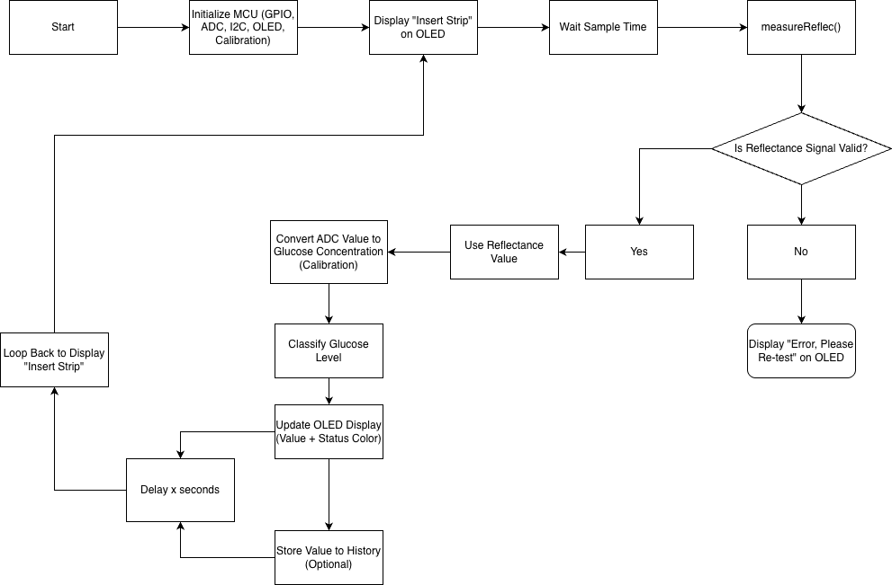
Figure A1. Initial firmware flowchart designed during the conceptual phase. The system follows a single linear measurement path: the MCU initializes peripherals, prompts the user to insert a strip, waits a fixed sample time, and takes a single reflectance reading. If the signal is valid, the ADC value is converted to a glucose concentration using stored calibration coefficients, classified by severity, and displayed on the OLED with a color-coded status indicator. Invalid signals prompt the user to re-test. This design was superseded by the kinetic measurement architecture shown in Figure A2, which addressed the limitations of fixed-time endpoint readings across different glucose concentrations.

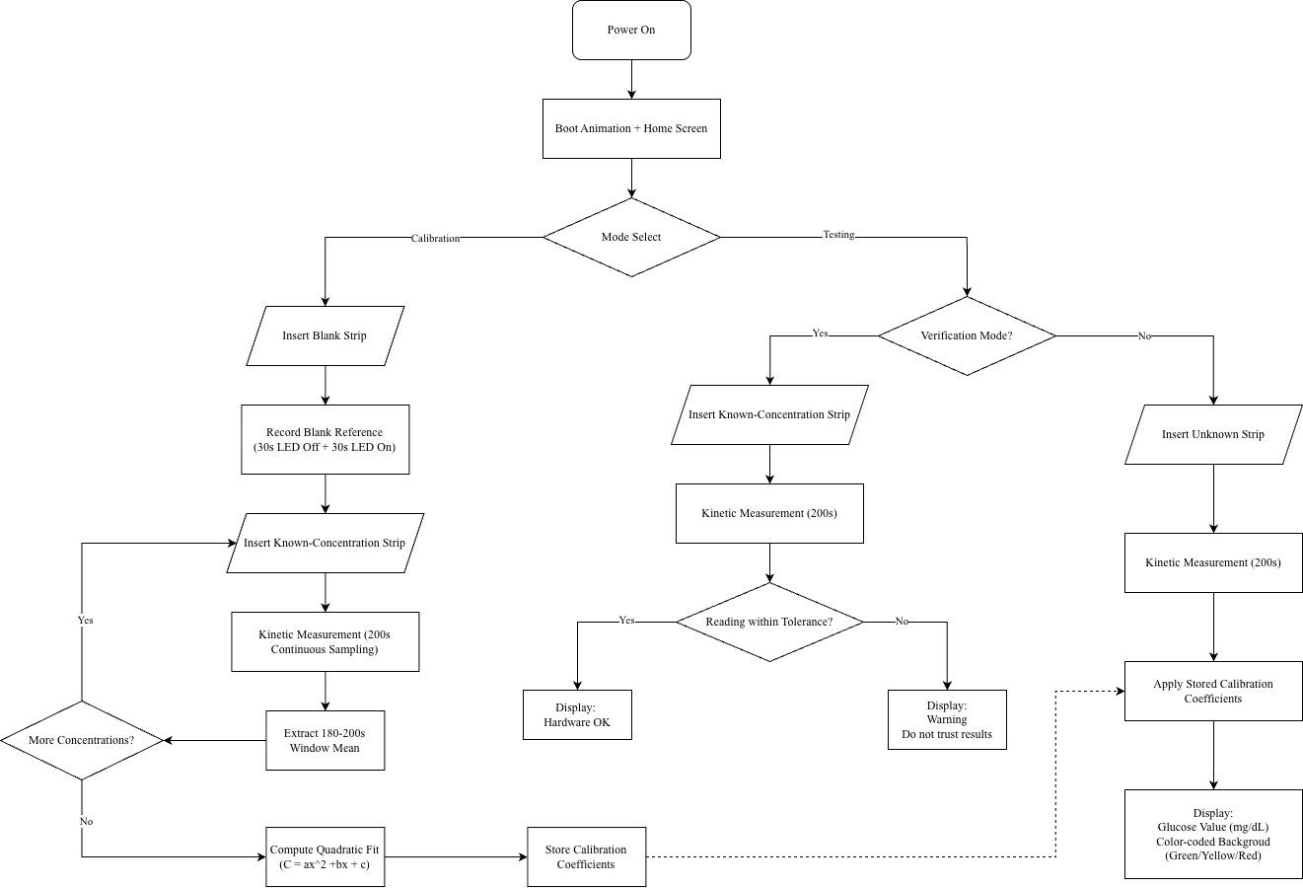
Figure A2. Final firmware flowchart for the P.I.P. glucose monitoring device. The system supports three operational modes: calibration mode builds the quadratic standard curve from multiple known-concentration strips over repeated 200-second kinetic measurements, verification mode checks hardware integrity by comparing a single known-concentration reading against stored coefficients, and testing mode measures unknown samples and displays the result with a color-coded background. All modes use a 200-second kinetic sampling window with glucose estimates derived from the 180–200 s plateau region.

Appendix B. CAD Production

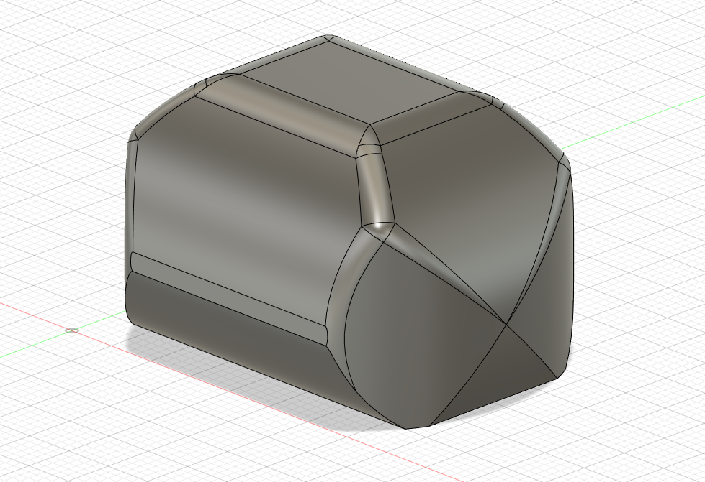
Figure B1. Shell design version one, including a “blocky” design. Originally structured as a test to utilize and adapt to the use of an unfamiliar software, Fusion360.
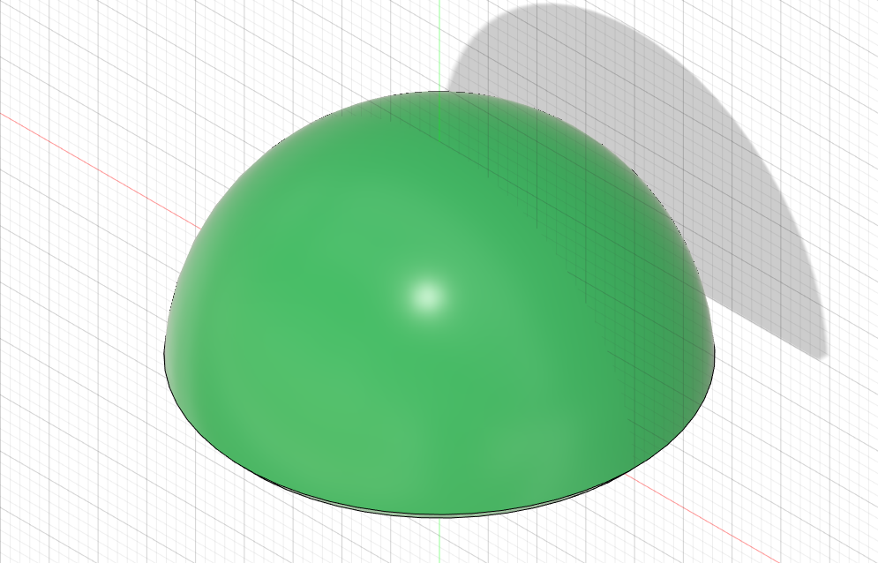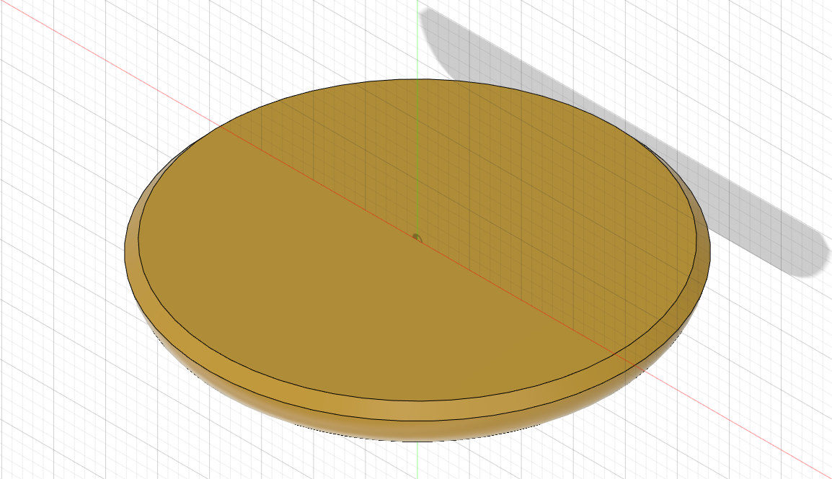
Figure B2. Second iteration of the shell design, including a more rounded design to mirror that of an actual turtle. The CAD model still lacks the elliptical shape originally illustrated.
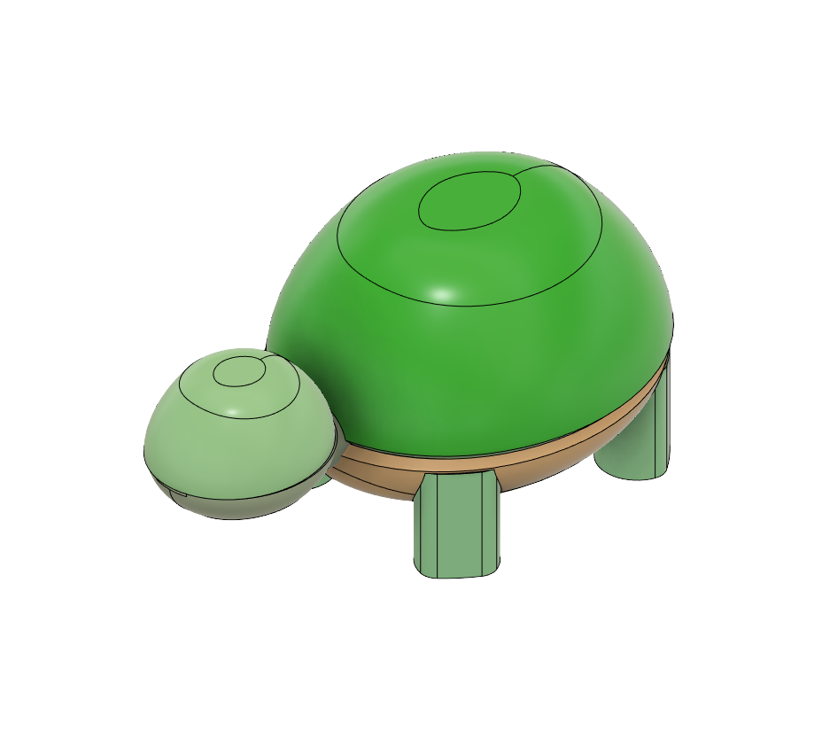
Figure B3. Original design of the finished CAD model of P.I.P. including a more elliptical design of the shell referenced in Fig. B4. Design depicts a smaller head that keeps all components within the body instead of including the head.
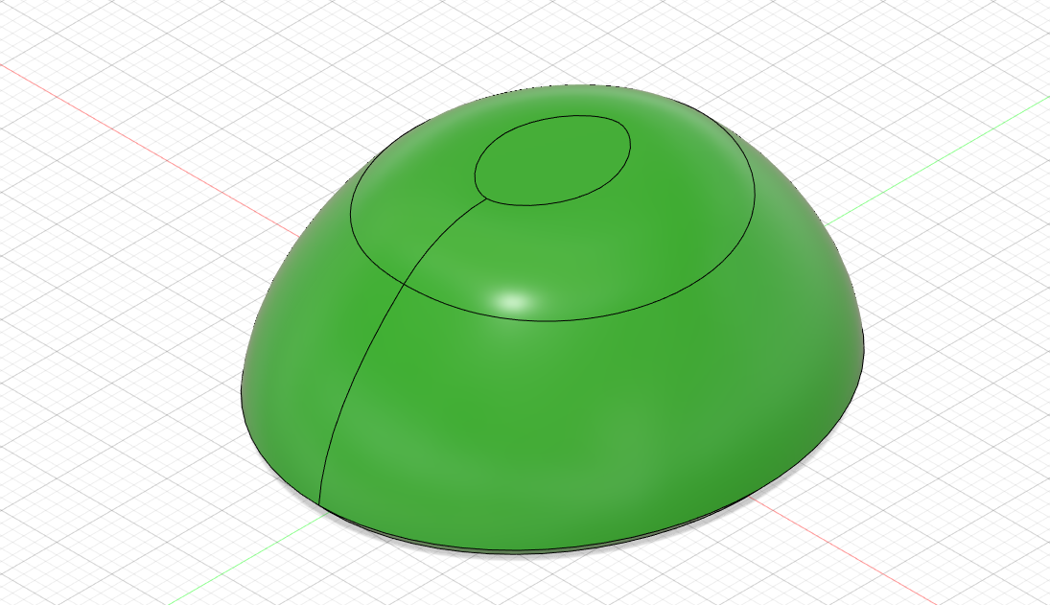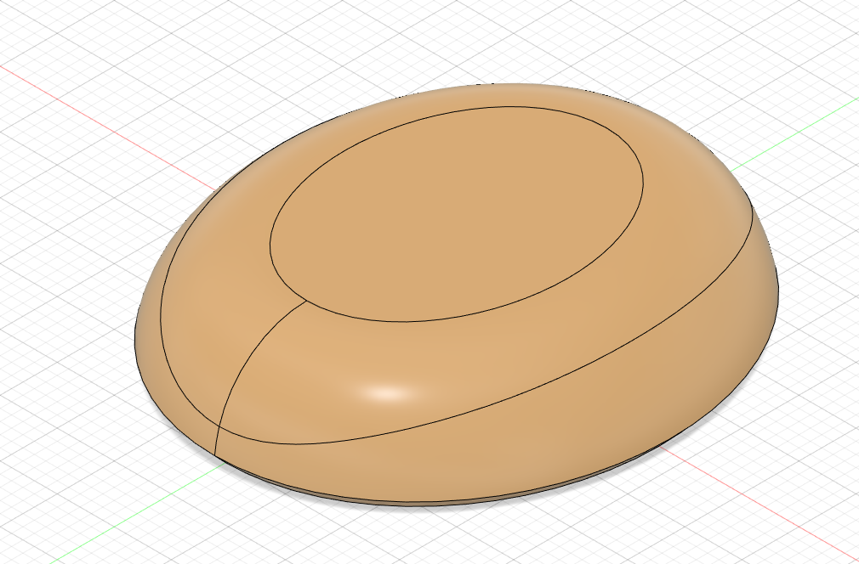
Figure B4. Finalized shell design that adapts the elliptical shape, closely resembling the shell shape of an actual turtle or tortoise. Prior to any shelling or drilling techniques for a satisfying visual representation.
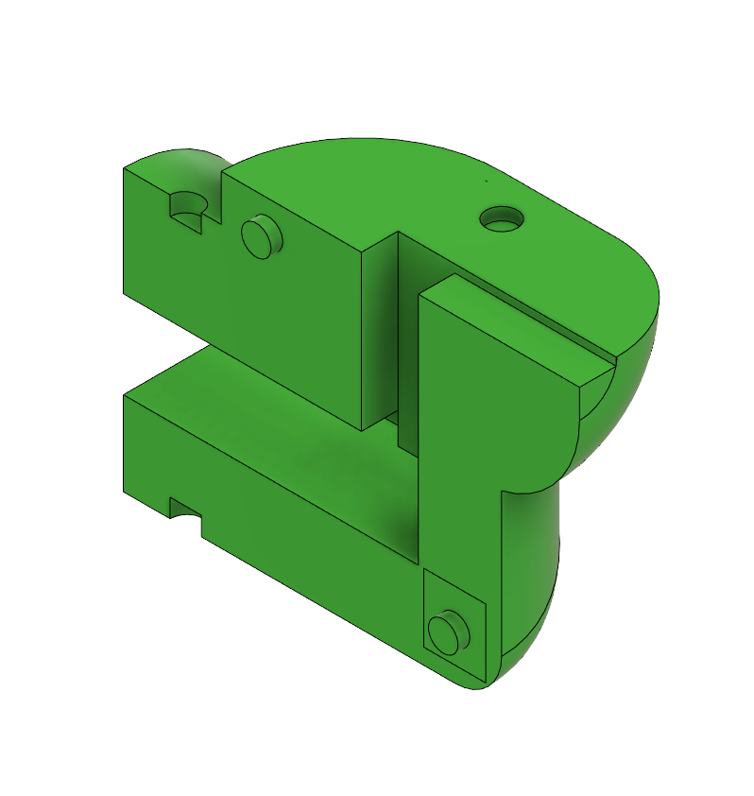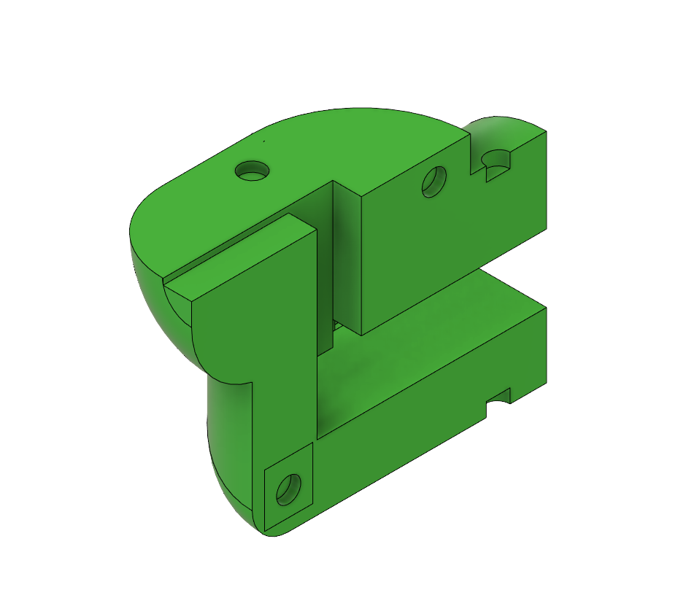
Figure B5. Original CAD model of the P.I.P. device’s neck, showing the larger framework used to position the photodiode and LED for reflectance measurement from the test strip. The model includes a common pin design for assembly and a guide rail for test strip insertion.
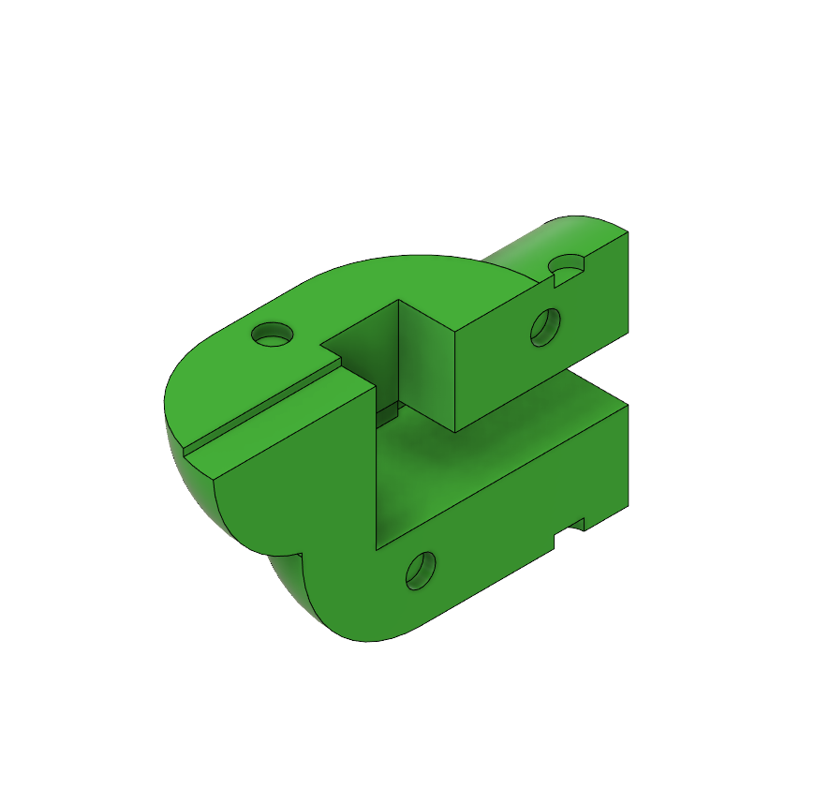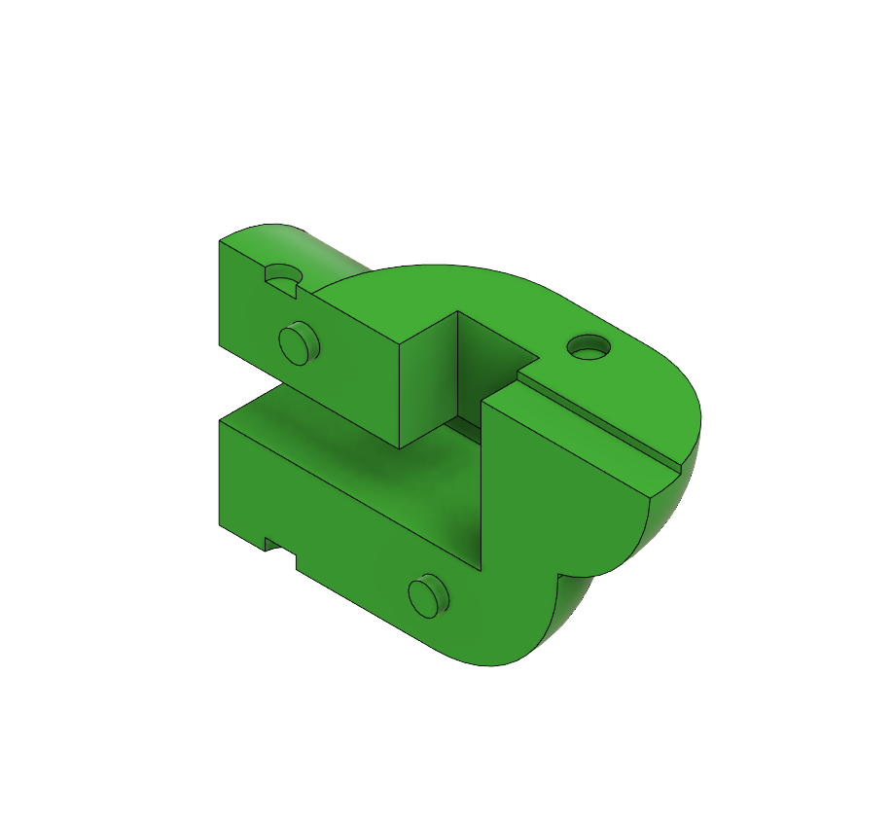
Figure B6. Finalized model for the left and right neck-piece of the P.I.P. device, demonstrating a guide rail, hollowed out inners for a miniature breadboard. Fitting allows for the Light Box (Fig. B7) to slot within the center and clip together both with the top head piece and the shells (Fig. B9 and B10).
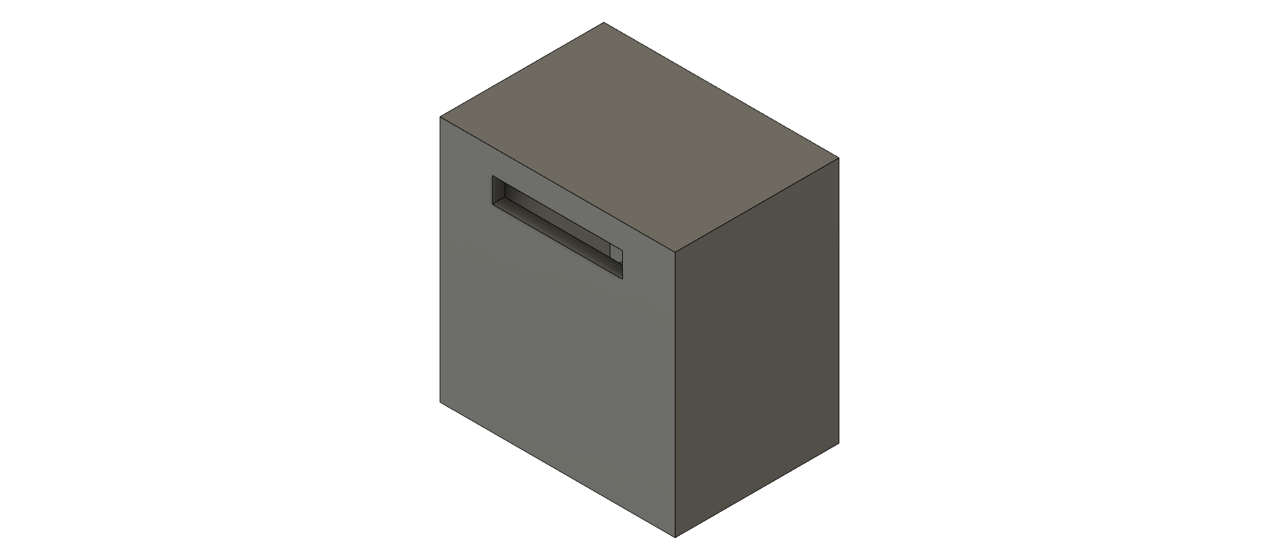
Figure B7. CAD design for the Light Box utilizing the original design used to produce desired calibration curves. Including an inner wall to split the photodiode and LED, while yielding a slot to hold and guide the test strips.
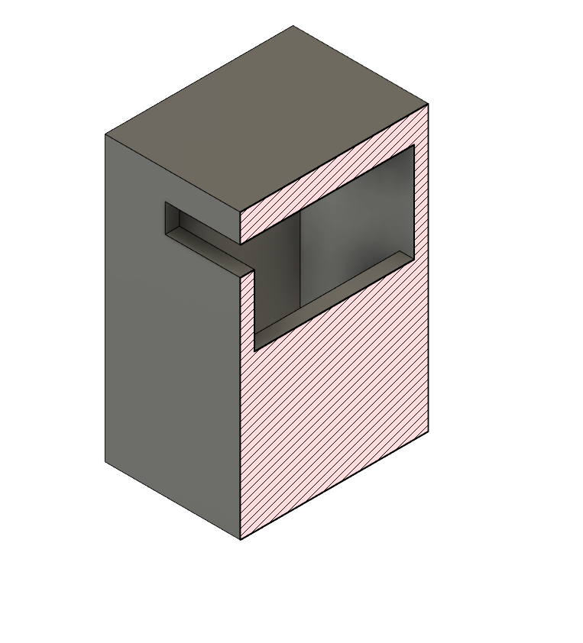
Figure B8. Cross-sectional view of the Light Box depicted within Fig. B7, revealing the general shape within the box that divides the two sections for the aforementioned photodiode and LED.
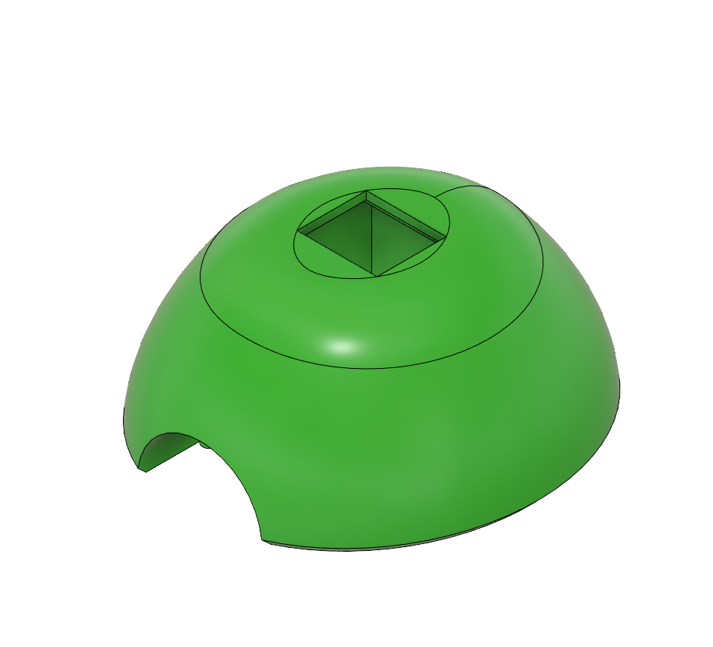
Figure B9. Finalized CAD model for the P.I.P. device’s top shelling, including a slot for the OLED display and a slot to clip the neck piece depicted within Fig. B6.
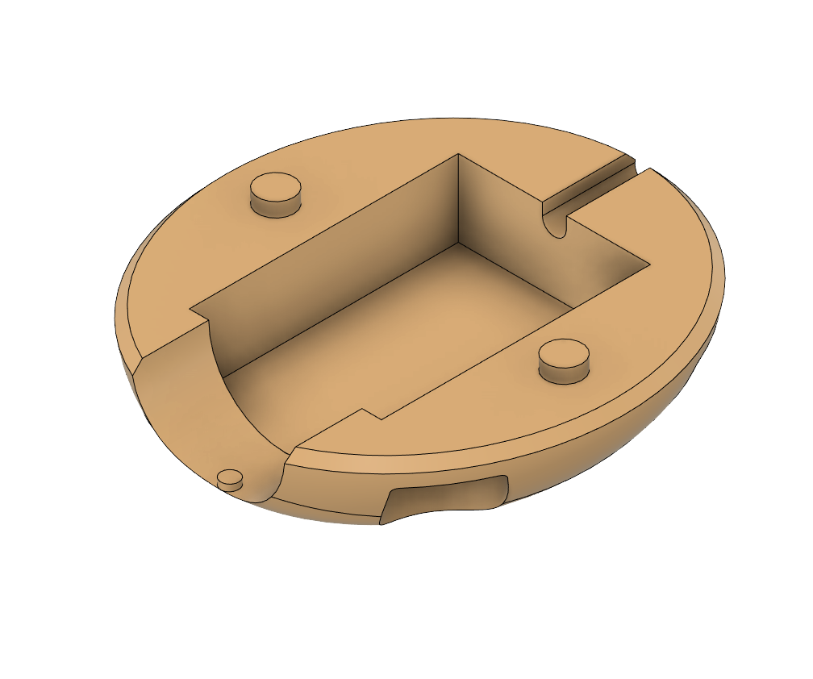
Figure B10. Finalized CAD model for the P.I.P. device’s bottom shelling, including housing for components, a slot to clip the neck piece depicted within Fig. B6, and a cable opening for USB programming and serial communication
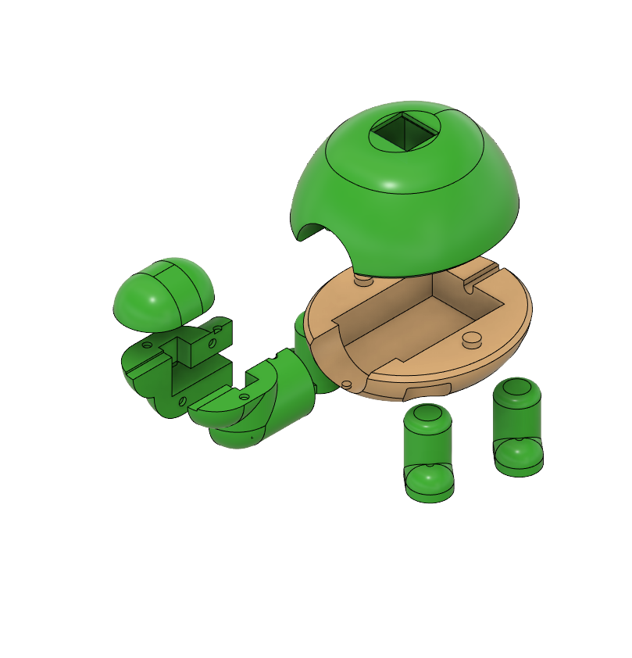
Figure B11. Finalized assembly of the P.I.P. device casing, including both sections of the shell, head component with slot for a breadboard and light box.

Appendix C. Circuit Schematics
This appendix documents the analog front-end and supporting circuitry for the P.I.P. device. Figures C1 and C2 show the conceptual schematic and the final as-built schematic incorporating the modifications made during prototyping.
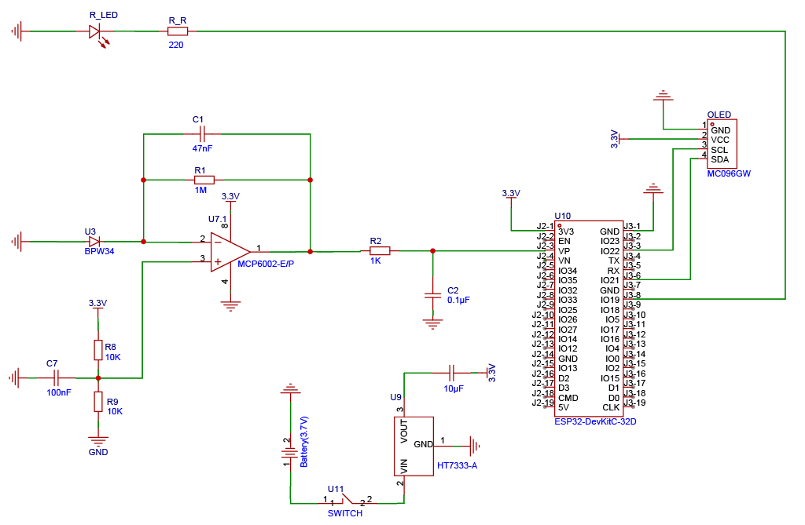
Figure C1. Initial circuit schematic designed during the conceptual phase. The transimpedance amplifier uses a 1 MΩ feedback resistor with a 47 nF compensation capacitor. The non-inverting input is referenced to a 1.65 V virtual ground provided by a voltage divider (R8 = R9 = 10 kΩ). The red LED is driven through a 220 Ω current-limiting resistor. The display is a monochrome I2C OLED (MC096GW), and the voltage regulator is an HT7333-A. This design was modified during prototyping as described in the section of Prototype Development.

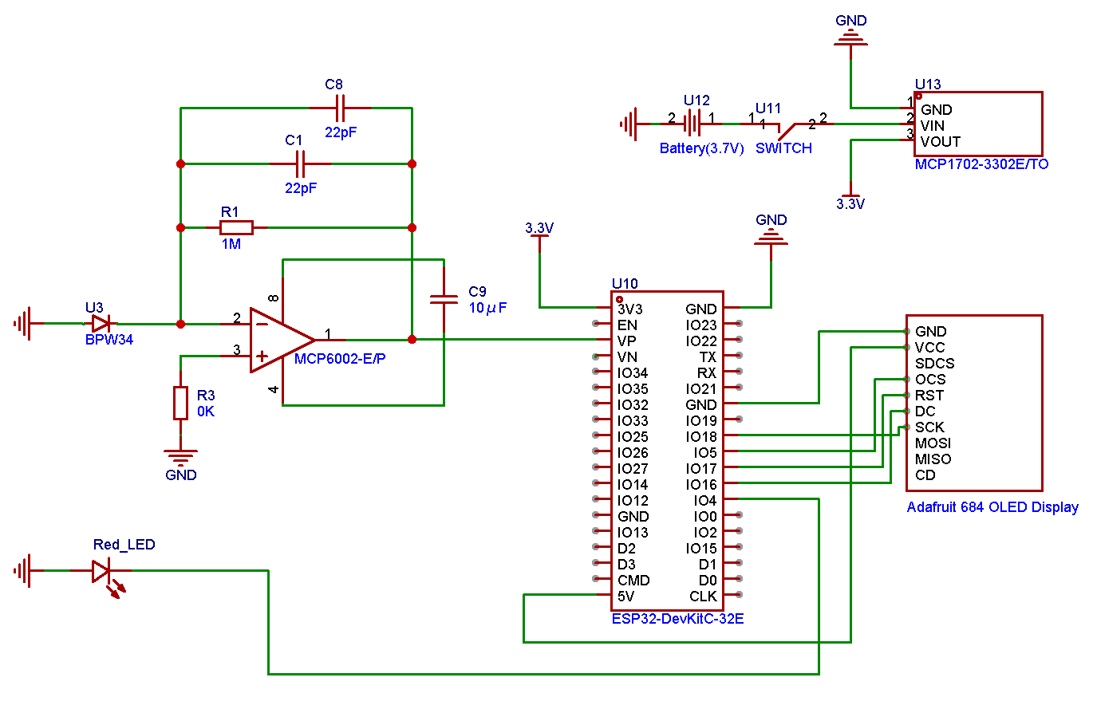
Figure C2. Final as-built circuit schematic reflecting all modifications made during prototyping. The compensation capacitor was changed to two 22 pF capacitors in parallel. The voltage divider was replaced with a 0 Ω resistor connecting the non-inverting input directly to ground. The LED current-limiting resistor was removed. The display was upgraded to an Adafruit SSD1331 color OLED (SPI). The voltage regulator was changed to an MCP1702-3302E/TO. The second channel of the MCP6002 (Pins 5–7) is configured as a unity-gain follower. A 10 μF decoupling capacitor was added between VDD and VSS.
C.1 Pin Assignment
Macro | GPIO | I/O | Function | Connected module
ADC_PIN | 36 (VP) | Input (analog) | Photodiode signal via TIA | BPW34 → MCP6002
LED_PIN | 4 | Output (digital) | LED on/off control | Red LED, 630–660 nm
PIN_CS | 5 | Output (digital) | SPI chip select | SSD1331 OLED
PIN_DC | 16 | Output (digital) | Data / command select | SSD1331 OLED
PIN_RST | 17 | Output (digital) | Display reset | SSD1331 OLED
(SCK) | 18 | Output (SPI clock) | SPI clock (default VSPI) | SSD1331 OLED
(MOSI) | 23 | Output (SPI data) | SPI data out (default VSPI) | SSD1331 OLED
Table C1. ESP32-WROOM-32E pin assignments for the deployed firmware (Listing G.5). The five C macros (ADC_PIN, LED_PIN, PIN_CS, PIN_DC, PIN_RST) are defined explicitly in the firmware; the SPI clock (SCK) and data (MOSI) lines are not declared as macros and instead use the ESP32 default VSPI hardware bus pins, which are physically routed to the SSD1331 OLED. The analog input on GPIO36 is one of the ESP32 ADC1 channels and is sampled with the standard 12-bit analogRead() function.

Appendix D. Prototype Photographs
This appendix documents the physical prototype of P.I.P. Photographs were taken during final assembly to record the mechanical layout, electrical integration, and optical sensor configuration.
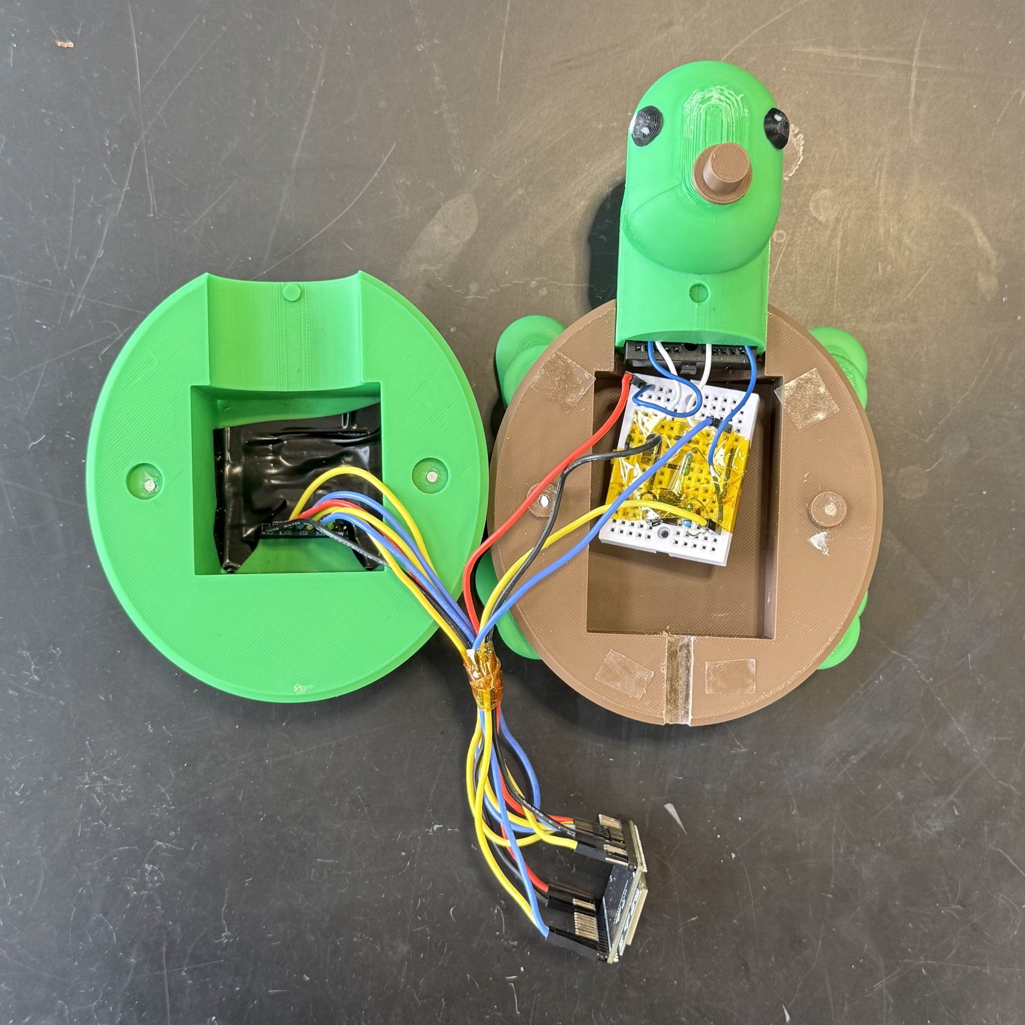
Figure D1. Head segment with eyes and snout attached. The aesthetic features installed on the head module make the device visually approachable for the pediatric target population. The brown snout sits above the strip insertion path at the front of the head.
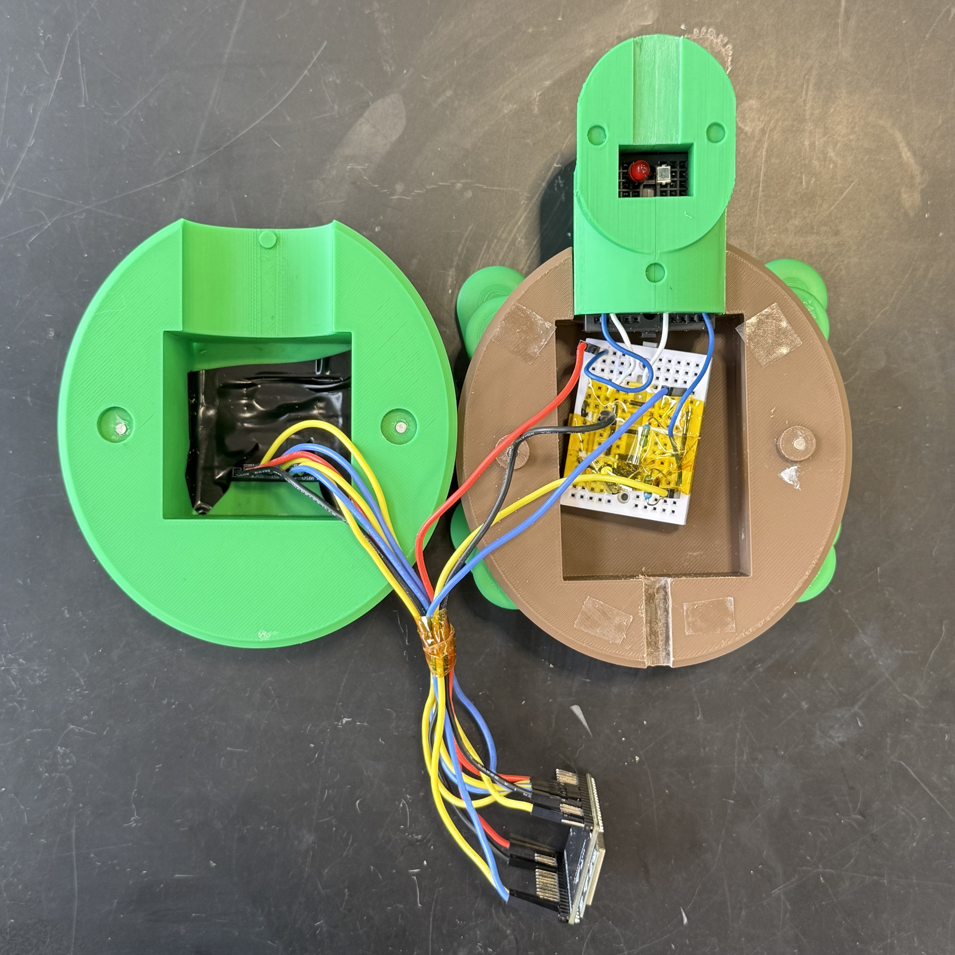
Figure D2. Optical module seated on head segment. Disassembled view with the sensor housing aligned to the turtle head. The strip slot in the head segment couples directly to the optical chambers above. Reproducible calibration depends on this alignment because the LED–photodiode–strip spacing determines the measured reflectance signal.
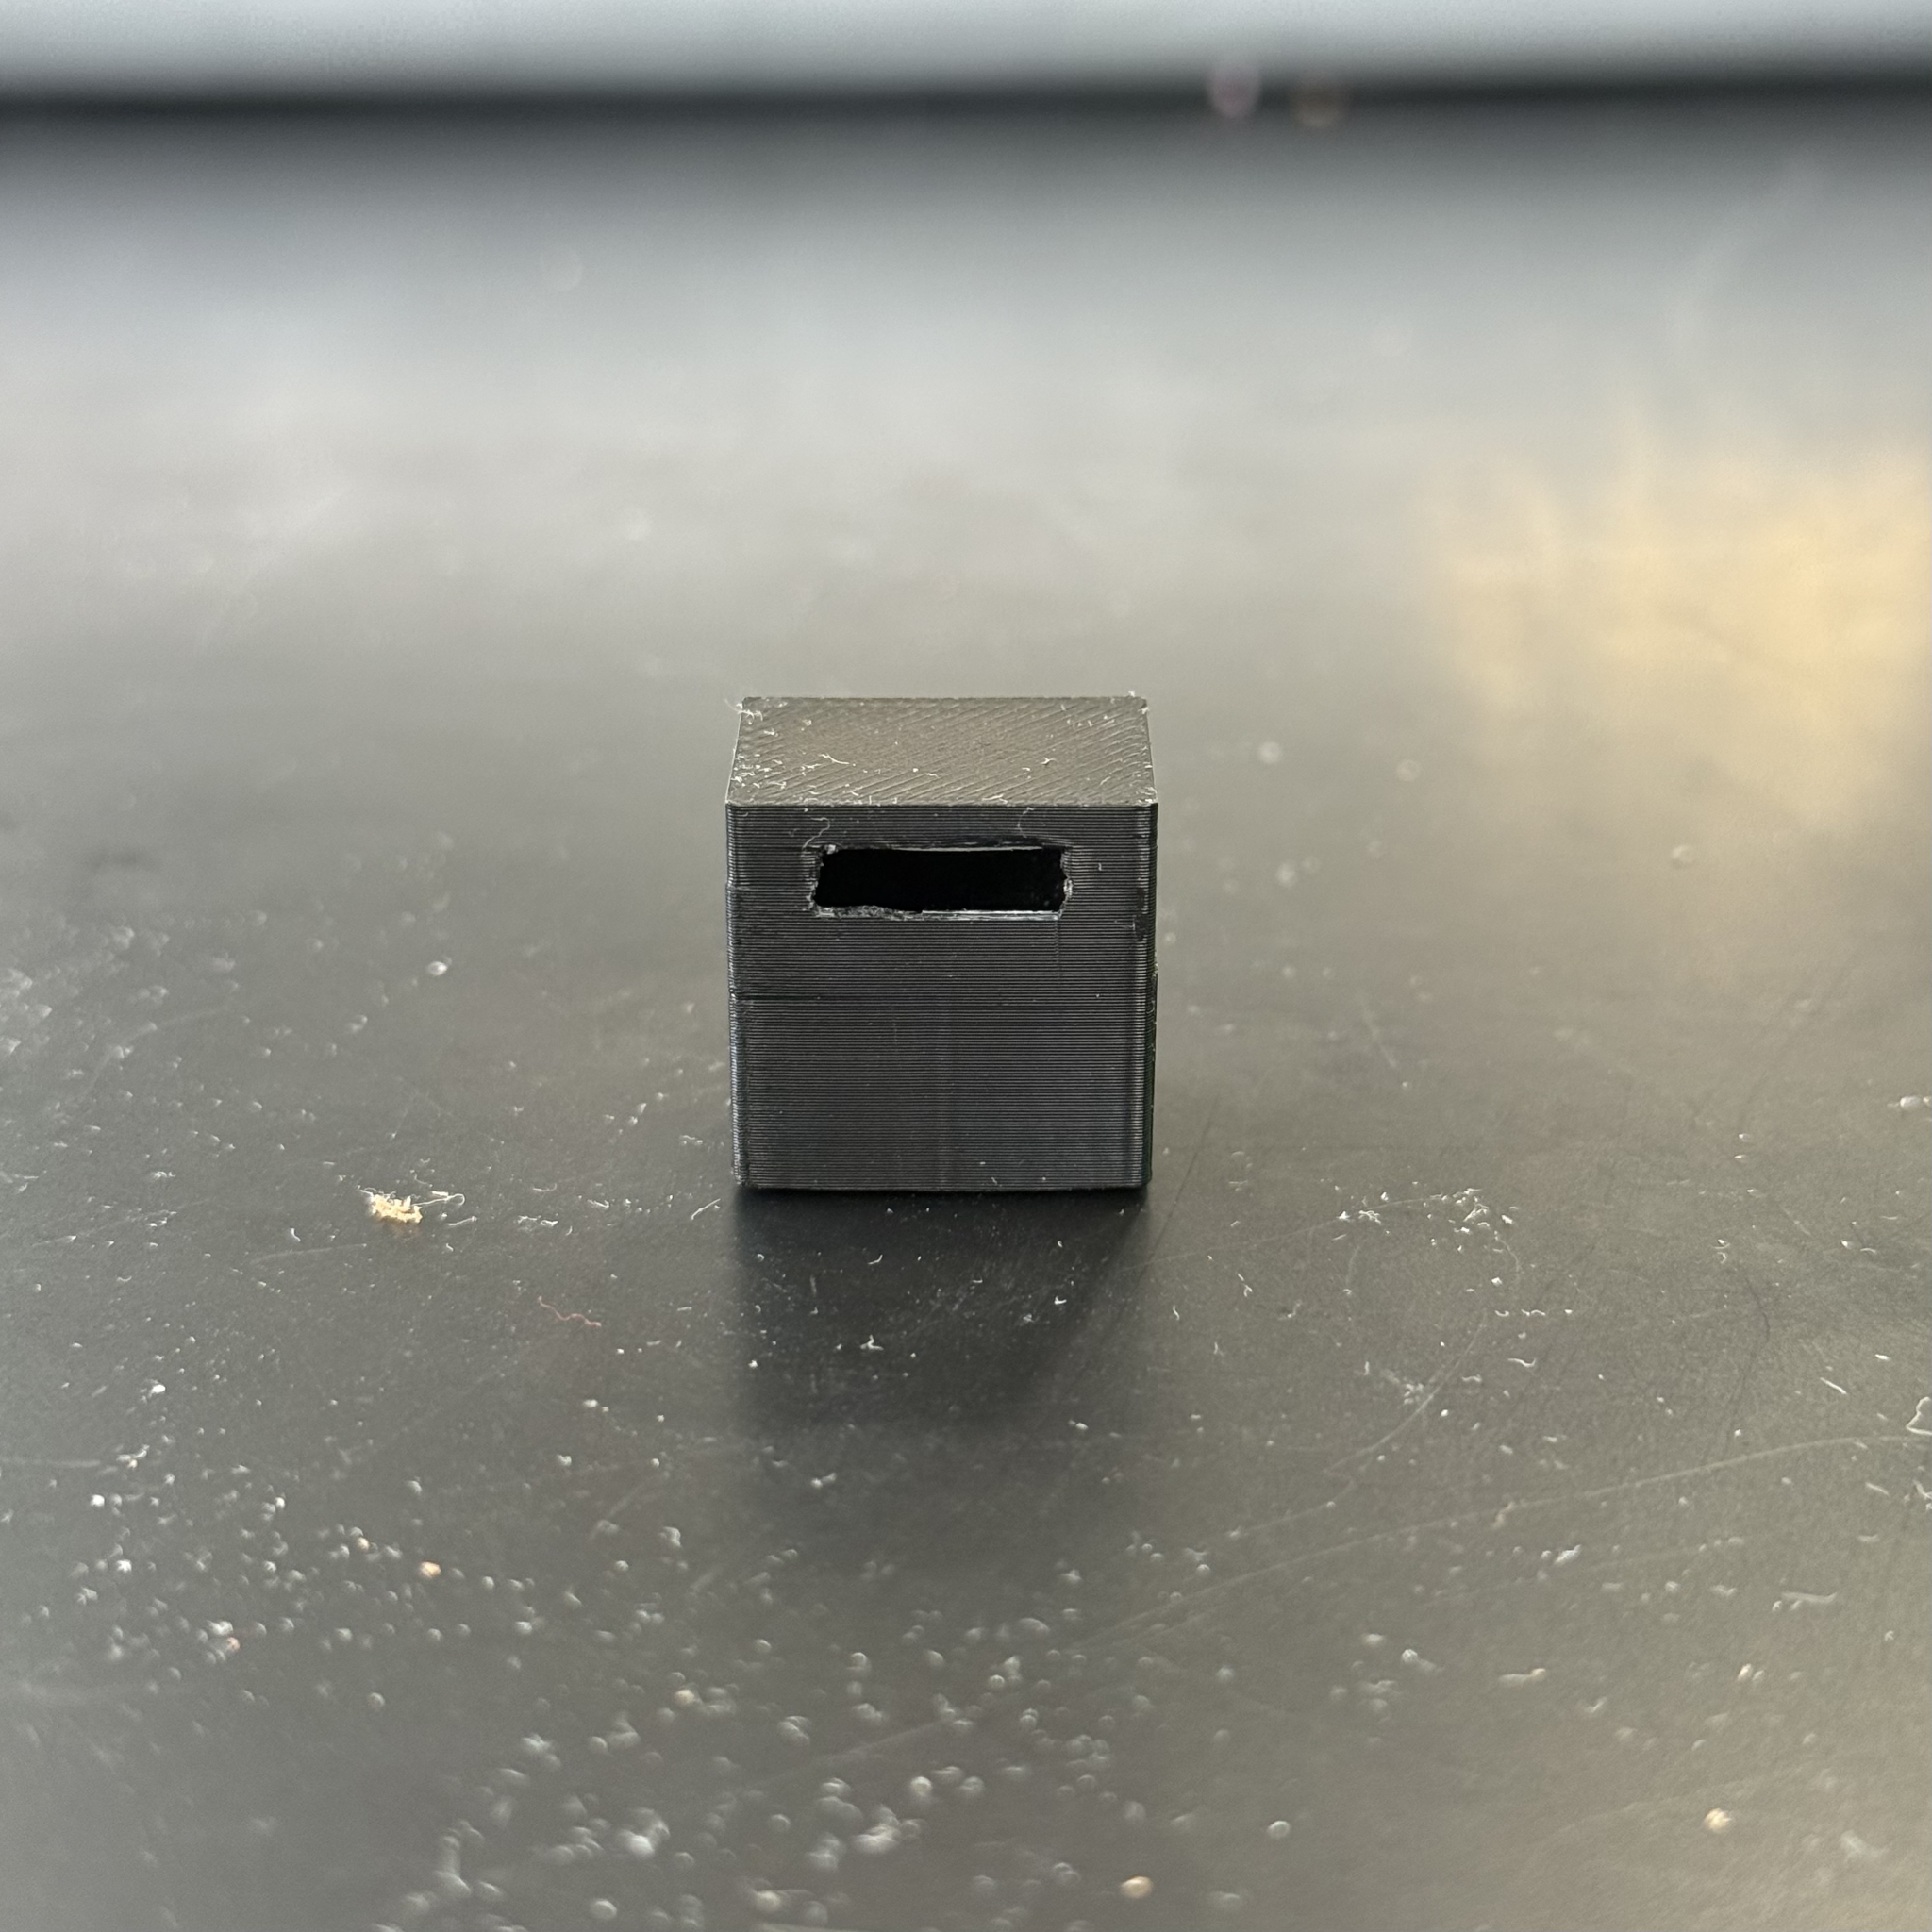
Figure D3. Optical sensor housing, front view. The black PLA housing mounts on the turtle head and contains the LED–photodiode optical assembly. The rectangular aperture accepts the TMB test strip and positions the reaction zone at a fixed distance from the optical components. Black filament suppresses stray light reflections within the sensing chamber.
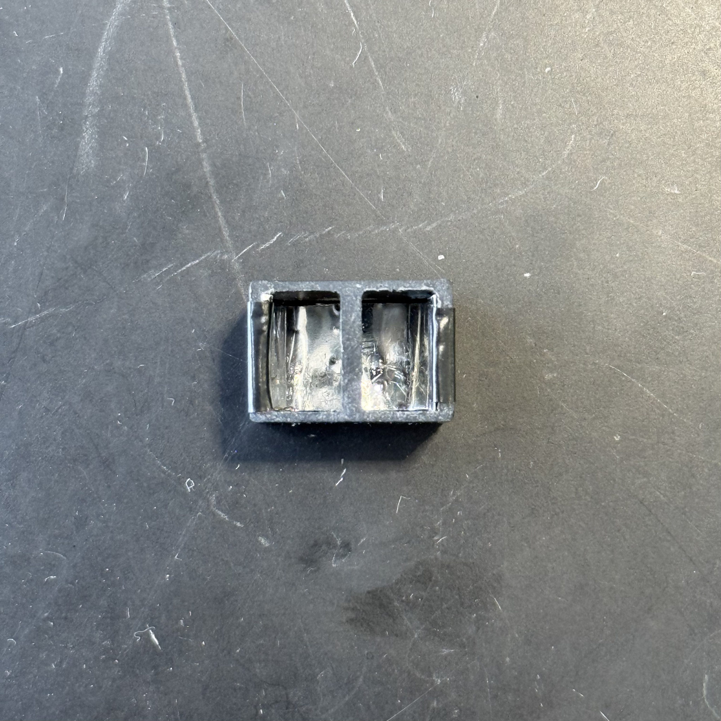
Figure D4. Optical sensor housing, internal view. The two-chamber cavity inside the sensor housing contains a central 3D-printed wall that separates the LED (left chamber) from the BPW34 photodiode (right chamber). The wall enforces reflectance-mode geometry by blocking direct line of sight between emitter and detector, so the photodiode current responds primarily to light reflected from the test strip surface.
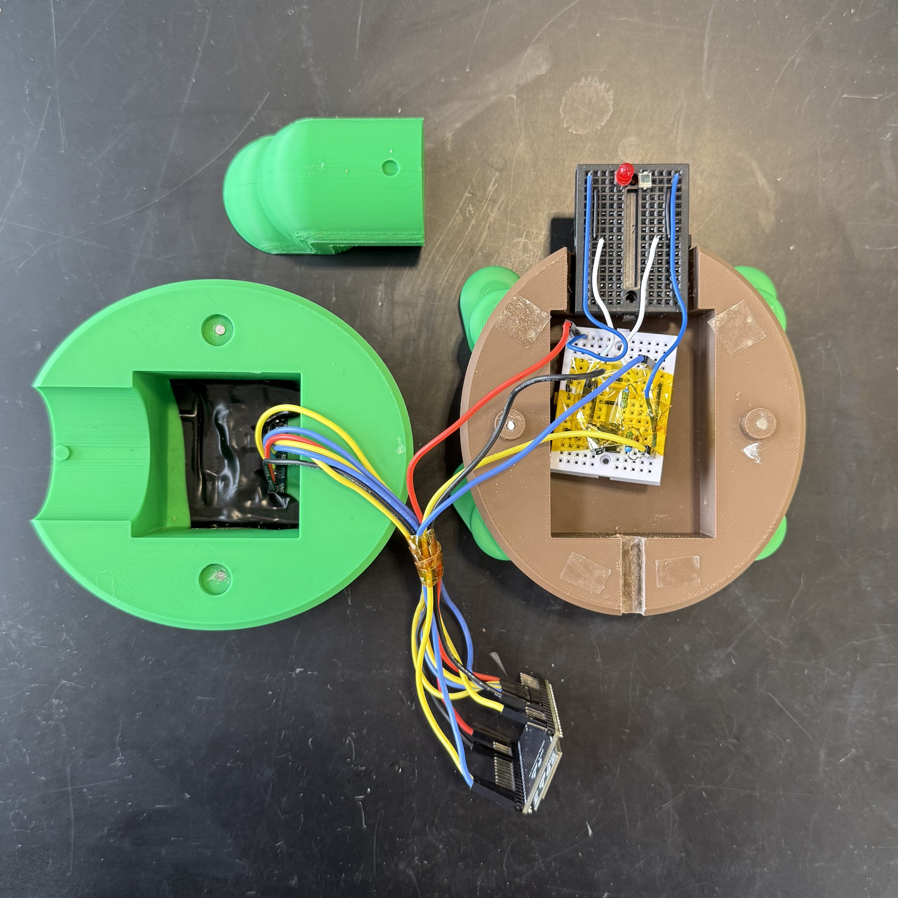
Figure D5. Internal layout with head and neck removed. The same disassembled configuration as Figure D3 with the turtle’s head and neck detached for clarity. The yellow Kapton tape covering the analog circuitry provides electrical insulation and mechanical stabilization of the breadboard wiring during shell reassembly.
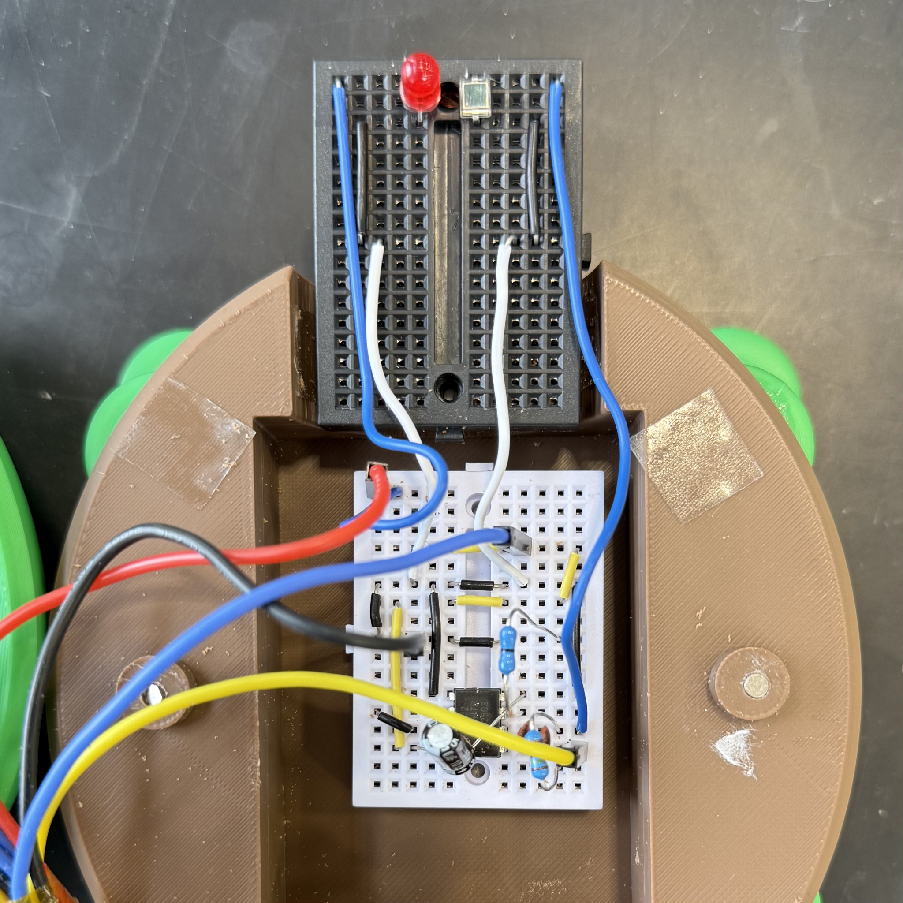
Figure D6. Internal electronics, top view. The analog front-end and optical module sit inside the upper shell. The small auxiliary breadboard (top) hosts the red LED (630–660 nm) and BPW34 photodiode in reflectance geometry. The main breadboard (bottom) carries the MCP6002 transimpedance amplifier with 1 MΩ feedback resistor and parallel 22 pF compensation capacitors.
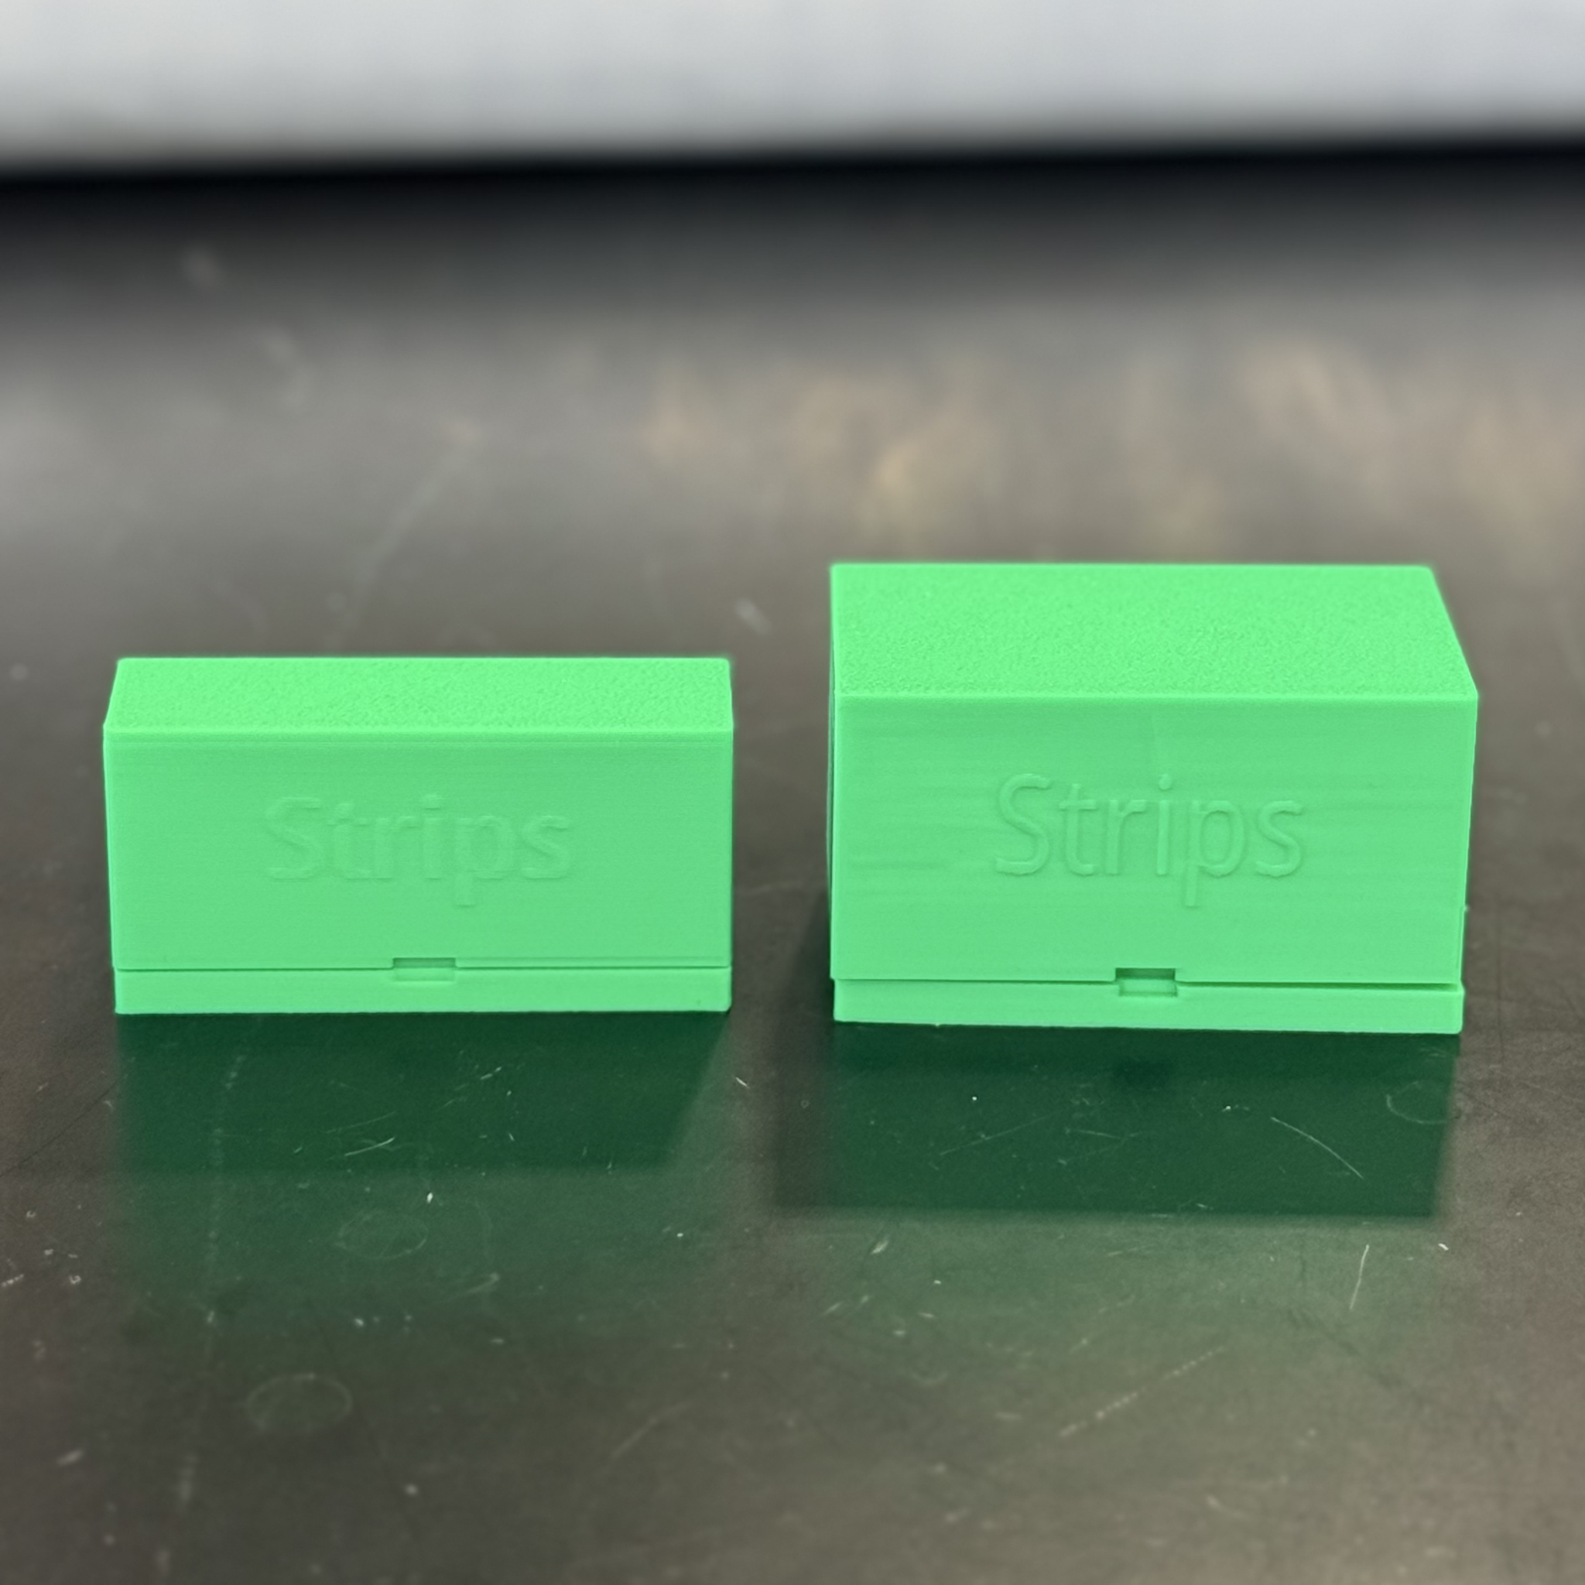
Figure D7. Test strip storage containers. Two iterations of the 3D-printed PLA storage cases for the TMB-coated test strips, sized to hold different strip quantities. The hinged lid design protects the photochemically sensitive strips from ambient light and humidity prior to use, preserving TMB reagent activity for reliable calibration.
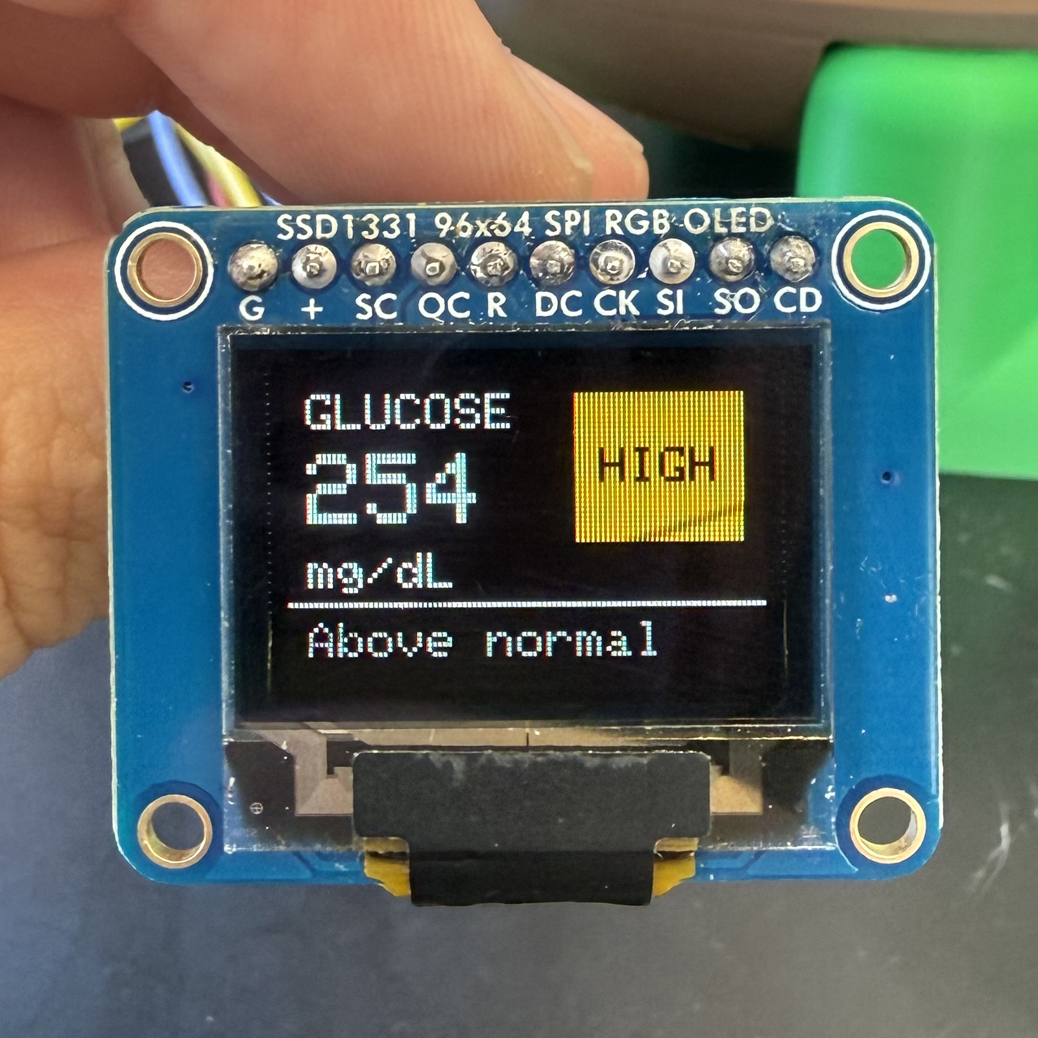
Figure D8. OLED user interface displaying a sample reading. Close-up of the SSD1331 96×64 RGB OLED module that integrates into the assembled enclosure (shown installed in Figure D1). The result screen reports the measured glucose concentration as a large numeric value (254 mg/dL) on the left, with a categorical alert badge (HIGH) and a descriptive status line (Above normal) on the right. This layout translates the numeric measurement into pediatric-friendly language and supports the design goal of delivering an interpretable result without requiring the user to recall reference ranges.

​​Appendix E. Bill of Material and Cost Analysis
This appendix presents the bill of materials and cost analysis for the P.I.P. prototype based on the team’s actual procurement records. Pricing reflects small-quantity orders placed during development from Digi-Key, Carolina, MilliporeSigma, CSHyde, and the Bambu Store. Sections E.1 through E.4 itemize the per-device cost of one assembled prototype. Section E.5 summarizes the cost and analyzes the effect of two near-term substitutions on the final unit cost. Section E.6 provides the full project procurement record.

E.1 Electronics and Optical Subsystem
Component | Part Number / Spec | Qty | Unit (USD) | Subtotal (USD) | Source
ESP32 development module | ESP32-DEVKITC-32E | 1 | 10.00 | 10.00 | Digi-Key
Silicon photodiode | BPW34 (Vishay) | 1 | 0.87 | 0.87 | Digi-Key
Dual op-amp (TIA) | MCP6002-E/P (DIP-8) | 1 | 0.50 | 0.50 | Digi-Key
Red LED, 5 mm THT | Würth 151051RS11000 | 1 | 0.15 | 0.15 | Digi-Key
RGB OLED display, 0.95″ | Adafruit SSD1331 (PID 684) | 1 | 29.95 | 29.95 | Digi-Key
Slide power switch | C&K JS202011CQN | 1 | 0.75 | 0.75 | Digi-Key
Feedback resistor, 1/4 W | 1 MΩ carbon film (kit) | 1 | 0.05 | 0.05 | SparkFun resistor kit
Compensation capacitor | 22 pF C0G ceramic (kit) | 2 | 0.05 | 0.10 | SparkFun capacitor kit
Decoupling capacitor | 10 μF electrolytic (kit) | 1 | 0.10 | 0.10 | SparkFun capacitor kit
Jumper wires (allocated) | M/M, 2.54 mm pitch | — | 0.50 | 0.50 | Gearbox Labs kit
Subsystem Subtotal | 42.97
Table E1. Active and passive components for the analog front-end, microcontroller, and display. The MCP6002-E/P op-amp operates as a transimpedance amplifier with the 1 MΩ feedback resistor and two 22 pF compensation capacitors in parallel, as documented in Figure C2. The SSD1331 OLED uses a hardware SPI interface (CS = GPIO5, DC = GPIO16, RST = GPIO17, SCK = GPIO18, MOSI = GPIO23). Resistor, capacitor, and jumper wire allocations come from project-level kits and represent the per-device share of those purchases. The Adafruit SSD1331 breakout accounts for approximately 70 percent of the subsystem cost; substitution with a generic SSD1331 module from alternate suppliers reduces the display cost to roughly $6 to $10.

E.2 Power Subsystem
Component | Part Number / Spec | Qty | Unit (USD) | Subtotal (USD) | Source
Lithium polymer battery pack | Globtek BL0750F5030481S1PCTC, 3.7 V, 700 mAh | 1 | 8.99 | 8.99 | Digi-Key
LDO voltage regulator | MCP1702-3302E/TO | 1 | 0.50 | 0.50 | Digi-Key
Subsystem Subtotal | 9.49
Table E2. Power hardware in the designed prototype configuration. The Globtek BL0750F5030481S1PCTC supplies 3.7 V at 700 mAh from a single-cell lithium polymer pack with integrated protection circuitry, feeding the MCP1702-3302E/TO LDO regulator. The MCP1702 produces the 3.3 V rail used by the ESP32, the analog front-end, and the OLED. Both parts were procured and bench-tested independently. The expo demonstration ran on USB power supplied through the ESP32 DevKit micro-USB port because consolidation of the battery and LDO onto the perfboard remained pending at the time of the field test, as documented in the project recommendations.

E.3 Mechanical and Enclosure
Component | Part Number / Spec | Qty | Unit (USD) | Subtotal (USD) | Source
PLA filament (shell + housing, ≈35 g) | Bambu PLA Basic | 35 g | 0.70 | 0.70 | Bambu Store
Aluminum foil chamber lining | Household grade | — | 0.05 | 0.05 | Lab supply
Kapton polyimide tape | 12 mm width | — | 0.30 | 0.30 | Amazon
Subsystem Subtotal | 1.05
Table E3. Materials for the turtle-shell enclosure, optical sensor housing, and internal wiring management. Filament cost reflects the printed mass of one complete device drawn from a 1 kg Bambu PLA Basic spool at $19.99. The aluminum foil lining of the inner shell walls suppresses signal loss from light absorption inside the optical chamber. Kapton tape provides electrical insulation and mechanical stabilization of the breadboard wiring during reassembly.

E.4 Test Strip Consumables (Amortized per Strip)
Component | Part Number / Spec | Qty | Unit (USD) | Subtotal (USD) | Source
Whatman filter paper strip | Grade 1 chromatography (15×2 cm) | 1 | 0.05 | 0.05 | Carolina 689114
PET laminate film | Optically clear, 100 μm | 1 | 0.05 | 0.05 | CSHyde 48-1F-OC
Black light-blocking tape | Electrical, vinyl | — | 0.05 | 0.05 | Lab supply
Subsystem Subtotal | 0.15
Table E4. Materials that the team purchased directly for strip fabrication. Per-strip costs reflect the team’s actual procurement: Whatman Grade 1 chromatography strips from Carolina, optically clear PET film from CSHyde, and black electrical tape from lab supply. Enzyme reagents (glucose oxidase, horseradish peroxidase) and the TMB chromogenic substrate come from existing laboratory inventory and do not appear in the team procurement record. A reasonable allocation for these reagents at small-volume Sigma-Aldrich pricing adds roughly $0.80 to $1.00 per strip, bringing the fully loaded per-strip cost to approximately $1.00.

E.5 Cost Summary and Substitution Analysis
Cost Category | Cost (USD)
Electronics and Optical Subsystem (E.1) | 42.97
Power Subsystem (E.2) | 9.49
Mechanical and Enclosure (E.3) | 1.05
As-Built Per-Device Total | 53.51
Test Strip Consumables, per strip (E.4) | 0.15
Table E5. Per-device cost breakdown of the as-built prototype. The total of $53.51 exceeds the $50 design target by approximately $3.51 in the current configuration. The Adafruit SSD1331 display, sourced for its proven driver compatibility and hardware reliability, accounts for the dominant share of subsystem cost.
The following table examines the effect of two substitutions identified during the design review: a generic SSD1331 OLED module in place of the Adafruit breakout, and a generic 3.7 V lithium polymer cell of equivalent capacity in place of the Globtek pack. Both substitutions preserve the existing firmware, schematic, and mechanical interface.
Configuration | Per-Device Cost (USD)
As-built configuration (current prototype) | 53.51
Substitute generic SSD1331 OLED ($7.50) | 31.06
Substitute generic 3.7 V LiPo battery ($5.00) | 49.52
Both substitutions combined | 27.07
Table E6. Substitution analysis showing the effect of low-impact part swaps on the final unit cost. The combined substitutions reduce the per-device total to approximately $27.07, well below the $50 target. The OLED substitution alone delivers most of the savings, indicating that future production builds achieve the cost objective primarily through display sourcing.

E.6 Project Procurement Summary
The table below records all components and consumables purchased during the project, including items used at the project level (resistor and capacitor kits, jumper wires, breadboards, filament spools) that share their cost across multiple builds and prototyping phases. The MCP1702-3302E/TO regulator appears in the original benchmark; the as-built device uses the functionally equivalent MCP1702-3302E/TO purchased separately.
Item | Vendor SKU | Qty | Unit (USD) | Total (USD) | Vendor
ESP32 DevKitC | 1965-ESP32-DEVKITC-32E-ND | 2 | 10.00 | 20.00 | Digi-Key
BPW34 photodiode | 751-1015-ND | 10 | 0.87 | 8.7 | Digi-Key
MCP6002-E/P op-amp | MCP6002-E/P-ND | 5 | 0.50 | 2.50 | Digi-Key
Red LED 151051RS11000 | 732-5016-ND | 5 | 0.15 | 0.75 | Digi-Key
Adafruit SSD1331 OLED | 684-ND | 1 | 29.95 | 29.95 | Digi-Key
MCP1702-3302E/TO regulator | MCP1702-3302E/TO-ND | 25 | 0.42 | 10.50 | Digi-Key
Globtek BL0750 LiPo battery pack | 1939-BL0750F5030481S1PCTC-ND | 2 | 8.99 | 17.98 | Digi-Key
C&K JS202011CQN switch | 401-2001-ND | 5 | 0.75 | 3.75 | Digi-Key
Jumper wires kit (M/M, 40) | 4166-PARTJUMPERWIRESM/M(40)-ND | 1 | 6.00 | 6.00 | Digi-Key
SparkFun resistor kit | 1568-10969-ND | 1 | 10.54 | 10.54 | Digi-Key
SparkFun capacitor kit | 1568-13698-ND | 1 | 11.50 | 11.50 | Digi-Key
Solderless breadboard, small | DKS-BBOARD3.3-ND | 1 | 8.06 | 8.06 | Digi-Key
Solderless breadboard, large | DKS-BBOARD6.5-ND | 1 | 11.13 | 11.13 | Digi-Key
Bambu PLA Basic filament | PLA Basic | 2 | 19.99 | 39.98 | Bambu Store
Whatman filter paper, Grade 3 | WHA1003055 | 100 | 0.20 | 20.00 | MilliporeSigma
Whatman filter paper, Grade 5 | WHA1005055 | 100 | 0.17 | 17.00 | MilliporeSigma
Whatman filter strip, Grade 1 | 689114 | 100 | 0.05 | 4.95 | Carolina
Optically clear PET film | 48-1F-OC | 1 | 45.72 | 45.72 | CSHyde
Project Procurement Total | 269.01
Table E7. Consolidated procurement record across Digi-Key, Carolina, MilliporeSigma, CSHyde, and the Bambu Store. The project total of $269.01 covers components for multiple prototype builds, kit-based prototyping inventory, two filament spools, and bulk strip fabrication materials. Per-device cost in Sections E.1 through E.5 derives from the unit prices in this table.

Appendix F. Enclosure Geometry Iterations and Calibration Data
This appendix documents the calibration data for the three enclosure iterations described in Section of Experimental Methods & Testing. Figures F1 through F3 present the kinetic response curves and quadratic calibration fits for the standalone optical housing, the partial turtle shell, and the complete turtle shell respectively. Figure F4 extends the complete turtle-shell dataset to a 500 mg/dL strip and demonstrates the upper boundary of the calibrated range. The relative intensity change at each time point was computed as the difference between the running ADC reading and the t = 0 baseline of the same strip, and endpoint values were averaged over the 180–200 s plateau window (n = 34 samples per concentration). Each of Figures F1 through F3 presents the calibration in two orientations: panel (b) shows C = f(x), the inverse form used by the firmware to back-calculate concentration from a measured intensity reading; panel (c) shows x = f(C), the experimental measurement direction with glucose concentration on the abscissa. Geometry 3 produced the monotonic calibration adopted in the final firmware. Geometries 1 and 2 document the geometric refinements that motivated the final enclosure design.
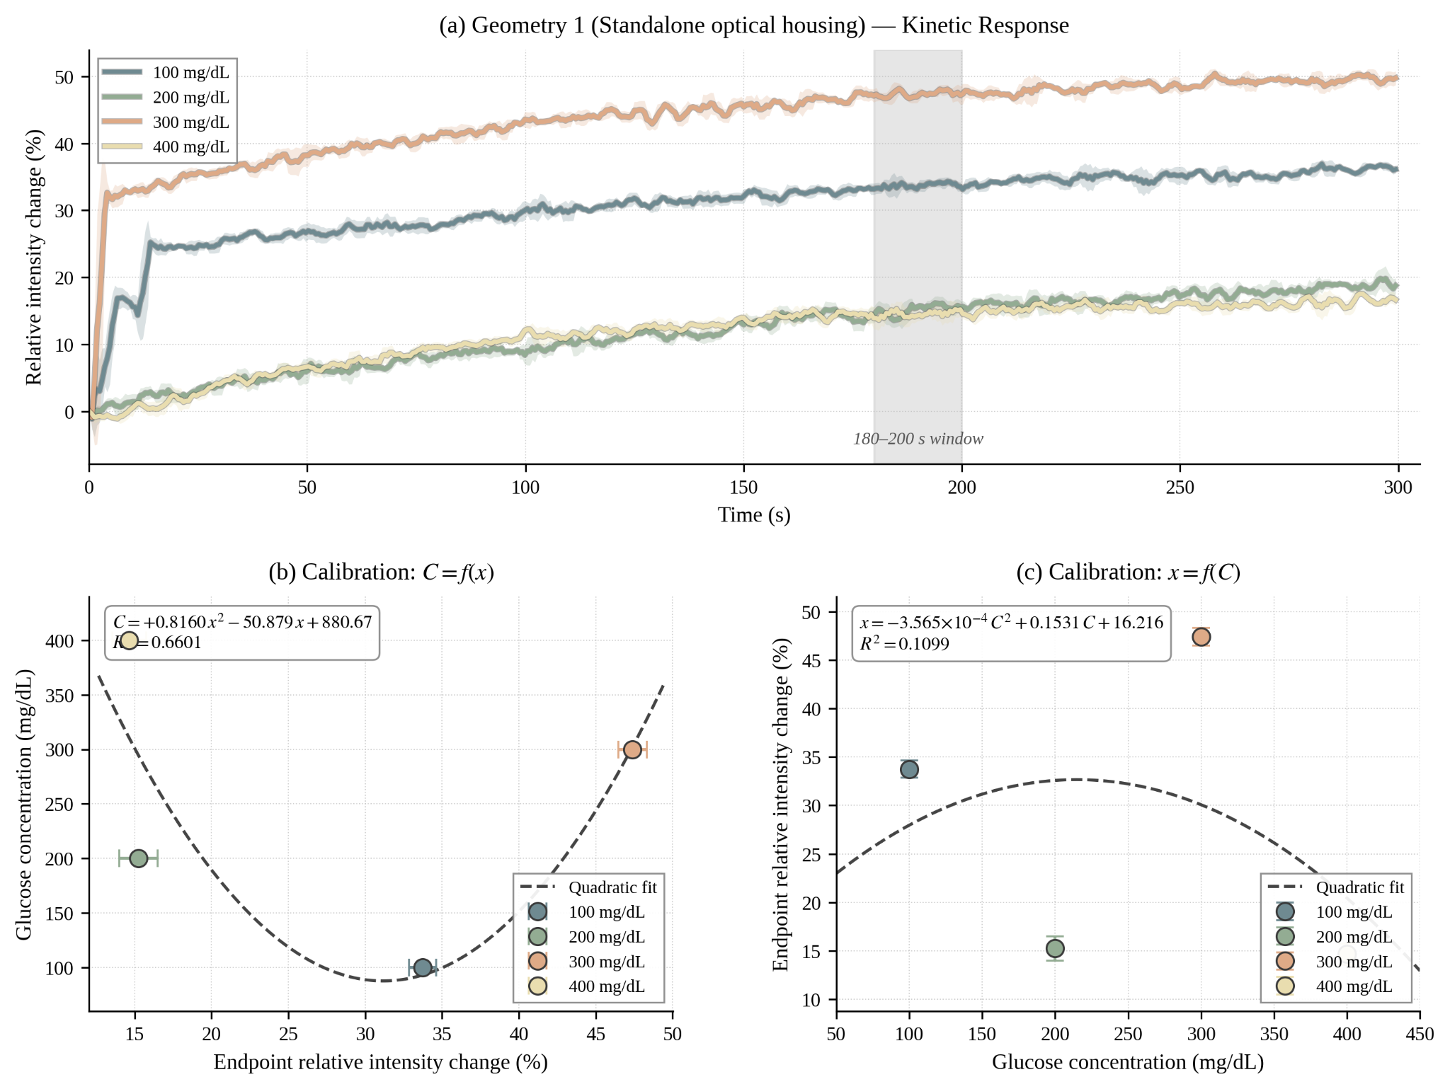
Figure F1. Geometry 1 — Standalone optical housing. A 3D-printed black housing with an internal divider wall and a top-side strip slot, placed over the breadboard to cover the LED and photodiode. Panel (a) shows kinetic response curves over a 300 s reaction window with the 180–200 s endpoint window highlighted in gray; shaded regions represent ±1 rolling standard deviation. Panels (b) and (c) show the quadratic calibration fits in both orientations. The point ordering of the zeroed endpoint values is scattered relative to glucose concentration, indicating that inter-strip baseline differences in initial reflectance dominate over the kinetic signal in this configuration.
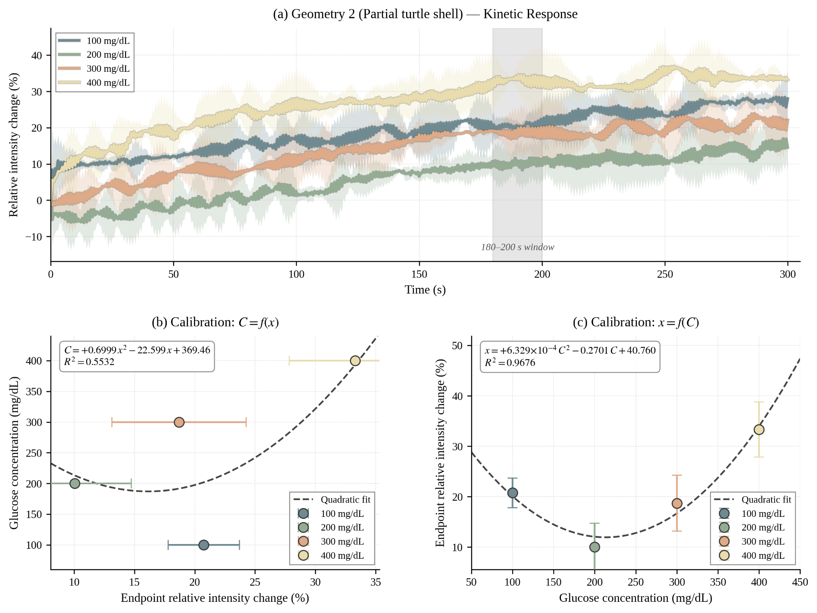
Figure F2. Geometry 2 — Partial turtle shell. The optical components were integrated into the printed turtle-head module, and testing occurred before the surrounding shell body was added. Panel layout matches Figure F1. Three compounding effects degraded calibration in this configuration: ambient-light leakage through the open rear of the head module, an extended optical path of approximately 8 to 9 cm that reduced the photodiode-incident signal, and mechanical play in the head module on the test bench. The kinetic curves exhibit elevated local variance and the calibration response remains scattered relative to glucose concentration.
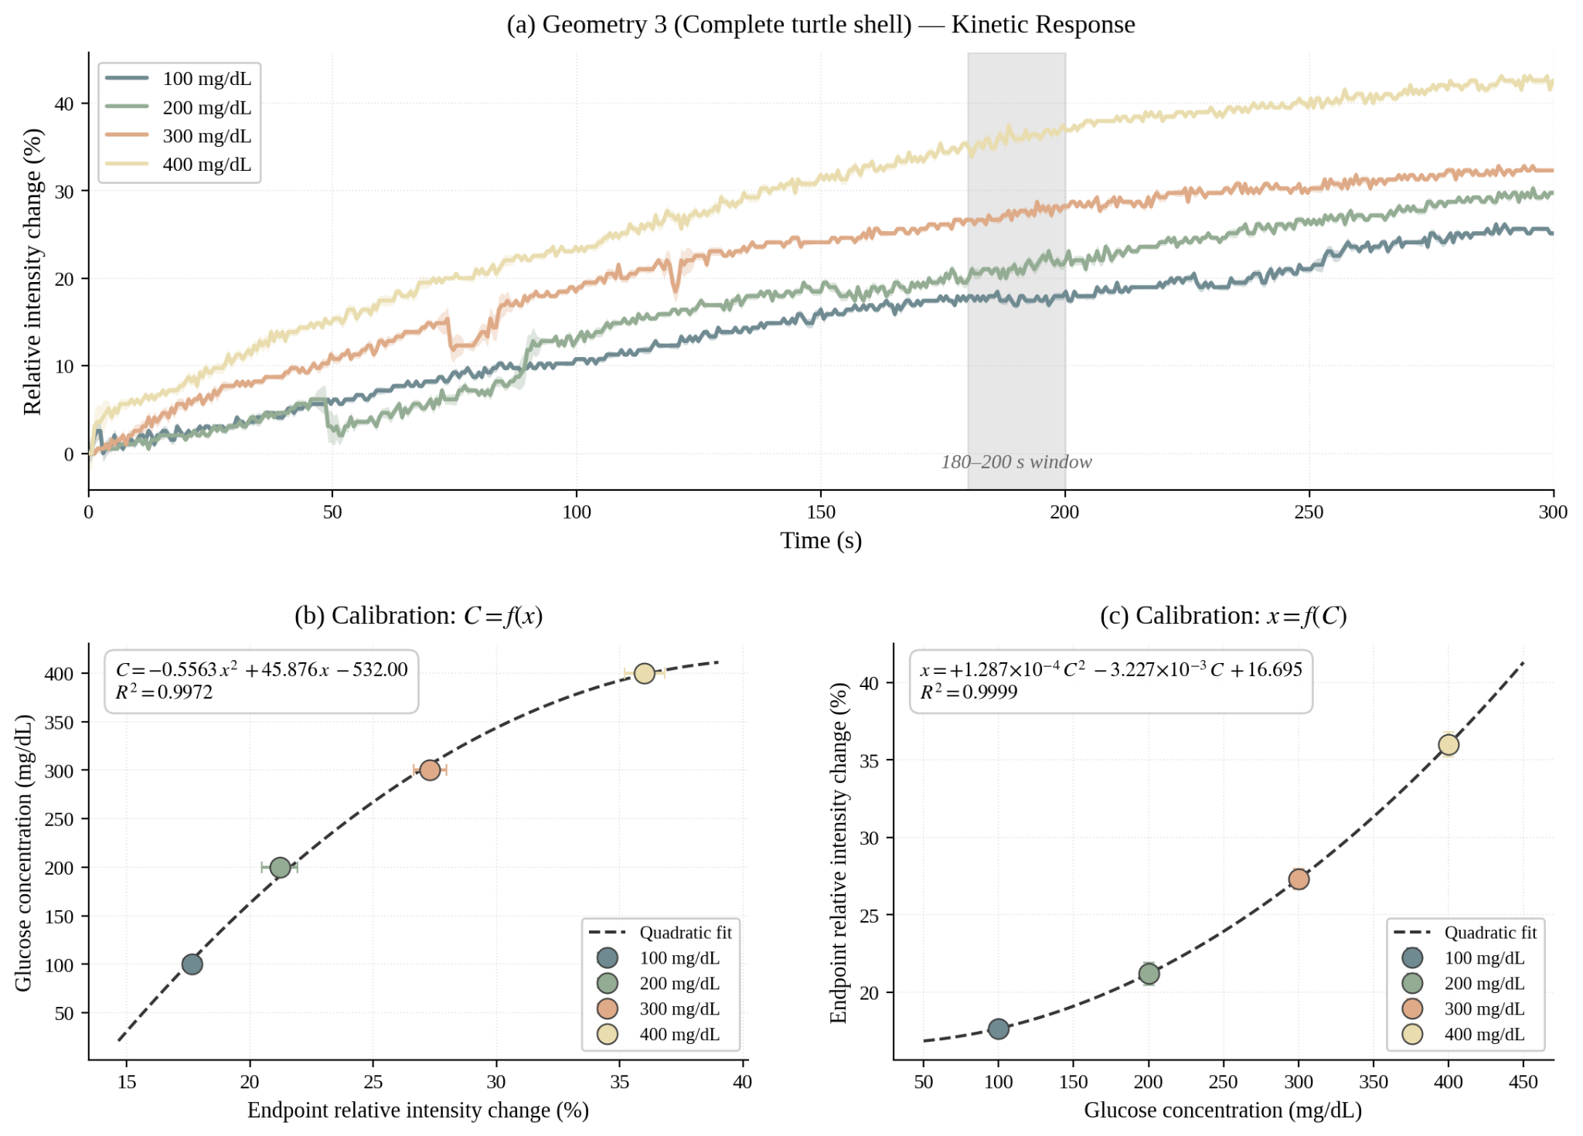
Figure F3. Geometry 3 — Complete turtle shell. The final integrated enclosure with the head module, shell body, and aluminum-foil-lined inner walls. Panel layout matches Figure F1. The kinetic curves show clean monotonic separation across the 100–400 mg/dL range, and the quadratic calibration C = a·x² + b·x + c (a = −0.556251, b = +45.8762, c = −532.003; coefficients stored in firmware as CAL_A, CAL_B, CAL_C in Listing G.5) achieves R² = 0.9972 on the four-point calibration set.
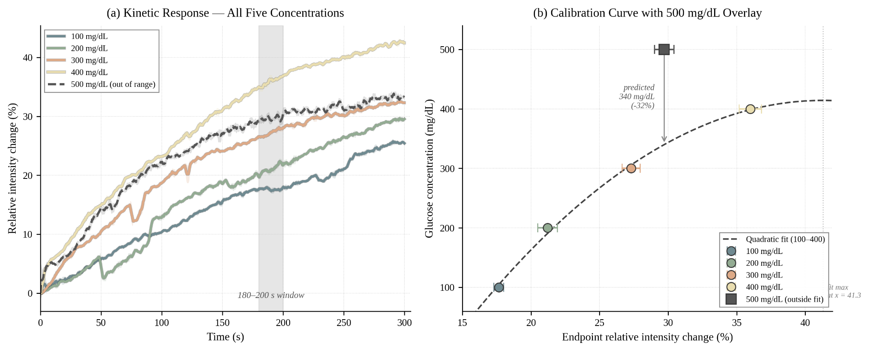
Figure F4. Calibration range limit at 500 mg/dL. Data collected in the complete turtle-shell configuration (Geometry 3) under the same protocol as Figure F3 (n = 34 samples in the 180–200 s window). Panel (a) overlays the kinetic response curves for all five tested concentrations; the 500 mg/dL curve (dashed) tracks below the 400 mg/dL response and crosses near the 300 mg/dL band, indicating saturation of the kinetic signal beyond the calibrated range. Panel (b) plots the 500 mg/dL endpoint on the C = f(x) calibration curve fitted to the 100–400 mg/dL data. Inverting the calibration with the measured 500 mg/dL endpoint of x = 29.7% yields a predicted concentration of 340 mg/dL, an error of −32%. The fitted parabola reaches its maximum at x ≈ 41.3, beyond which the inverse mapping is no longer single-valued. These observations establish 400 mg/dL as the upper limit of the device's reportable range.
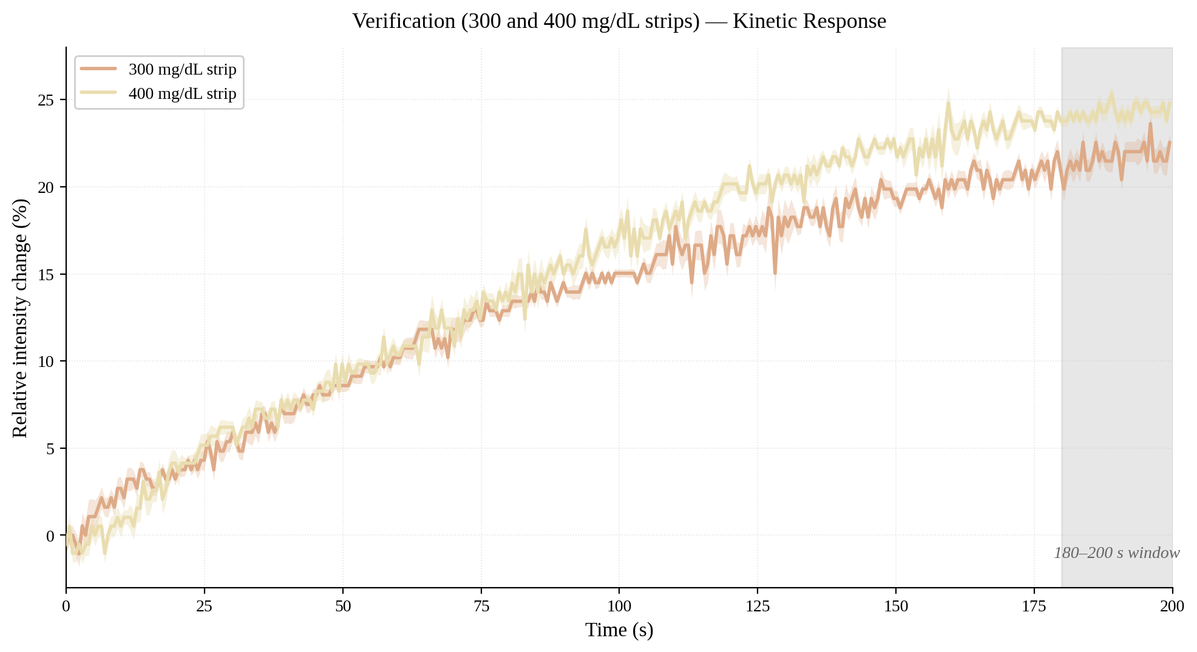
Figure F5. Verification — Independently prepared 300 and 400 mg/dL strips. Data collected in the complete turtle-shell configuration (Geometry 3) under the same protocol as Figure F3 (n = 34 samples in the 180–200 s window) using strips fabricated separately from the calibration set. The kinetic response curves track each other through approximately 75 s and separate thereafter, with both curves entering the endpoint window in the correct rank order (400 mg/dL above 300 mg/dL). The within-window standard deviations are 0.71% for the 300 mg/dL strip and 0.43% for the 400 mg/dL strip, both substantially smaller than the 2.6 percentage-point endpoint separation between the two concentrations, indicating that measurement noise is not the dominant source of error. Back-calculation through the stored quadratic calibration coefficients (Figure F3) yields 201 mg/dL for the 300 mg/dL strip (−32.9% error) and 254 mg/dL for the 400 mg/dL strip (−36.5% error), implicating inter-strip enzymatic variability and minor optical-path differences as the primary error sources.
F.1 Calibration Coefficients
Parameter | Value
a (CAL_A) | −0.556251
b (CAL_B) | +45.8762
c (CAL_C) | −532.003
R² | 0.9972
Calibrated concentration range | 100–400 mg/dL
Endpoint window | 180–200 s (n = 34)
Firmware reportable clamp | 20–600 mg/dL
Table F1. Quadratic calibration coefficients stored in the deployed firmware (Listing G.5, macros CAL_A, CAL_B, CAL_C), corresponding to the Geometry 3 calibration shown in Figure F3. The glucose concentration C (mg/dL) is computed from the within-window mean of the zeroed normalized signal x (%) as C = a·x² + b·x + c, evaluated on the 180–200 s endpoint window (n = 34 samples). The fit was developed on calibration strips at 100, 200, 300, and 400 mg/dL with R² = 0.9972, and the firmware clamps the displayed result to a 20–600 mg/dL reportable range to reject obviously out-of-range readings.

Appendix G. Firmware and Software Source Code
This appendix documents the complete firmware and supporting software developed for the P.I.P. device. The five listings cover the full software pipeline: hardware verification of the photodiode front end (G.1), serial-driven calibration data collection (G.2), host-side serial logging (G.3), post-processing of calibration runs (G.4), and the deployed measurement firmware on the final device (G.5). The Arduino C++ files (Listings G.1, G.2, G.5) target the ESP32-WROOM-32E and compile under the Arduino IDE with the Adafruit GFX and SSD1331 libraries. The Python files (Listings G.3, G.4) require Python 3 with the pyserial and pandas packages.

G.1 Hardware Verification Firmware
A standalone sketch that exercises the photodiode front-end during initial hardware bring-up. The program toggles the red LED, samples the BPW34 photodiode through the MCP6002 transimpedance amplifier, and prints both the LED-OFF and LED-ON ADC readings over serial. This firmware confirmed that the analog signal chain produced a stable differential signal before progressing to calibration runs.
Listing G1. photodiode_check.ino — hardware verification firmware for the BPW34 photodiode and MCP6002 TIA front-end.
/**
* @file photodiode_check.ino
* @brief Hardware verification firmware for the BPW34 photodiode and
* MCP6002 transimpedance amplifier front-end.
*
* Intended for initial bring-up of the P.I.P. analog signal chain. Runs a
* one-shot diagnostic sequence on power-up, prints results to serial at
* 115200 baud, and reports a PASS/FAIL summary. Reset the ESP32 to run again.
*
* Hardware:
* ADC_PIN (GPIO36 / VP) - photodiode output through MCP6002 TIA
* LED_PIN (GPIO4) - red LED, 630-660 nm
*
* Output: Serial console only (no OLED required).
*/

#define ADC_PIN 36
#define LED_PIN 4
#define N_SAMPLES 50
#define SAMPLE_DELAY_MS 5

/**
* @brief Read the ADC n times and return the mean.
* @param n Number of samples to average.
* @return Averaged 12-bit ADC value (0-4095).
*/
int readAvg(int n) {
long sum = 0;
for (int i = 0; i < n; i++) {
sum += analogRead(ADC_PIN);
delay(SAMPLE_DELAY_MS);
}
return (int)(sum / n);
}

/**
* @brief Print a 40-character ASCII bar graph of val scaled to maxVal,
* followed by the numeric value.
*/
void printBar(int val, int maxVal) {
int barLen = map(val, 0, maxVal, 0, 40);
barLen = constrain(barLen, 0, 40);
Serial.print(" [");
for (int i = 0; i < 40; i++) {
Serial.print(i < barLen ? '#' : ' ');
}
Serial.print("] ");
Serial.println(val);
}

/**
* @brief Run the four-stage health check once on boot.
*
* Test 1 - Ambient reading with LED off. Detects stuck-at-zero or stuck-at-
* saturation faults in the photodiode or TIA stage.
* Test 2 - LED-on reading. Confirms the photodiode responds to red light.
* Test 3 - Differential analysis. Reports the ON minus OFF delta.
* Test 4 - Stability check. Takes ten rapid reads and reports the noise
* range (max minus min) to detect oscillation or loose connections.
*
* The function then aggregates the four tests into a PASS/FAIL diagnosis.
*/
void setup() {
Serial.begin(115200);
delay(500);
pinMode(LED_PIN, OUTPUT);
digitalWrite(LED_PIN, LOW);

Serial.println();
Serial.println("========================================");
Serial.println(" BPW34 PHOTODIODE HEALTH CHECK");
Serial.println("========================================");
Serial.println();

// Test 1: Ambient reading with LED off.
Serial.println("[Test 1] Ambient reading (LED OFF)...");
delay(200);
int ambient = readAvg(N_SAMPLES);
Serial.print(" ADC = ");
Serial.println(ambient);
printBar(ambient, 4095);

bool stuckZero = (ambient == 0);
bool stuckMax = (ambient >= 4090);

if (stuckZero) {
Serial.println(" !! ADC stuck at 0. Possible causes:");
Serial.println(" - Photodiode disconnected");
Serial.println(" - GND wire broken");
Serial.println(" - Wrong ADC pin (verify GPIO36 / VP)");
} else if (stuckMax) {
Serial.println(" !! ADC saturated at 4095. Possible causes:");
Serial.println(" - Feedback resistor too large (try smaller Rf)");
Serial.println(" - Strong ambient light");
Serial.println(" - Op-amp output saturated");
} else {
Serial.println(" OK - ADC reading in range");
}
Serial.println();

// Test 2: LED response.
Serial.println("[Test 2] LED response (LED ON)...");
digitalWrite(LED_PIN, HIGH);
delay(50);
int ledOn = readAvg(N_SAMPLES);
digitalWrite(LED_PIN, LOW);
Serial.print(" ADC = ");
Serial.println(ledOn);
printBar(ledOn, 4095);
Serial.println();

// Test 3: Differential analysis.
int delta = ledOn - ambient;
Serial.println("[Test 3] Differential analysis...");
Serial.print(" LED OFF: "); Serial.println(ambient);
Serial.print(" LED ON: "); Serial.println(ledOn);
Serial.print(" Delta: "); Serial.println(delta);
Serial.println();

// Test 4: Stability over ten rapid reads.
Serial.println("[Test 4] Stability (10 rapid reads, LED ON)...");
digitalWrite(LED_PIN, HIGH);
delay(50);
int minVal = 9999, maxVal = 0;
int readings[10];
for (int i = 0; i < 10; i++) {
readings[i] = readAvg(10);
if (readings[i] < minVal) minVal = readings[i];
if (readings[i] > maxVal) maxVal = readings[i];
Serial.print(" #"); Serial.print(i + 1);
Serial.print(": "); Serial.println(readings[i]);
}
digitalWrite(LED_PIN, LOW);
int noise = maxVal - minVal;
Serial.print(" Range: "); Serial.print(minVal);
Serial.print(" - "); Serial.println(maxVal);
Serial.print(" Noise (max-min): "); Serial.println(noise);
Serial.println();

// Aggregate diagnosis.
Serial.println("========================================");
Serial.println(" DIAGNOSIS");
Serial.println("========================================");

int failCount = 0;

// Check A: basic photodiode connection.
if (stuckZero) {
Serial.println(" [FAIL] Photodiode not detected (ADC=0)");
failCount++;
} else if (stuckMax) {
Serial.println(" [FAIL] ADC saturated (4095). Check Rf or ambient light");
failCount++;
} else {
Serial.println(" [PASS] Photodiode connected");
}

// Check B: LED produces a measurable signal change.
if (abs(delta) < 20) {
Serial.println(" [FAIL] No LED response (|delta| < 20)");
Serial.println(" LED dead, or LED light not reaching photodiode");
failCount++;
} else if (delta < 0) {
Serial.println(" [WARN] Negative delta. LED ON reads LOWER than OFF.");
Serial.println(" Possible reverse wiring or op-amp issue");
failCount++;
} else {
Serial.print(" [PASS] LED response OK (delta = ");
Serial.print(delta); Serial.println(")");
}

// Check C: signal stability.
if (noise > 100) {
Serial.println(" [WARN] High noise. Verify connections and 22pF cap");
failCount++;
} else {
Serial.print(" [PASS] Stable signal (noise = ");
Serial.print(noise); Serial.println(")");
}

// Check D: ADC headroom.
if (ledOn >= 4080) {
Serial.println(" [WARN] LED-ON reading near saturation");
Serial.println(" Increase Rf or move LED further from photodiode");
failCount++;
} else {
Serial.println(" [PASS] ADC range OK");
}

Serial.println("----------------------------------------");
if (failCount == 0) {
Serial.println(" >>> PHOTODIODE IS ALIVE AND HEALTHY <<<");
} else {
Serial.print(" >>> "); Serial.print(failCount);
Serial.println(" issue(s) found. See above. <<<");
}
Serial.println("========================================");
Serial.println();
Serial.println("Done. Reset ESP32 to run again.");
}

/** @brief Idle. Diagnostic runs once in setup(). */
void loop() {
}

G.2 Kinetic Calibration Firmware
The ESP32 firmware that drove all calibration data collection sessions reported in Appendix F. It performs differential ADC sampling at a configurable interval (default 500 ms) over a 5-minute window, with the LED toggled OFF then ON for each reading and a 30 ms settle time before each ADC capture. Each reading is the mean of 30 successive ADC samples. The first 3 seconds of each run are designated as an auto-blank window: the differential readings collected during this period are averaged to produce the blank reference (blank_diff) used to normalize subsequent samples. CSV output is streamed continuously over the serial port for capture by the host-side logger (Listing G.3). Serial commands accept start, stop, settime <s>, setrate <ms>, setblanktime <s>, and go.
Listing G2. kinetic_calibration.ino — ESP32 kinetic calibration firmware. CSV columns: time_ms, time_s, adc_diff, norm_pct, phase.
/**
* @file kinetic_calibration.ino
* @brief Kinetic calibration firmware for the P.I.P. glucose biosensor reader.
*
* Drives all calibration data collection sessions. Performs differential ADC
* sampling at a configurable interval (default 500 ms) over a 5-minute window,
* with the LED toggled OFF then ON for each reading. Each ADC sample is the
* mean of 30 successive reads. CSV output is streamed continuously over the
* serial port for capture by the host-side logger (Listing G.3).
*
* Hardware:
* LED (red 630-660 nm) -> GPIO4
* Photodiode ADC -> GPIO36
* OLED SSD1331 SPI -> CS=5, DC=16, RST=17, SCK=18, MOSI=23
*
* Serial commands (115200 baud):
* start Arm the firmware. Prompts for 'go' to begin the run.
* go Begin baseline collection and CSV streaming.
* stop Abort the current run.
* blank Place a blank strip and acquire the reference value.
* settime <seconds> Set total run duration (default 300).
* setrate <ms> Set sample interval (default 500).
*
* CSV columns: time_ms, time_s, adc_diff, norm_pct
*/

#include <Adafruit_GFX.h>
#include <Adafruit_SSD1331.h>
#include <SPI.h>

// Pin definitions
#define LED_PIN 4
#define ADC_PIN 36
#define OLED_CS 5
#define OLED_DC 16
#define OLED_RST 17

// RGB565 colors
#define BLACK 0x0000
#define WHITE 0xFFFF
#define RED 0xF800
#define GREEN 0x07E0
#define BLUE 0x001F
#define CYAN 0x07FF
#define YELLOW 0xFFE0

// Sampling configuration
unsigned long sampleIntervalMs = 500; // sample interval (ms)
unsigned long totalDurationMs = 300000; // total run length (ms), default 5 min
const int AVG_SAMPLES = 20; // ADC samples averaged per read
const int BASELINE_SECS = 10; // baseline window length (seconds)

// State
Adafruit_SSD1331 oled = Adafruit_SSD1331(OLED_CS, OLED_DC, OLED_RST);

bool isRunning = false;
int blankDiff = 0; // blank reference differential
bool blankSet = false;
unsigned long startTime = 0;
int sampleCount = 0;

/**
* @brief Read the ADC n times back-to-back and return the mean.
* @param n Number of samples to average.
* @return Averaged 12-bit ADC value (0-4095).
*/
int readADC_avg(int n) {
long sum = 0;
for (int i = 0; i < n; i++) {
sum += analogRead(ADC_PIN);
delayMicroseconds(200);
}
return (int)(sum / n);
}

/**
* @brief Take a differential reading: (LED ON value) minus (LED OFF value).
* Cancels ambient light. Leaves the LED in its prior state on exit;
* callers manage LED state for continuous-sampling phases.
*/
int readDifferential() {
digitalWrite(LED_PIN, LOW);
delay(50);
int offVal = readADC_avg(AVG_SAMPLES);

digitalWrite(LED_PIN, HIGH);
delay(50);
int onVal = readADC_avg(AVG_SAMPLES);

return onVal - offVal;
}

/** @brief Clear the OLED to black. */
void oledClear() {
oled.fillScreen(BLACK);
}

/**
* @brief Display a one- or two-line status message on the OLED.
* @param line1 Top line (always shown).
* @param line2 Bottom line (optional, default empty).
* @param color Text color (default WHITE).
*/
void oledStatus(const char* line1, const char* line2 = "", uint16_t color = WHITE) {
oled.fillScreen(BLACK);
oled.setTextColor(color);
oled.setTextSize(1);
oled.setCursor(0, 4);
oled.println(line1);
oled.setCursor(0, 20);
oled.println(line2);
}

/**
* @brief Render a live-data frame: elapsed time, raw differential value,
* normalized percentage (if blank set), and an intensity bar.
*/
void oledLiveData(int elapsed_s, int diffVal, int normVal) {
oled.fillScreen(BLACK);
oled.setTextSize(1);

oled.setTextColor(CYAN);
oled.setCursor(0, 0);
oled.print("T: ");
oled.print(elapsed_s);
oled.println("s");

oled.setTextColor(WHITE);
oled.setCursor(0, 14);
oled.print("Diff: ");
oled.println(diffVal);

if (blankSet) {
oled.setTextColor(YELLOW);
oled.setCursor(0, 28);
oled.print("Norm: ");
oled.println(normVal);
}

int barWidth = map(constrain(diffVal, 0, 4000), 0, 4000, 0, 96);
oled.fillRect(0, 48, barWidth, 14, BLUE);
oled.drawRect(0, 48, 96, 14, WHITE);
}

/**
* @brief Collect an LED-OFF baseline and report the mean to serial.
* The mean serves as a diagnostic readout of ambient light level.
*/
void collectBaseline() {
Serial.println("# Collecting baseline (LED OFF)...");
oledStatus("Baseline...", "LED OFF", YELLOW);

digitalWrite(LED_PIN, LOW);
delay(500);

long sum = 0;
int n = BASELINE_SECS * (1000 / sampleIntervalMs);
if (n < 5) n = 5;

for (int i = 0; i < n; i++) {
sum += readADC_avg(AVG_SAMPLES);
delay(sampleIntervalMs);
}
long baselineAmbient = sum / n;
Serial.print("# Baseline ambient: ");
Serial.println(baselineAmbient);
}

/**
* @brief Acquire a blank-strip reference. After a 3 s settling delay the
* firmware records a single differential reading and stores it as
* the normalization reference for subsequent runs.
*/
void doBlankCalibration() {
Serial.println("# Blank calibration. Place blank strip and wait...");
oledStatus("BLANK CAL", "Place strip", GREEN);
delay(3000);

blankDiff = readDifferential();
blankSet = true;

Serial.print("# Blank reference diff: ");
Serial.println(blankDiff);

oledStatus("Blank set!", String(blankDiff).c_str(), GREEN);
delay(2000);
}

/** @brief Print the run header and CSV column row to serial. */
void printCSVHeader() {
Serial.println();
Serial.println("# --- Kinetic Calibration Run ---");
Serial.print("# Sample interval: ");
Serial.print(sampleIntervalMs);
Serial.println(" ms");
Serial.print("# Total duration: ");
Serial.print(totalDurationMs / 1000);
Serial.println(" s");
Serial.print("# Blank ref: ");
Serial.println(blankSet ? String(blankDiff) : "NOT SET");
Serial.println("# --------------------------------");
Serial.println("time_ms,time_s,adc_diff,norm_pct");
}

/**
* @brief Initialize peripherals and print the command help banner.
*/
void setup() {
Serial.begin(115200);
delay(500);

pinMode(LED_PIN, OUTPUT);
digitalWrite(LED_PIN, LOW);
analogSetAttenuation(ADC_11db);

oled.begin();
oledClear();
oledStatus("Biosensor", "Ready", GREEN);

Serial.println();
Serial.println("=== Kinetic Calibration Firmware ===");
Serial.println("Commands: start, stop, blank, settime <s>, setrate <ms>");
Serial.println("Place strip -> type 'start' -> data streams as CSV");
}

/**
* @brief Main loop. Dispatches serial commands and drives the per-tick
* differential sampling when isRunning is true.
*/
void loop() {
// Handle serial commands.
if (Serial.available()) {
String cmd = Serial.readStringUntil('\n');
cmd.trim();
cmd.toLowerCase();

if (cmd == "start") {
if (!blankSet) {
Serial.println("# WARNING: No blank reference. Use 'blank' first for normalized data.");
}
Serial.println("# Strip placed? Send 'go' when ready.");
oledStatus("Waiting...", "Send 'go'", YELLOW);
while (true) {
if (Serial.available()) {
String ready = Serial.readStringUntil('\n');
ready.trim();
if (ready == "go") break;
}
delay(50);
}
Serial.println("# Starting now!");

collectBaseline();
printCSVHeader();

isRunning = true;
startTime = millis();
sampleCount = 0;

digitalWrite(LED_PIN, HIGH);
delay(100);

} else if (cmd == "stop") {
isRunning = false;
digitalWrite(LED_PIN, LOW);
Serial.println("# Stopped.");
Serial.print("# Total samples: ");
Serial.println(sampleCount);
oledStatus("Stopped", String(sampleCount).c_str(), RED);

} else if (cmd == "blank") {
doBlankCalibration();

} else if (cmd.startsWith("settime")) {
int val = cmd.substring(8).toInt();
if (val > 0) {
totalDurationMs = (unsigned long)val * 1000;
Serial.print("# Duration set: ");
Serial.print(val);
Serial.println("s");
}

} else if (cmd.startsWith("setrate")) {
int val = cmd.substring(8).toInt();
if (val >= 100) {
sampleIntervalMs = val;
Serial.print("# Interval set: ");
Serial.print(val);
Serial.println("ms");
}
}
}

// Sampling loop.
if (isRunning) {
unsigned long elapsed = millis() - startTime;

if (elapsed >= totalDurationMs) {
isRunning = false;
digitalWrite(LED_PIN, LOW);
Serial.println("# Done.");
Serial.print("# Total samples: ");
Serial.println(sampleCount);
oledStatus("Done!", String(sampleCount).c_str(), GREEN);
return;
}

// Differential read with 30 ms LED settle time and 30-sample averaging.
digitalWrite(LED_PIN, LOW);
delay(30);
int offVal = readADC_avg(30);
digitalWrite(LED_PIN, HIGH);
delay(30);
int onVal = readADC_avg(30);
int diff = onVal - offVal;

// Normalize against blank reference.
float normPct = 0;
if (blankSet && blankDiff > 0) {
normPct = ((float)(blankDiff - diff) / blankDiff) * 100.0;
}

// CSV row.
float elapsed_s = elapsed / 1000.0;
Serial.print(elapsed);
Serial.print(",");
Serial.print(elapsed_s, 2);
Serial.print(",");
Serial.print(diff);
Serial.print(",");
Serial.println(normPct, 2);

sampleCount++;

// Refresh OLED roughly once per second to avoid flicker.
if (sampleCount % max(1, (int)(1000 / sampleIntervalMs)) == 0) {
oledLiveData((int)elapsed_s, diff, (int)normPct);
}

delay(sampleIntervalMs);
}
}

G.3 Calibration Serial Logger
A Python companion to Listing G.2 that captures the firmware's CSV serial output to timestamped files. The script auto-detects the ESP32 serial port across common USB-serial chipsets (CP210x, CH340, FTDI, Silicon Labs), prompts for a concentration label at the start of each run, and writes each kinetic capture to calibration_data/kinetic_<concentration>_<timestamp>.csv. Typed commands in the terminal are forwarded to the firmware over the same serial connection, so the operator can run an entire calibration session from one terminal window without switching tools.
Listing G3. serial_logger.py — host-side serial logger that captures kinetic firmware output to timestamped CSV files.
"""
Serial-to-CSV logger for the kinetic calibration firmware (Listing G.2).

Captures the firmware's CSV serial output to timestamped files. A new CSV file
is opened automatically on each ``start`` command. Files are named
``kinetic_<concentration>_<YYYYMMDD_HHMMSS>.csv`` and written to the
``calibration_data/`` directory.

Usage
-----
python serial_logger.py

The script auto-detects common USB-to-UART adapters (CP210x, CH340, FTDI). If
detection fails, available ports are listed and the user selects one.

Interactive commands (entered at the local prompt and forwarded to the ESP32):
start Begin a new run. Prompts for a concentration label.
stop Abort the current run.
blank Acquire a blank reference on the firmware side.
settime <seconds> Set total run duration on the firmware side.
setrate <ms> Set sample interval on the firmware side.
quit Close the serial port and exit.

Dependencies: pyserial.
"""

import os
import threading
import time

import serial
import serial.tools.list_ports

BAUD_RATE = 115200
OUTPUT_DIR = "calibration_data"

def find_esp32_port():
"""Return the device path of the first plausible ESP32 serial port.

Scans available ports and matches common USB-UART adapter descriptors. If
no match is found the available ports are listed and the user selects one
by index. Returns ``None`` if no ports are present at all.
"""
ports = serial.tools.list_ports.comports()
for p in ports:
desc = (p.description + (p.manufacturer or "")).lower()
if any(k in desc for k in ["cp210", "ch340", "ftdi", "usb", "serial", "silicon labs"]):
return p.device
if ports:
print("Available ports:")
for i, p in enumerate(ports):
print(f" [{i}] {p.device} - {p.description}")
idx = int(input("Select port number: "))
return ports[idx].device
return None

def main():
"""Run the serial logger main loop.

Opens the serial port, spawns a keyboard input thread for forwarding
commands to the firmware, and continuously reads incoming lines. CSV
rows are recognized by the firmware-emitted header line beginning with
``time_ms,`` and routed into a freshly opened timestamped file. Subsequent
numeric data lines are appended until the firmware emits ``# Done`` or
``# Stopped``.
"""
os.makedirs(OUTPUT_DIR, exist_ok=True)

port = find_esp32_port()
if not port:
print("No serial port found!")
return

print(f"Connecting to {port} @ {BAUD_RATE}...")
ser = serial.Serial(port, BAUD_RATE, timeout=1)
time.sleep(2) # Allow ESP32 to reset on connect
print("Connected! Waiting for data...\n")
print("Commands: type and press Enter to send to ESP32")
print(" blank / start / stop / settime <s> / setrate <ms> / quit\n")

csv_file = None
sample_count = 0
conc_label = ""

def input_thread():
"""Forward each line from stdin to the serial port.

Intercepts ``quit`` to exit cleanly and ``start`` to prompt the user
for a concentration label that names the next CSV file.
"""
nonlocal conc_label
while True:
try:
cmd = input()
if cmd.strip().lower() == "quit":
print("Exiting...")
os._exit(0)
if cmd.strip().lower() == "start":
conc_label = input("Enter concentration (e.g. 0, 50, 100 mg/dL): ").strip()
ser.write((cmd + "\n").encode())
except EOFError:
break

t = threading.Thread(target=input_thread, daemon=True)
t.start()

try:
while True:
if ser.in_waiting:
line = ser.readline().decode("utf-8", errors="replace").strip()
if not line:
continue

print(line)

# New run detected. Open a fresh timestamped CSV.
if line.startswith("time_ms,"):
timestamp = time.strftime("%Y%m%d_%H%M%S")
conc = conc_label if conc_label else "unknown"
filename = os.path.join(OUTPUT_DIR, f"kinetic_{conc}_{timestamp}.csv")
if csv_file:
csv_file.close()
csv_file = open(filename, "w")
csv_file.write(f"# concentration: {conc}\n")
csv_file.write(line + "\n")
csv_file.flush()
sample_count = 0
print(f"\n>>> Saving to: {filename}\n")
continue

# Data row (starts with a digit).
if csv_file and line and line[0].isdigit():
csv_file.write(line + "\n")
csv_file.flush()
sample_count += 1

# End-of-run marker.
if "# Done" in line or "# Stopped" in line:
if csv_file:
csv_file.close()
csv_file = None
conc_label = ""
print(f"\n>>> CSV saved! ({sample_count} samples)\n")

time.sleep(0.01)

except KeyboardInterrupt:
print("\nExiting...")
finally:
if csv_file:
csv_file.close()
ser.close()

if __name__ == "__main__":
main()

G.4 Calibration Data Smoothing
A short post-processing utility that averages every N consecutive samples in a calibration CSV file to reduce point-to-point ADC noise before plotting. The default group size of 4 samples corresponds to roughly 2 seconds at the 500 ms sampling interval. Time stamps from the first sample of each group are retained while adc_diff and norm_pct columns are averaged. The script accepts glob patterns and writes outputs to a specified directory with _smoothed appended to each filename.
Listing G4. smooth.py — calibration CSV averaging utility for noise reduction prior to analysis.
"""
Post-processing script for kinetic calibration CSV files.

Averages every N consecutive readings within each input CSV to produce a
smoothed version. The original metadata header line (beginning with ``#``)
is preserved at the top of the output file. Intended for noise reduction
on raw firmware output before curve fitting.

Usage
-----
python smooth.py <input.csv> [<input2.csv> ...] [-o <output_dir>]

The input arguments accept glob patterns (e.g. ``calibration_data/*.csv``).
Each input file produces a corresponding ``<basename>_smoothed.csv`` written
to the output directory (default: current directory).

Dependencies: pandas.
"""

import argparse
import glob
import os

import pandas as pd

GROUP_SIZE = 4

def smooth_file(fpath, out_dir):
"""Average every ``GROUP_SIZE`` rows of one CSV file and write the result.

Reads the first line as a metadata header (preserved verbatim), then
parses the remaining rows with pandas. Numeric columns ``adc_diff`` and
``norm_pct`` are mean-aggregated; ``time_ms`` and ``time_s`` keep the
first value of each group as the representative timestamp.

Parameters
----------
fpath : str
Path to the input CSV.
out_dir : str
Destination directory for the smoothed file.
"""
with open(fpath) as f:
header_line = f.readline().strip()

df = pd.read_csv(fpath, comment="#")

groups = df.groupby(df.index // GROUP_SIZE)
smoothed = groups.agg({
"time_ms": "first",
"time_s": "first",
"adc_diff": "mean",
"norm_pct": "mean",
}).reset_index(drop=True)

smoothed["adc_diff"] = smoothed["adc_diff"].round(2)
smoothed["norm_pct"] = smoothed["norm_pct"].round(2)

basename = os.path.basename(fpath).replace(".csv", "_smoothed.csv")
out = os.path.join(out_dir, basename)

with open(out, "w") as f:
f.write(header_line + "\n")
smoothed.to_csv(f, index=False)

print(f"{os.path.basename(fpath)}: {len(df)} -> {len(smoothed)} rows => {out}")

def main():
"""Parse arguments, expand glob patterns, and smooth each input file."""
parser = argparse.ArgumentParser(
description="Average every N consecutive readings."
)
parser.add_argument("inputs", nargs="+", help="Input CSV files or glob patterns")
parser.add_argument("-o", "--output", default=".",
help="Output directory (default: current dir)")
args = parser.parse_args()

os.makedirs(args.output, exist_ok=True)

files = []
for pattern in args.inputs:
files.extend(glob.glob(pattern))

for fpath in sorted(files):
smooth_file(fpath, args.output)

if __name__ == "__main__":
main()

G.5 Device Main Program
The firmware deployed on the assembled P.I.P. device. It implements the complete measurement pipeline: ambient baseline collection with the LED off, blank reference normalization, continuous kinetic measurement with output captured over a 180–200 s endpoint window, application of the calibration equation C = -0.556251x² + 45.8762x - 532.003 (Appendix F, Geometry 3) to compute the glucose concentration, and rendering of the result on the SSD1331 OLED with color-coded glucose-range indicators (very low, low, normal, high, very high). Unlike the calibration firmware in Listing G.2, this version operates from on-device controls and visual feedback rather than a host-side serial interface.
Listing G5. main_program.ino — deployed device firmware implementing measurement, calibration application, and OLED display.
/**
* @file main_program.ino
* @brief Deployed measurement firmware for the P.I.P. (Personal Insulin Pal)
* glucose biosensor.
*
* This is the firmware that runs on the final device. It performs a 200-second
* kinetic measurement on a TMB strip, averages the zeroed normalized signal
* over a 180-200 s endpoint window, and converts the result to a glucose
* concentration using a quadratic calibration curve. Results are displayed
* on the SSD1331 OLED with a color-coded status block (V.LOW / LOW / OK /
* HIGH / V.HIGH).
*
* Hardware:
* LED (red 630-660 nm) -> GPIO4
* Photodiode ADC -> GPIO36 (VP)
* OLED SSD1331 SPI -> CS=5, DC=16, RST=17, SCK=18, MOSI=23
*
* Serial commands (115200 baud):
* start Run a full measurement cycle (baseline -> 200 s -> result).
* cal Run a calibration verification against a 100 mg/dL reference.
*
* On boot the device plays a splash animation (Miami M reveal followed by
* a turtle and the "P.I.P. / Insulin Pal" title) and then idles on the home
* screen until a serial command arrives.
*/

#include <SPI.h>
#include <Adafruit_GFX.h>
#include <Adafruit_SSD1331.h>

// Pin definitions
#define PIN_CS 5
#define PIN_DC 16
#define PIN_RST 17
#define ADC_PIN 36 // Photodiode BPW34 (VP)
#define LED_PIN 4 // Red LED 630-660 nm

// Screen dimensions
#define SCREEN_W 96
#define SCREEN_H 64

// RGB565 colors
#define COLOR_BLACK 0x0000
#define COLOR_WHITE 0xFFFF
#define COLOR_GREEN 0x07E0
#define COLOR_RED 0xF800
#define COLOR_YELLOW 0xFFE0
#define COLOR_DARKGREEN 0x03E0
#define COLOR_ORANGE 0xFD20
#define COLOR_GREY 0x7BEF
#define MIAMI_RED 0xC0A7 // Miami University red (~#C3163B)
#define SHELL_MID 0x05E0 // medium green for turtle shell cells
#define TURTLE_SKIN 0x5CC0 // olive-green for turtle head and legs

// Glucose status thresholds (mg/dL)
#define GLUCOSE_VERYLOW 54
#define GLUCOSE_LOW 70
#define GLUCOSE_HIGH 180
#define GLUCOSE_VERYHIGH 300
#define GLUCOSE_MIN_CLAMP 20.0f
#define GLUCOSE_MAX_CLAMP 600.0f

// Sampling configuration
#define N_AVG 20
#define LED_WARMUP_MS 15
#define READING_INTERVAL_MS 580 // ~0.58 s per reading (matches calibration)
#define TOTAL_MEASURE_S 200
#define WINDOW_START_S 180
#define WINDOW_END_S 200

// Quadratic calibration coefficients.
// concentration = CAL_A * x^2 + CAL_B * x + CAL_C
// where x is the zeroed norm_pct averaged over the 180-200 s window.
#define CAL_A (-0.556251f)
#define CAL_B ( 45.8762f)
#define CAL_C (-532.003f)

// Calibration verification configuration
#define REF_GLUCOSE_MGDL 100.0f
#define CAL_TOLERANCE_PCT 0.20f
#define CAL_MAX_ATTEMPTS 2
#define CAL_INSERT_DELAY_MS 5000

// Globals
Adafruit_SSD1331 display = Adafruit_SSD1331(&SPI, PIN_CS, PIN_DC, PIN_RST);
float baselineDiff = 0;

// ────────────────────────────────────────────────────────────
// LOW-LEVEL HELPERS
// ────────────────────────────────────────────────────────────

/**
* @brief Read the ADC n times back-to-back and return the mean.
* @param n Number of samples to average.
* @return Averaged 12-bit ADC value (0-4095).
*/
int readAvg(int n) {
long sum = 0;
for (int i = 0; i < n; i++) {
sum += analogRead(ADC_PIN);
delay(5);
}
return (int)(sum / n);
}

/**
* @brief Take a single differential reading.
* Reads ambient (LED off), then signal (LED on) after a fixed warmup
* delay, then turns the LED off again. Returns signal minus ambient.
*/
float takeDiffReading() {
digitalWrite(LED_PIN, LOW);
delay(10);
int ambient = readAvg(N_AVG);
digitalWrite(LED_PIN, HIGH);
delay(LED_WARMUP_MS);
int signal = readAvg(N_AVG);
digitalWrite(LED_PIN, LOW);
return (float)(signal - ambient);
}

/**
* @brief Establish the empty-chamber baseline used for normalization.
* Averages five differential reads taken 100 ms apart.
*/
float measureBaseline() {
float sum = 0;
int n = 5;
for (int i = 0; i < n; i++) {
sum += takeDiffReading();
delay(100);
}
return sum / n;
}

/**
* @brief Convert a raw differential reading to a normalized percentage
* relative to the empty-chamber baseline. Returns 0 if the baseline
* has not been established.
*/
float diffToNormPct(float diff) {
if (baselineDiff <= 0) return 0;
return (1.0f - diff / baselineDiff) * 100.0f;
}

/**
* @brief Apply the quadratic calibration curve to a zeroed norm_pct value
* and clamp the result to the physiologically reasonable range
* [GLUCOSE_MIN_CLAMP, GLUCOSE_MAX_CLAMP].
*/
float zeroedToGlucose(float x) {
float result = CAL_A * x * x + CAL_B * x + CAL_C;
if (result < GLUCOSE_MIN_CLAMP) result = GLUCOSE_MIN_CLAMP;
if (result > GLUCOSE_MAX_CLAMP) result = GLUCOSE_MAX_CLAMP;
return result;
}

// ────────────────────────────────────────────────────────────
// DISPLAY FUNCTIONS
// ────────────────────────────────────────────────────────────

/**
* @brief Render a one- or two-line plain status message on the OLED.
* @param line1 Top line.
* @param line2 Bottom line (optional, default nullptr).
*/
void displayMessage(const char* line1, const char* line2 = nullptr) {
display.fillScreen(COLOR_BLACK);
display.setTextColor(COLOR_WHITE);
display.setTextSize(1);
display.setCursor(4, 18);
display.print(line1);
if (line2) {
display.setCursor(4, 33);
display.print(line2);
}
}

/**
* @brief Draw the live measurement progress screen.
* Shows elapsed/total seconds, a progress bar (green when inside the
* endpoint averaging window, grey otherwise), and the window range.
*/
void displayProgress(int elapsedSec, int totalSec, bool inWindow) {
display.fillScreen(COLOR_BLACK);
display.setTextColor(COLOR_WHITE);
display.setTextSize(1);
display.setCursor(4, 4);
display.print(inWindow ? "Collecting..." : "Measuring...");
display.setCursor(4, 18);
display.print(elapsedSec);
display.print(" / ");
display.print(totalSec);
display.print(" s");
int barX = 4, barY = 34, barW = SCREEN_W - 8, barH = 10;
display.drawRect(barX, barY, barW, barH, COLOR_WHITE);
int fillW = (int)((float)elapsedSec / totalSec * (barW - 2));
if (fillW > 0)
display.fillRect(barX + 1, barY + 1, fillW, barH - 2,
inWindow ? COLOR_GREEN : COLOR_GREY);
display.setCursor(4, 50);
display.setTextColor(COLOR_GREY);
display.print("Window: ");
display.print(WINDOW_START_S);
display.print("-");
display.print(WINDOW_END_S);
display.print("s");
}

/**
* @brief Draw the final result screen.
* Shows the numeric glucose value, a colored status block (red /
* orange / green / yellow / red for V.LOW / LOW / OK / HIGH / V.HIGH),
* and a one-line range descriptor.
*/
void displayResult(float glucose) {
display.fillScreen(COLOR_BLACK);
display.setTextColor(COLOR_WHITE);
display.setTextSize(1);
display.setCursor(4, 4);
display.print("GLUCOSE");
display.setTextSize(2);
display.setCursor(4, 16);
display.print((int)glucose);
display.setTextSize(1);
display.setCursor(4, 36);
display.print("mg/dL");

uint16_t blockColor;
const char* status;
if (glucose < GLUCOSE_VERYLOW) { blockColor = COLOR_RED; status = "V.LOW"; }
else if (glucose < GLUCOSE_LOW) { blockColor = COLOR_ORANGE; status = "LOW"; }
else if (glucose <= GLUCOSE_HIGH) { blockColor = COLOR_GREEN; status = "OK"; }
else if (glucose <= GLUCOSE_VERYHIGH) { blockColor = COLOR_YELLOW; status = "HIGH"; }
else { blockColor = COLOR_RED; status = "V.HIGH"; }

int bx = 58, by = 4, bw = 34, bh = 30;
display.fillRect(bx, by, bw, bh, blockColor);
uint16_t labelColor = (blockColor == COLOR_YELLOW) ? COLOR_BLACK : COLOR_WHITE;
display.setTextColor(labelColor);
display.setTextSize(1);
int textW = strlen(status) * 6;
display.setCursor(bx + (bw - textW) / 2, by + 11);
display.print(status);

display.drawFastHLine(0, 46, SCREEN_W, COLOR_WHITE);
display.setTextColor(COLOR_GREY);
display.setTextSize(1);
display.setCursor(4, 50);
if (glucose < GLUCOSE_LOW) display.print("Below normal");
else if (glucose <= GLUCOSE_HIGH) display.print("Normal range");
else display.print("Above normal");
}

// ────────────────────────────────────────────────────────────
// SPLASH ANIMATION
// ────────────────────────────────────────────────────────────

/**
* @brief Draw one scanline of the Miami M shape.
*
* @param bx Left edge of the M bounding box on screen.
* @param bw Total width of the M bounding box.
* @param row Scanline index from top (0 = topmost row of the M).
* @param color Fill color.
*
* Shape logic:
* The two outer columns (col_width pixels each) flare slightly at the
* bottom. Inner edges converge from an open V at the top to fully closed
* at v_depth. Below v_depth the M is solid fill.
*/
void drawMRow(int bx, int bw, int row, uint16_t color) {
const int v_depth = 34; // row where the V notch fully closes
const int col_width = 18; // outer stroke thickness in pixels
int y = 4 + row; // 4-pixel top margin
int flare = (row > 42) ? (row - 42) / 2 : 0;
int x_left = max(0, bx - flare);
int x_right = min(SCREEN_W - 1, bx + bw + flare);
int half_v = bw / 2 - col_width; // distance each inner edge travels to center

if (row < v_depth) {
int il = (bx + col_width) + (half_v * row / v_depth);
int ir = (bx + bw - col_width) - (half_v * row / v_depth);
if (il > x_left) display.drawFastHLine(x_left, y, il - x_left, color);
if (x_right > ir) display.drawFastHLine(ir, y, x_right - ir, color);
} else {
display.drawFastHLine(x_left, y, x_right - x_left, color);
}
}

/**
* @brief Draw a top-down pixel-art turtle centered at (cx, cy).
* Total footprint roughly 22 px wide by 24 px tall.
*/
void drawTurtle(int cx, int cy) {
// Legs (drawn behind the shell)
display.fillCircle(cx - 8, cy - 4, 3, TURTLE_SKIN); // front-left
display.fillCircle(cx + 8, cy - 4, 3, TURTLE_SKIN); // front-right
display.fillCircle(cx - 8, cy + 4, 3, TURTLE_SKIN); // rear-left
display.fillCircle(cx + 8, cy + 4, 3, TURTLE_SKIN); // rear-right
// Tail
display.fillCircle(cx, cy + 8, 2, TURTLE_SKIN);
// Shell body
display.fillCircle(cx, cy, 7, COLOR_DARKGREEN);
// Hex-cell highlights on the shell
display.fillCircle(cx, cy, 3, COLOR_GREEN); // bright center
display.fillCircle(cx - 3, cy - 2, 2, SHELL_MID); // top-left cell
display.fillCircle(cx + 3, cy - 2, 2, SHELL_MID); // top-right cell
display.fillCircle(cx - 3, cy + 2, 2, SHELL_MID); // bottom-left cell
display.fillCircle(cx + 3, cy + 2, 2, SHELL_MID); // bottom-right cell
// Head
display.fillCircle(cx, cy - 10, 3, TURTLE_SKIN);
display.fillRect(cx - 1, cy - 7, 2, 3, TURTLE_SKIN); // neck
// Eyes
display.drawPixel(cx - 1, cy - 11, COLOR_BLACK);
display.drawPixel(cx + 1, cy - 11, COLOR_BLACK);
}

/**
* @brief Boot splash sequence.
*
* Phase 1 — Miami M scanline reveal (top to bottom, ~1 s).
* Phase 2 — White flash wipe.
* Phase 3 — Turtle plus typewriter "P.I.P." plus "Insulin Pal".
*
* The final splash frame remains on screen until a serial command arrives.
*/
void splashAnimation() {
const int M_BX = 18; // M left edge (centered on 96 px screen)
const int M_BW = 60; // M width
const int M_BH = 56; // M height (ends at y = 60, leaving 4 px bottom margin)

// Phase 1: Miami M reveal.
display.fillScreen(COLOR_BLACK);
for (int row = 0; row < M_BH; row++) {
drawMRow(M_BX, M_BW, row, MIAMI_RED);
delay(18); // 18 ms per row, ~1 s total
}
delay(900);

// Phase 2: flash-wipe transition.
display.fillScreen(COLOR_WHITE);
delay(60);
display.fillScreen(COLOR_BLACK);
delay(60);

// Phase 3: turtle plus typewriter title.
// Turtle: center (48, 18), head top at y~5, tail bottom at y~28.
drawTurtle(48, 18);
delay(250);

// "P.I.P." - textSize 2, 12 px/char, 6 chars = 72 px, x=12 to center.
display.setTextSize(2);
const char* title = "P.I.P.";
int tLen = strlen(title);
for (int i = 0; i < tLen; i++) {
display.fillRect(12, 36, 72, 16, COLOR_BLACK);
display.setTextColor(MIAMI_RED);
display.setCursor(12, 36);
for (int j = 0; j <= i; j++) display.print(title[j]);
delay(110);
}

// "Insulin Pal" - textSize 1, 6 px/char, 11 chars = 66 px, x=15 to center.
display.setTextSize(1);
const char* sub = "Insulin Pal";
int sLen = strlen(sub);
for (int i = 0; i < sLen; i++) {
display.fillRect(15, 56, 66, 8, COLOR_BLACK);
display.setTextColor(COLOR_WHITE);
display.setCursor(15, 56);
for (int j = 0; j <= i; j++) display.print(sub[j]);
delay(65);
}

delay(1300);
}

/**
* @brief Static home screen (no animation).
* Redraws the turtle and title so the device idles on the P.I.P.
* screen after a measurement or calibration finishes.
*/
void showHomeScreen() {
display.fillScreen(COLOR_BLACK);
drawTurtle(48, 18);
display.setTextSize(2);
display.setTextColor(MIAMI_RED);
display.setCursor(12, 36);
display.print("P.I.P.");
display.setTextSize(1);
display.setTextColor(COLOR_WHITE);
display.setCursor(15, 56);
display.print("Insulin Pal");
}

// ────────────────────────────────────────────────────────────
// MAIN MEASUREMENT CYCLE
// ────────────────────────────────────────────────────────────

/**
* @brief Run a full measurement cycle.
*
* Sequence:
* 1. Empty-chamber baseline acquisition.
* 2. User prompt to insert the strip.
* 3. Initial reading captured at t~0 for zero-normalization.
* 4. 200-second sampling loop. Each row is streamed as CSV
* (time_s, adc_diff, norm_pct, zeroed). Readings within the
* 180-200 s window are averaged.
* 5. Quadratic curve applied to the windowed average to produce a
* glucose concentration. Result rendered on the OLED.
*/
void runMeasurement() {
// 1. Empty-chamber baseline.
Serial.println("=== BASELINE ===");
displayMessage("Baseline...", "Keep empty");
delay(2000);
baselineDiff = measureBaseline();
Serial.print("Baseline diff: "); Serial.println(baselineDiff);

if (baselineDiff < 50) {
Serial.println("ERROR: baseline too low. Check LED and photodiode.");
displayMessage("ERROR", "Check sensor");
delay(3000);
return;
}

// 2. Prompt for the strip.
displayMessage("Insert strip", "then wait...");
delay(5000);

// 3. Initial reading (t~0) for zero-normalization.
float initialDiff = takeDiffReading();
float initialNorm = diffToNormPct(initialDiff);
Serial.println("=== MEASUREMENT START ===");
Serial.print("Initial diff: "); Serial.println(initialDiff);
Serial.print("Initial norm%: "); Serial.println(initialNorm);
Serial.println("time_s,adc_diff,norm_pct,zeroed");

// 4. 200-second measurement loop.
unsigned long startMs = millis();
float windowSum = 0;
int windowCount = 0;
int lastDisplaySec = -1;

while (true) {
unsigned long elapsed = millis() - startMs;
int elapsedSec = (int)(elapsed / 1000);
if (elapsedSec >= TOTAL_MEASURE_S) break;

float diff = takeDiffReading();
float normPct = diffToNormPct(diff);
float zeroed = normPct - initialNorm;
float timeSec = elapsed / 1000.0f;

Serial.print(timeSec, 2); Serial.print(",");
Serial.print(diff, 1); Serial.print(",");
Serial.print(normPct, 2); Serial.print(",");
Serial.println(zeroed, 2);

bool inWindow = (elapsedSec >= WINDOW_START_S && elapsedSec < WINDOW_END_S);
if (inWindow) { windowSum += zeroed; windowCount++; }

if (elapsedSec != lastDisplaySec) {
displayProgress(elapsedSec, TOTAL_MEASURE_S, inWindow);
lastDisplaySec = elapsedSec;
}

unsigned long readingDuration = millis() - (startMs + elapsed);
if (readingDuration < READING_INTERVAL_MS)
delay(READING_INTERVAL_MS - readingDuration);
}

// 5. Compute and display the result.
Serial.println("=== RESULT ===");
if (windowCount < 5) {
Serial.println("ERROR: too few data points in window.");
displayMessage("ERROR", "Insufficient data");
delay(3000);
return;
}

float avgZeroed = windowSum / windowCount;
float glucose = zeroedToGlucose(avgZeroed);

Serial.print("Window points: "); Serial.println(windowCount);
Serial.print("Avg zeroed norm%: "); Serial.println(avgZeroed, 2);
Serial.print("Glucose: "); Serial.print(glucose, 1);
Serial.println(" mg/dL");

displayResult(glucose);
}

// ────────────────────────────────────────────────────────────
// CALIBRATION VERIFICATION
// ────────────────────────────────────────────────────────────

/**
* @brief Run a calibration verification cycle against a reference strip.
*
* Re-acquires the baseline, then runs up to CAL_MAX_ATTEMPTS measurements
* on a REF_GLUCOSE_MGDL reference strip. A run is judged PASS when the
* absolute relative error is at or below CAL_TOLERANCE_PCT. The PASS or
* FAIL verdict is rendered on a full-screen colored panel.
*/
void runCalibrationCheck() {
Serial.println("=== CALIBRATION CHECK ===");
displayMessage("Baseline...", "Keep empty");
delay(2000);
baselineDiff = measureBaseline();
Serial.print("Baseline diff: "); Serial.println(baselineDiff);

for (int attempt = 1; attempt <= CAL_MAX_ATTEMPTS; attempt++) {
Serial.print("Attempt "); Serial.print(attempt);
Serial.print("/"); Serial.println(CAL_MAX_ATTEMPTS);

char line2[24];
snprintf(line2, sizeof(line2), "%d mg/dL ref", (int)REF_GLUCOSE_MGDL);
displayMessage("Insert REF:", line2);
delay(CAL_INSERT_DELAY_MS);

displayMessage("Measuring...", "Cal strip");

float initialDiff = takeDiffReading();
float initialNorm = diffToNormPct(initialDiff);
unsigned long startMs = millis();
float windowSum = 0;
int windowCount = 0;
int lastSec = -1;

while (true) {
unsigned long elapsed = millis() - startMs;
int sec = (int)(elapsed / 1000);
if (sec >= TOTAL_MEASURE_S) break;

float diff = takeDiffReading();
float normPct = diffToNormPct(diff);
float zeroed = normPct - initialNorm;

bool inWin = (sec >= WINDOW_START_S && sec < WINDOW_END_S);
if (inWin) { windowSum += zeroed; windowCount++; }
if (sec != lastSec) {
displayProgress(sec, TOTAL_MEASURE_S, inWin);
lastSec = sec;
}

unsigned long dur = millis() - (startMs + elapsed);
if (dur < READING_INTERVAL_MS) delay(READING_INTERVAL_MS - dur);
}

if (windowCount < 5) {
displayMessage("CAL ERROR", "No data");
delay(2500);
continue;
}

float avgZeroed = windowSum / windowCount;
float measured = zeroedToGlucose(avgZeroed);
float errorPct = (measured - REF_GLUCOSE_MGDL) / REF_GLUCOSE_MGDL;

Serial.print(" Measured: "); Serial.print(measured);
Serial.print(" Error: "); Serial.print(errorPct * 100.0f);
Serial.println("%");

bool passed = (fabs(errorPct) <= CAL_TOLERANCE_PCT);

display.fillScreen(passed ? COLOR_GREEN : COLOR_RED);
display.setTextColor(COLOR_WHITE);
display.setTextSize(1);
display.setCursor(4, 4);
display.print("CALIBRATION");
display.setTextSize(2);
display.setCursor(4, 18);
display.print(passed ? "PASS" : "FAIL");
display.drawFastHLine(0, 40, SCREEN_W, COLOR_WHITE);
display.setTextSize(1);
display.setCursor(4, 45);
display.print("Read: "); display.print((int)measured);
display.setCursor(4, 55);
display.print("Ref: "); display.print((int)REF_GLUCOSE_MGDL);
delay(3000);

if (passed) { Serial.println(" >>> PASS"); return; }
Serial.println(" >>> FAIL");
if (attempt < CAL_MAX_ATTEMPTS) {
displayMessage("Retrying...", "Re-insert");
delay(2000);
}
}

Serial.println("CAL FAILED after all attempts.");
displayMessage("CAL FAIL", "Check device");
delay(3000);
}

// ────────────────────────────────────────────────────────────
// SETUP & LOOP
// ────────────────────────────────────────────────────────────

/**
* @brief Initialize peripherals, run the boot splash, and idle on the
* home screen until a serial command arrives.
*/
void setup() {
Serial.begin(115200);
Serial.println("=== P.I.P. Glucose Biosensor ===");

pinMode(LED_PIN, OUTPUT);
digitalWrite(LED_PIN, LOW);

SPI.begin(18, -1, 23, PIN_CS);
SPI.setFrequency(1000000);
display.begin();
display.fillScreen(COLOR_BLACK);

splashAnimation();

Serial.println("Commands:");
Serial.println(" start - begin measurement");
Serial.println(" cal - calibration check");
}

/**
* @brief Main loop. Dispatches the two top-level serial commands and
* returns the device to the home screen after calibration.
*/
void loop() {
if (!Serial.available()) return;

String cmd = Serial.readStringUntil('\n');
cmd.trim();
cmd.toLowerCase();

if (cmd == "start") {
runMeasurement();
Serial.println("\nSend 'start' for new test, 'cal' for calibration.");
} else if (cmd == "cal") {
runCalibrationCheck();
showHomeScreen();
} else {
Serial.print("Unknown command: "); Serial.println(cmd);
Serial.println("Use 'start' or 'cal'.");
}
}

Appendix H. Raw Calibration Data
This appendix documents the underlying serial-streamed CSV data that supports the calibration results presented in Appendix F. Section H.1 describes the firmware output schema and provides a representative excerpt. Section H.2 maps each calibration figure in Appendix F to its source session. Section H.3 presents the smoothing approach considered during analysis and the methodological reasoning behind its rejection. Section H.4 specifies the location of the complete archived dataset.

H.1 CSV Format and Firmware Output Schema
Each calibration session was captured as one CSV file per glucose concentration. The host-side serial logger described in Listing G.3 streams data continuously from the ESP32 over the duration of the run and writes one row per ADC sample. File names follow the pattern kinetic_<concentration_mg_dL>_<YYYYMMDD>_<HHMMSS>.csv, where the timestamp records the start of the session. The firmware emits four numeric fields and one categorical field per row. Field definitions are summarized in Table H1.
Table H1. Firmware CSV output schema.
Field | Type | Description
time_ms | int | Elapsed time since session start, in milliseconds.
time_s | float | Elapsed time since session start, in seconds.
adc_diff | int | Differential ADC reading (LED OFF minus LED ON) computed as the mean of 30 successive samples.
norm_pct | float | Reading normalized against the auto-blank reference and expressed as percent change. The value is fixed at zero during the blank phase.
phase | str | Equal to "blank" during the auto-blank window (first 3 seconds), and equal to "measure" for the remainder of the run.
A representative excerpt from a 100 mg/dL session shows the transition from the blank window to the measurement window, including the auto-blank summary line written by the firmware between the two phases.
# concentration: 100
time_ms,time_s,adc_diff,norm_pct,phase
118,0.12,502,0.00,blank
692,0.69,508,0.00,blank
1266,1.27,493,0.00,blank
1840,1.84,476,0.00,blank
2414,2.41,498,0.00,blank
2988,2.99,470,0.00,blank
3562,3.56,501,0.00,blank
# Auto-blank complete: 7 samples, blank_diff = 492
4652,4.65,474,3.66,measure
5246,5.25,498,-1.22,measure
5820,5.82,473,3.86,measure
6414,6.41,502,-2.03,measure
6988,6.99,465,5.49,measure
The phase field was added in the final firmware revision (Listing G.5). Earlier sessions captured during prototyping used an equivalent four-field schema that omitted the phase column. The auto-blank window for those runs was recorded in the design notebook rather than in the CSV stream.

H.2 Calibration Data Inventory
Three calibration sessions provided the raw data underlying the four figures in Appendix F. Each session corresponds to one of the enclosure geometries described in the Experimental Methods & Testing section. The mapping between figures, geometries, and source data is given in Table H2.
Table H2. Mapping of Appendix F calibration figures to source sessions.
Appendix F Figure | Enclosure Geometry | Source Session | Concentrations (mg/dL) | Samples per Concentration | Session Duration
F1 | Geometry 1, standalone optical housing | Success 1 | 100, 200, 300, 400 | 513 | ~300 s
F2 | Geometry 2, partial turtle shell | good 4 21 | 100, 200, 300, 400 | 515 | ~300 s
F3 | Geometry 3, complete turtle shell | Sheet8 | 100, 200, 300, 400 | 515 | ~300 s
F4 | Geometry 3, range extension | Sheet8 | 500 | 515 | ~300 s
All three sessions were collected with the calibration firmware in Listing G.2 at the default 500 ms sample interval. The 180–200 s endpoint window cited in the captions of F1 through F4 corresponds to 34 contiguous samples per concentration. These samples were averaged to produce the calibration points in panels (b) and (c) of each figure.

H.3 Smoothing Approach Considered and Rejected
During analysis of the Geometry 2 (partial turtle shell) session, the per-sample kinetic traces exhibited high-frequency oscillation that visually obscured the underlying monotonic trend across all four concentrations. Figure H1, panel (a), shows the unsmoothed traces. The oscillation reaches an amplitude of roughly ±10 percent around the local mean for the 400 mg/dL trace and produces visual interleaving between adjacent concentrations during the early-to-mid kinetic window.
A non-overlapping 4-sample block-average filter was applied as a candidate remediation. The filter groups the native ~0.5 s samples into consecutive sets of four, averages the adc_diff and norm_pct fields within each group, and assigns the timestamp of the first sample in the group to the resulting averaged row. The implementation appears as Listing G.4 in Appendix G. Figure H1, panel (b), shows the result on the same Geometry 2 dataset. The averaged traces resolve the four concentration levels into clean, well-separated curves, and considered in isolation this outcome would justify the use of the averaged series for the Geometry 2 calibration.
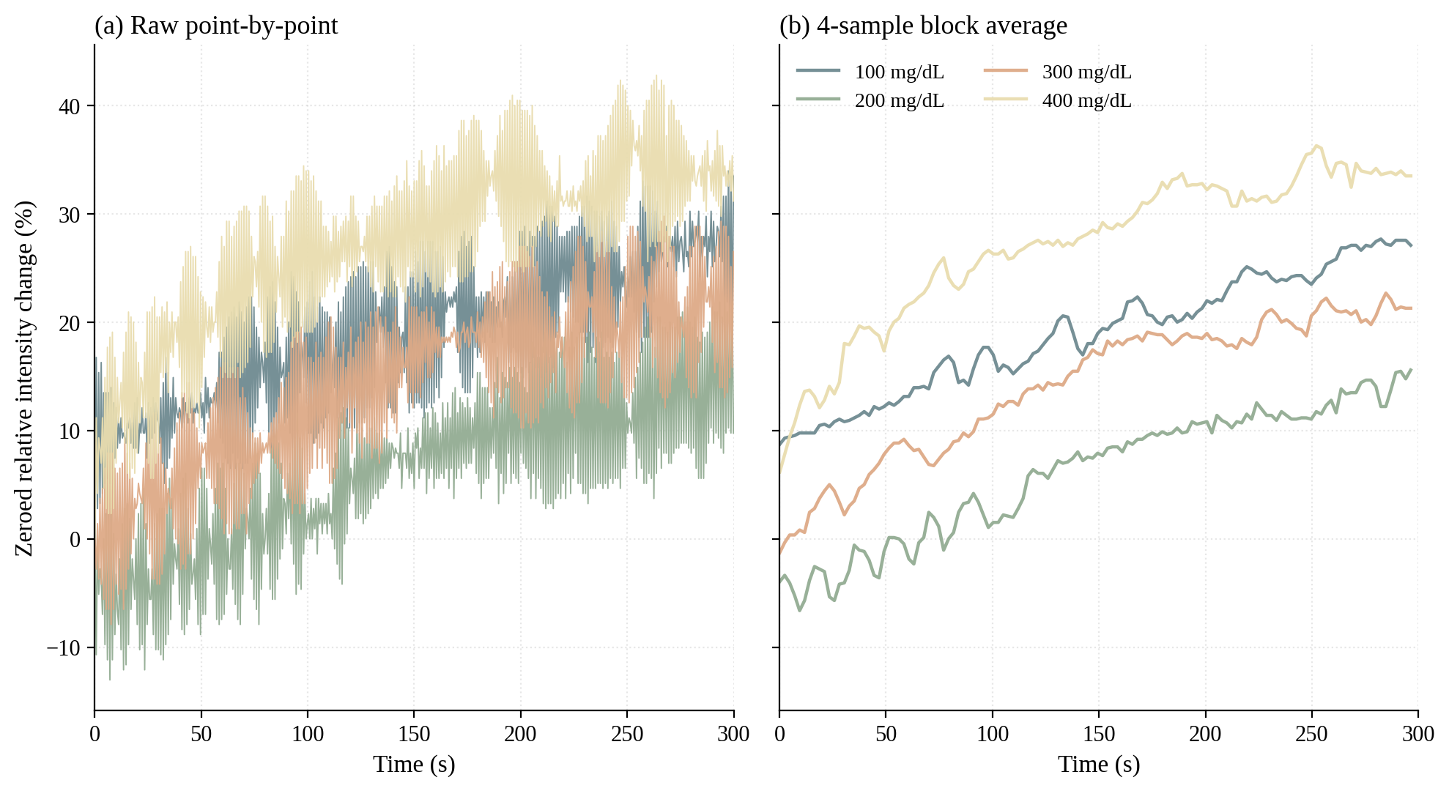
Figure H1. Smoothing comparison on the Geometry 2 (partial turtle shell) session. Panel (a) shows the unsmoothed zeroed relative intensity change at the native ~0.5 s sample interval, illustrating the oscillation that motivated the smoothing trial. Panel (b) shows the same data after non-overlapping 4-sample block averaging.
Applying the same filter to the Geometry 1 (standalone optical housing) session revealed a counter-effect in the early kinetic window. Figure H2 demonstrates this on the 100 mg/dL and 300 mg/dL strips from the Geometry 1 session. The 300 mg/dL strip exhibits a rapid onset that reaches 35.0 percent by the fourth raw sample (t = 1.84 s), as shown in panel (b). The first 4-sample block averages the four onset samples (0, −1.85, 15.74, 35.0 percent) into a single value of 12.2 percent, and the smoothing script assigns this averaged value to the timestamp of the first sample in the block, t = 0.10 s. The averaged trace therefore reports 12.2 percent intensity change at the start of the run rather than the rapid onset that the raw samples resolve, and the true approach to the early plateau is visible only in the second block at t = 2.43 s. The 100 mg/dL strip, which rises gradually over a longer window, is largely unaffected by the same averaging.
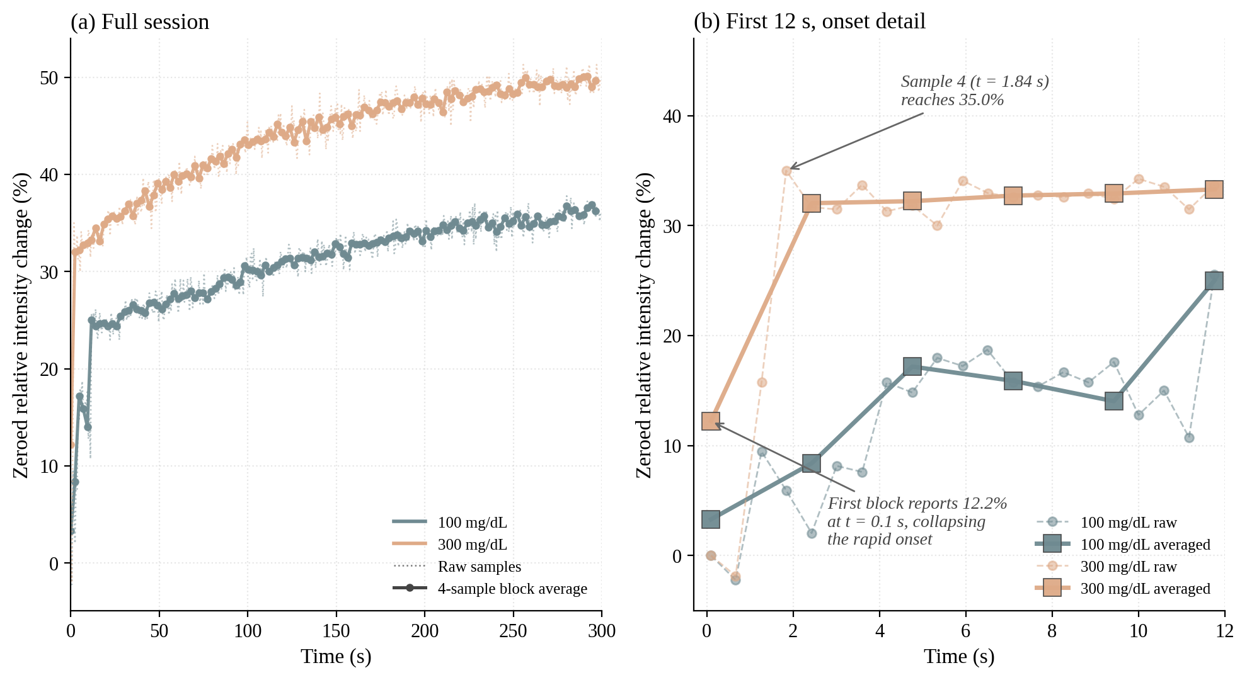
Figure H2. Effect of 4-sample block averaging on a fast-rising kinetic trace, Geometry 1 (standalone optical housing). Panel (a) overlays the raw samples (dotted) and the block-averaged series (solid with circles) for the 100 mg/dL and 300 mg/dL strips across the full 300 s session. Panel (b) zooms on the first 12 s and annotates the 300 mg/dL onset that the averaging filter collapses to a single early-time value.
The same onset-collapse mechanism applied to the Geometry 2 session, but the dominant smoothing artifact in that session manifested differently. Figure H3 shows the effect on the Geometry 2 100 mg/dL and 400 mg/dL strips. Panel (a) presents the full session, where the smoothed trace tracks the central tendency of the raw samples but discards a roughly ±7 percent envelope of variation. Panel (b) zooms on the t = 165–180 s window and reveals that the raw samples alternate cleanly between two approximately fixed values, near 24 percent and 38 percent for the 400 mg/dL strip. The 4-sample block average reports a single intermediate value of approximately 31 percent, which discards the alternating structure. The physical origin of the alternation was not characterized during the project, and the team treated it as information that the smoothing should not be permitted to remove without further investigation.
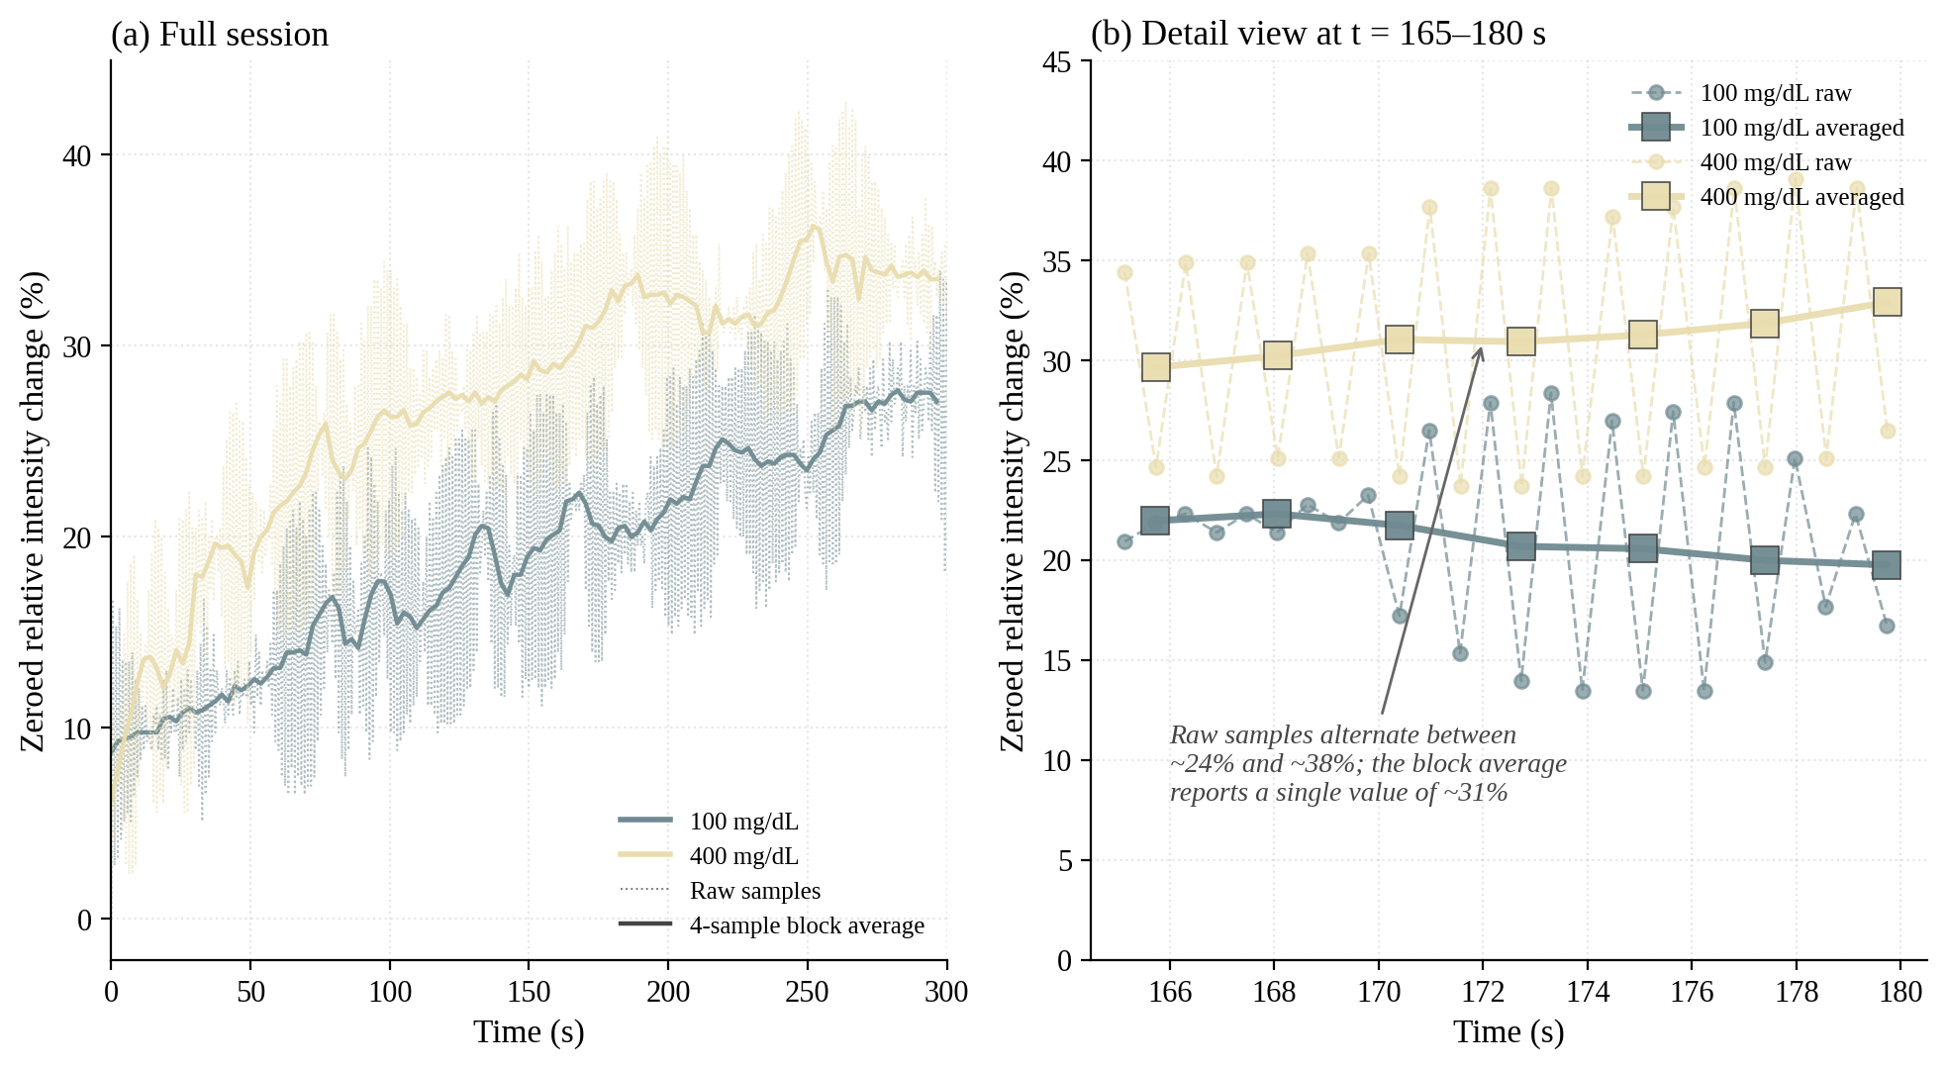
Figure H3. Effect of 4-sample block averaging on the Geometry 2 (partial turtle shell) session. Panel (a) shows the full 300 s session for the 100 mg/dL and 400 mg/dL strips, with the raw samples (dotted) and the block-averaged series (solid). Panel (b) zooms on the t = 165–180 s window where a regular sample-to-sample alternation in the raw 400 mg/dL trace is most visible.
The Geometry 3 (complete turtle shell) session did not exhibit either of these artifacts in a form that the smoothing would have meaningfully altered. Its kinetic onsets were slower and the rising portion of every concentration spanned more samples than the smoothing window, and the per-sample variation around the local mean was small enough that block averaging produced a near-identical trace. The block-average filter therefore produced a different result on each of the three sessions: it suppressed real fast-onset structure in Geometry 1, it collapsed an unexplained alternating pattern in Geometry 2, and it had little effect on Geometry 3. Adopting the smoothing for any single geometry would have introduced an inconsistency in the processing pipeline applied across the three calibration sessions. The team therefore adopted the unsmoothed data for all three calibration figures in Appendix F. This decision preserves a single processing pipeline across the calibration set and keeps the Geometry 2 oscillation visible in Figure F2 as a documented characteristic of the partial turtle shell configuration.

H.4 Full Data Availability
The complete CSV files for all three calibration sessions, including auto-blank windows, intermediate runs, and the discarded preliminary attempts not used in Appendix F, are archived on the team’s shared Google Drive. Access is available from the author upon request.

Appendix I. Reaction Chemistry Testing Success
This appendix documents the table detailing all the reaction success the chemistry subgroup achieved in their variable chemistry testing. Although there were numerous variations excluded that led to the presented results, it seemed a bit arbitrary to include all of them. Thus only the tests in which something was learned are mentioned here.
Table I1. Chemistry Success
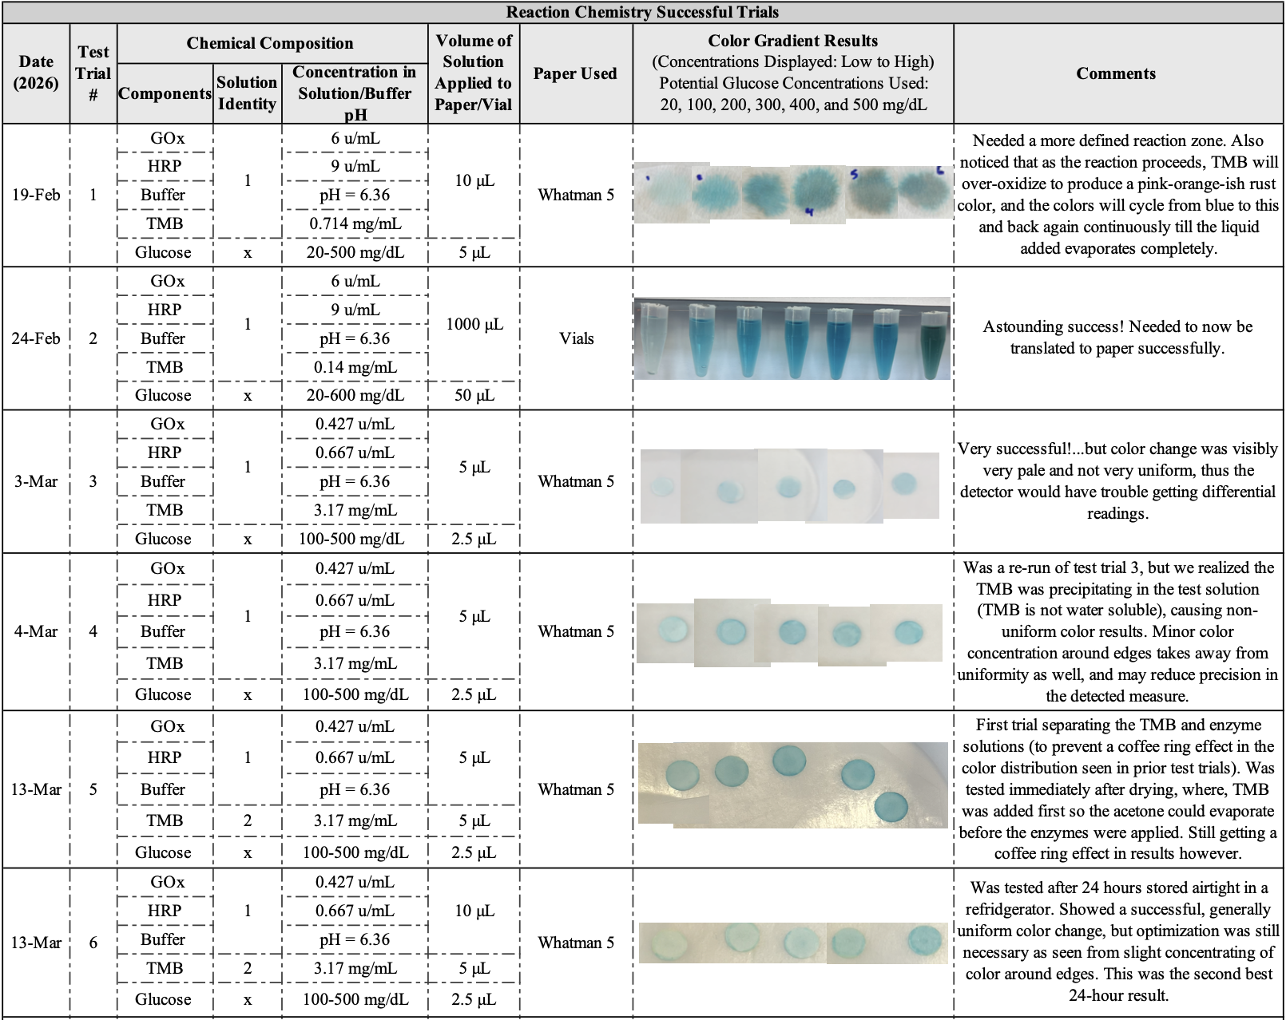

Table I1. Continued

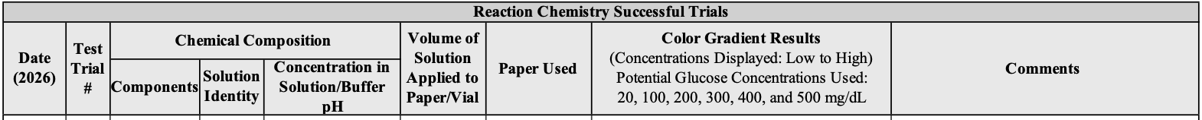
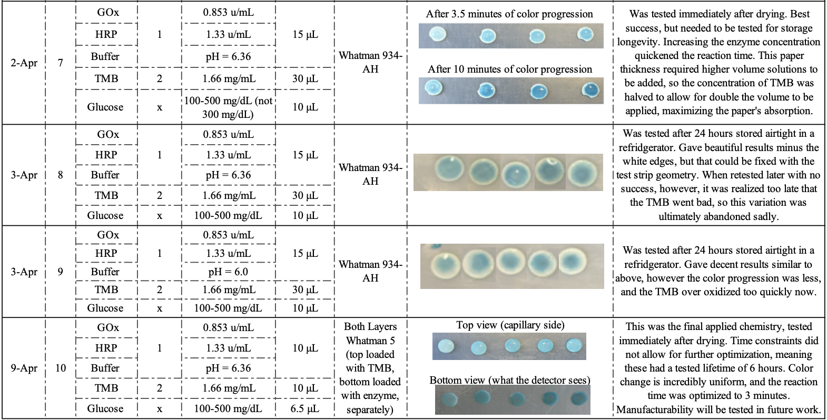

From Table I1, it can be seen that the chemistry subteam had their work cut out for them. Throughout the course of 11 working weeks, many optimization issues arose that garnered careful variation testing. From vials to the final defined 6 mm reaction zone. From one whole test solution to 2 separate ones. From uneven color distribution to the final uniform one. More than 60 individual test sets were conducted in total, and if more time was permitted, that number would likely double.
Some of the main issues the team ran into were not able to be optimized out, but others were. For instance, the coffee ring effect was a persistent problem. We determined that this effect came from the solutions diffusing to the edges as they were allowed to dry, which was only accelerated by the dropper technique used to impregnate the sheets with solution. Another issue experienced was from using only one test solution containing GOx, HRP, buffer, and TMB. In using one whole solution, the TMB was precipitating out of the liquid test solution in the form of solid particle flecks, which caused the color distribution to be nonuniform. This is because TMB is insoluble in water, and requires a strong solvent like acetone to be dissolved. To counteract this issue, the chemistry team, with the guidance of Dr. Berberich, decided to apply the components to the paper sheets in 2 parts, TMB in acetone, and the enzymes (GOx and HRP) in buffer solution. This change brought success. We tried first adding the enzyme, then the TMB, and quickly learned the acetone was burning the enzymes, creating inactivity. Then we added the TMB first, allowing 10-25 minutes for the acetone to evaporate, which was then followed by adding the enzyme. This worked well when tested soon after all components were dry, but the 24-hour tests lead to another coffee ring effect result. This coffee ring was likely the same issue as before, where the dropper method causes the TMB to diffuse to the edges, accelerated by the addition of the enzymes through the same method. Soaking the paper sheets was a proposed solution to this, however, the variability in amount of liquid absorbed caused this idea to be thrown out. In the final chemical design, this issue was not directly addressed as time ran out for useful life testing. Nevertheless, in theory, the method we ended up using should counteract this issue. The final design consisted of 2 paper layers. The first sheet was loaded with the TMB, and given time to dry completely. The second sheet was loaded with the enzyme solution, followed immediately by placing the TMB loaded sheet on top of this layer. We decided to use this procedure after a few variable tests, where this technique led to the most uniform color distribution we had achieved yet.
Other problems faced included increasing the reaction time, preventing air exposure (facilitates TMB to pre-oxidize, which disrupts even color results), and preventing TMB over-oxidation. Overall, the final chemical makeup of the test strips could have used more time for further optimization, but the final result of this design is sufficient.

Appendix J. Test Strip Fabrication Protocol
This appendix documents the complete fabrication procedure for the P.I.P. paper-based test strips. The sections cover materials, equipment, reagent preparation (buffer, enzyme working solution, TMB solution, and glucose calibration standards), paper and PET layer preparation, reagent deposition and assembly, storage, and observed failure modes. The procedure produces the strips used for the calibration and verification measurements reported in Section 7 and Appendix F.
Materials
- Whatman Grade 4 filter paper
- PET sheet stock
- Glucose oxidase (GOx) and horseradish peroxidase (HRP), supplied with original specific activities of 160 U/mL and 250 U/mL respectively
- 3,3',5,5'-tetramethylbenzidine (TMB) powder, stored at −20 °C until use
- Acetone (TMB solvent)
- Potassium phosphate buffer components: monobasic potassium phosphate (KH₂PO₄) and dibasic potassium phosphate (K₂HPO₄)
- Glucose powder (for calibration standards)
- Electrical tape
- Capillary-hole cover stickers
- Aluminum foil
Equipment
- 6 mm hole punch
- Dremel LC40 laser cutter
- Soldering iron (used as a heat-sealing tool at 420 °F; no solder applied)
- Micropipettes (10 μL)
- Airtight storage containers
Buffer Preparation: A pH 6.36 phosphate buffer was prepared by dissolving monobasic KH₂PO₄ and dibasic K₂HPO₄ separately in deionized water and combining the two solutions in the ratio required to reach pH 6.36.
Enzyme Solution Preparation: The GOx and HRP working solutions were prepared by the faculty advisor in the pH 6.36 phosphate buffer to final concentrations of 0.835 U/mL GOx and 1.33 U/mL HRP. The enzyme solutions were stored, refrigerated and used within their working day.
TMB Solution Preparation: TMB powder was removed from −20 °C storage immediately before use and dissolved in acetone at a final concentration of 3.15 mg/mL. TMB is insoluble in water, which makes acetone the required solvent. The prepared TMB solution was kept out of direct sunlight to prevent UV-induced oxidation.
Glucose Calibration Solutions: A 600 mg/dL glucose stock was prepared by dissolving glucose powder in deionized water. Working concentrations of 100, 200, 300, and 400 mg/dL were prepared by serial dilution from this stock using C₁V₁ = C₂V₂.
Paper Substrate Preparation: Whatman Grade 4 filter paper was punched into 6 mm diameter discs using a hole punch to ensure dimensional consistency across the test strip batch.
PET Layer Preparation: PET sheets were laser-cut on the Dremel LC40 into 10 × 50 mm top and bottom strips. The top strip included a 3 mm circular capillary opening positioned over the reaction zone; the bottom strip was a plain cut without features.
Reagent Deposition and Layer Assembly:
- Place a 6 mm Whatman Grade 4 disc on a clean bench surface.
- Pipette 10 μL of TMB-in-acetone solution onto the disc.
- Allow the disc to air dry on the bench (typical drying time 10–25 minutes). Keep the disc out of direct sunlight during drying. Confirm dryness visually before proceeding.
- Pipette 10 μL of the enzyme working solution onto a second 6 mm Whatman Grade 4 disc.
- Immediately place the dried TMB disc on top of the enzyme disc to preserve uniform enzyme distribution and prevent diffusion to the disc edges.
- Insert the layered disc assembly into the bottom PET strip at the reaction zone position.
- Place the top PET strip (with capillary opening) over the disc assembly, aligning the 3 mm hole with the disc center.
- Apply the capillary-hole cover sticker to the top opening to limit air exposure and prevent TMB pre-oxidation prior to use.
- Apply a strip of electrical tape across the PET assembly 1.5 cm from the bottom edge to mask the region exposed to light when the strip is inserted into the device.
- Heat-seal the top and bottom PET layers along their interface using the soldering iron at 420 °F (no solder applied, only heat).
- Transfer finished strips to an airtight container as quickly as possible after assembly.
Storage: Completed strips were wrapped in aluminum foil to block light, placed in an airtight container, and refrigerated. Strips demonstrated stable performance for approximately 6 hours at room temperature during the design expo demonstration. Formal longevity testing beyond this window was not performed. Long-term storage tracks the most sensitive reagent in the assembly (TMB), which is light-, air-, and temperature-sensitive.

Appendix K. Project Gantt Chart
This appendix documents the project Gantt chart used to plan and monitor the development of the P.I.P. device across the two-semester capstone timeline. The chart was maintained as a live spreadsheet throughout the project and tracked task ownership, planned start and due dates, duration, and percent completion across the four project phases described in the Project Management section.
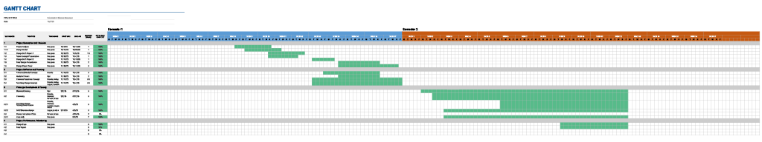
Figure K1. Project Gantt chart at the conclusion of two semesters. Tasks are organized under the four project phases: Project Conception and Initiation, Project Definition and Planning, Prototype Development and Testing, and Project Performance Monitoring. Each row records the task title, owner, start and due dates, planned duration in weeks, and percent completion.

